***Python IDLE comprises Python shell and Python Editor.***

***Python learning***

Printing Commenting Debugging String Manipulation and variables

***By default the calculation in python results in real numbers***

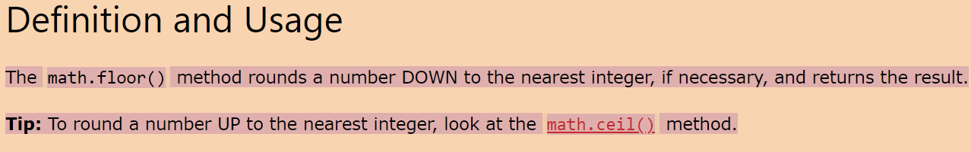

But in order to use this ***there is a need to import the Math Library***

import math

print(math.floor(18/5))

Python operator // (two slashes without any intervening blank) can be used. For example, 27 // 5 yields 5.  
**Real numbers are called floating point numbers in Computer Science terminology** in view of the floating point representation used to represent real numbers.

Python operator % (percentage sign), known as modulus, yields the remainder of the division, for example, 27 % 5 yields 2 because on dividing 27 by 5 we get 2 as the remainder.

***These are the arithmetical operators in Python***

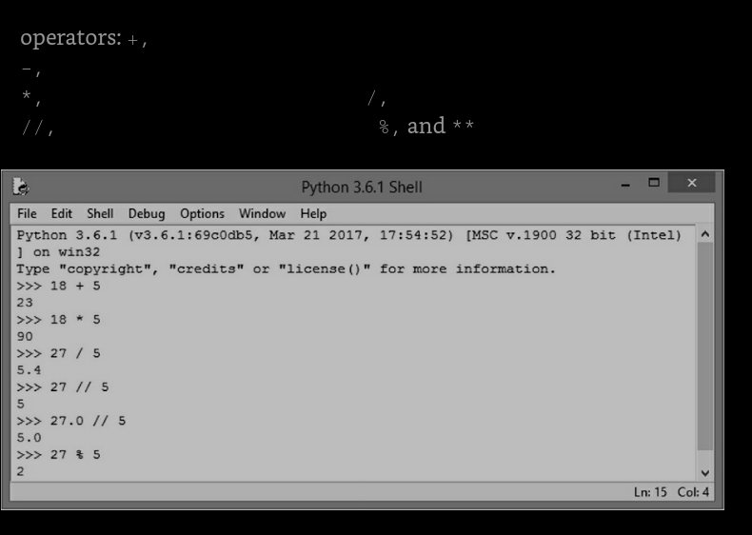

The exponentiation operator (**) yields raise to the power operation, i.e. ab. For example, 32 is expressed as 3 ** 2, and yields the value 9.

expressions. Note that whereas the expression 6 / 3 / 2 yields 1.0(= (6 / 3) / 2), the expression 2 ** 3 ** 2 yields 512 (= 2 ** (3 ** 2)). This is so because whereas the operator / (as also +, -, *, //, %) is evaluated left to right,

We say that the **operators, +, -, *, /, //, and %, are left associative operators** and the **operator ** is right associative.** **Python operator – (negation) yields negative of the operand.** For example, 10 * -5 multiplies 10 and -5 (negative of 5), yielding -50 as a result.

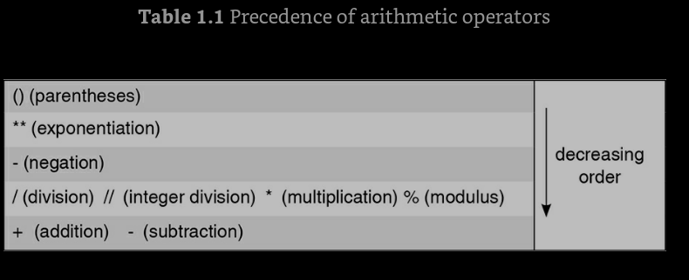

the expression **7 / 0 yields a zero division error( one of the type of the error )** since division by zero is a meaningless operation.

***Relational Operators***

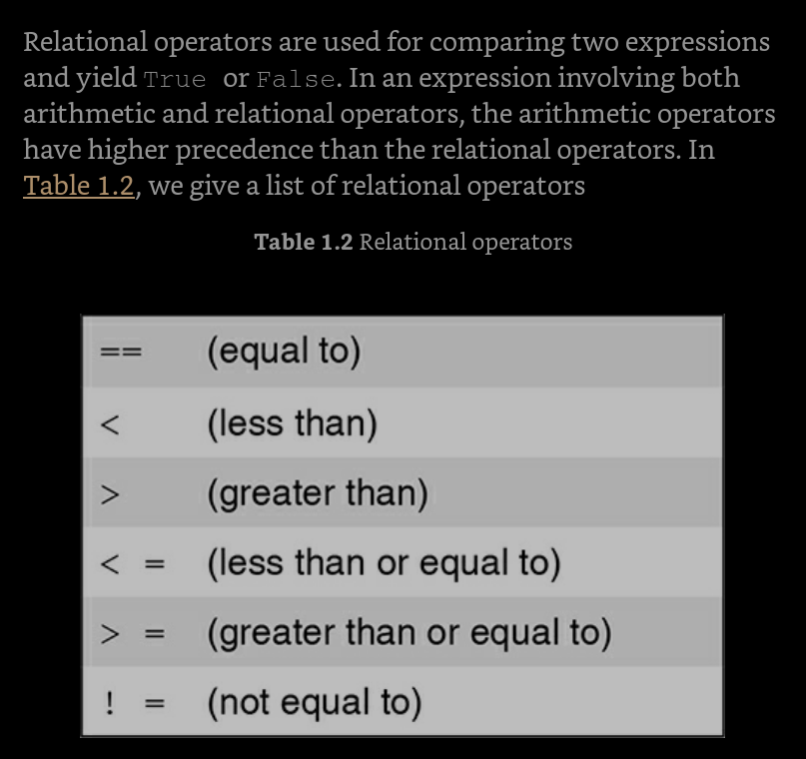5

respectively. As ***arithmetic operators have higher precedence than the relational operators, t***he expression 23 - 2.5 >= 5 * 4 is evaluated as if it were (23 - 2.5) >= (5 * 4).

When the relational operators are applied to strings, strings are compared left to right,

When the relational operators are applied to strings, strings are compared left to right, character by character, based on their ASCII codes, also called ASCII values. For example, ASCII codes of ***'A'-'Z', 'a'-'z', and '0'-'9' lie in the range [65, 90], [97, 122], and [48, 57],*** respectively. Thus, 'h' > 'H' yields True as ASCII value of 'h' (= 104) is greater than ASCII value of 'H' (= 72). Also, 'hello' > 'Hello' yields True since 'h' is greater than 'H'.

The Strings cannot be compared with the Integer values just like they cannot be concatenated with each other   
**Also, if a string is a prefix of another string, the longer string will be considered larger.**

**relational operators yield values: True**, **False**   
**ASCII values of characters are used for string comparison**   
Python 3 does not allow string values to be compared with numeric values

***Logical Operators***

The ***logical operators not, and, and or are applied to logical operands True and False, also called Boolean values,*** and yield either True or False.  
**The operator not is a unary operator, i.e. it requires only one operand.** The expressions not True and not False yield False and True, respectively.  
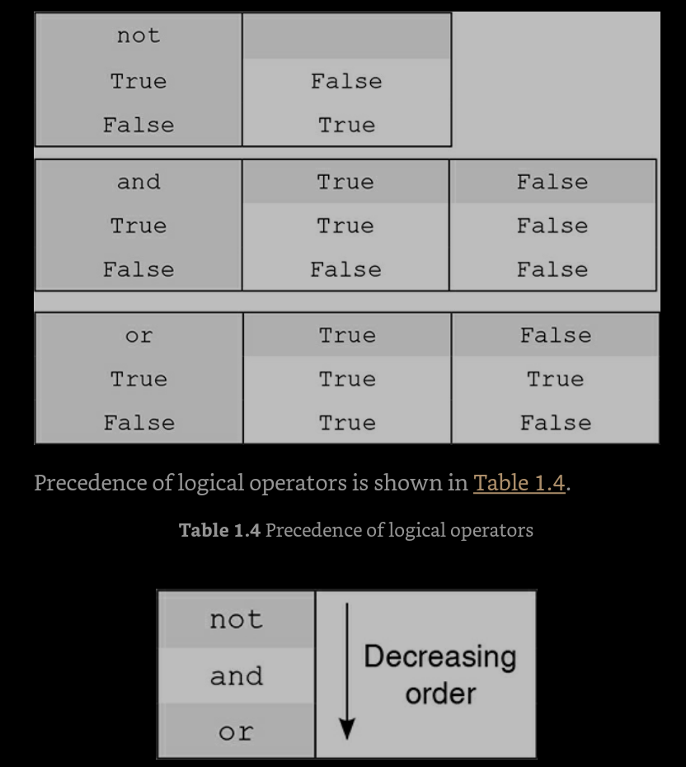

**While *evaluating an expression involving an and* operator, the second sub-expression is evaluated only if the first sub-expression yields True**. For example, in the expression (10 < 5) and ((5 / 0) < 10), since the first sub-expression (10 < 5) yields False, and thus determines the value of the entire expression as False, **Python does not evaluate the second sub-expression.**

**CONVERTING AND TO OR**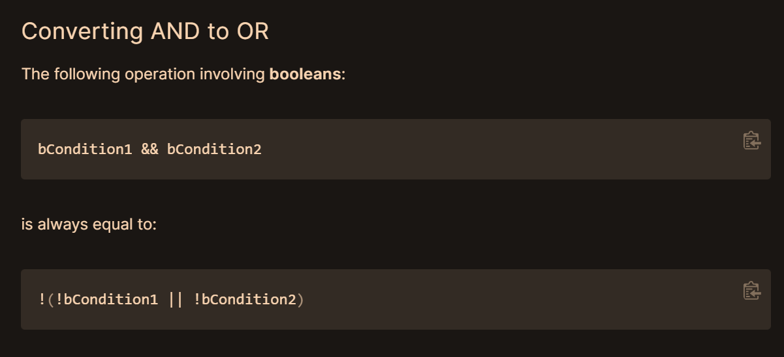

**CONVERTING OR TO AND**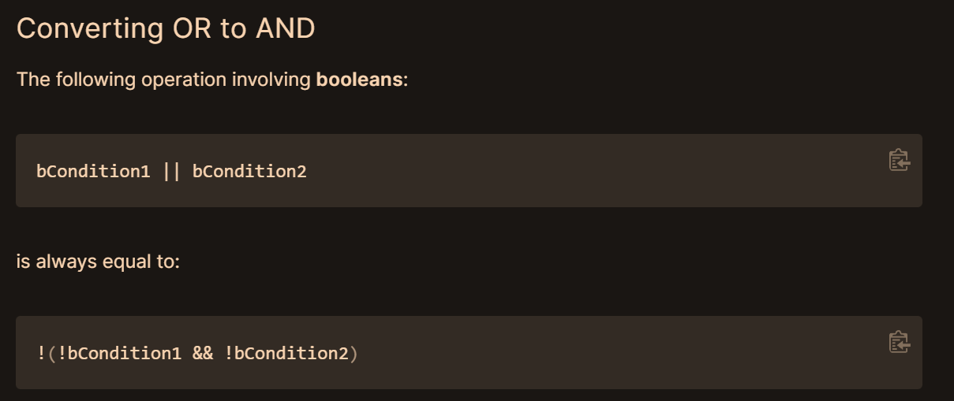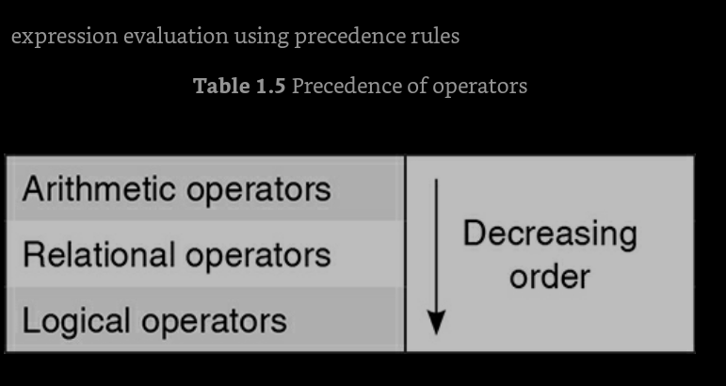

***Bitwise Operator***

Bitwise operators are the operators that operate on integers interpreted as strings of binary digits 0 and 1,

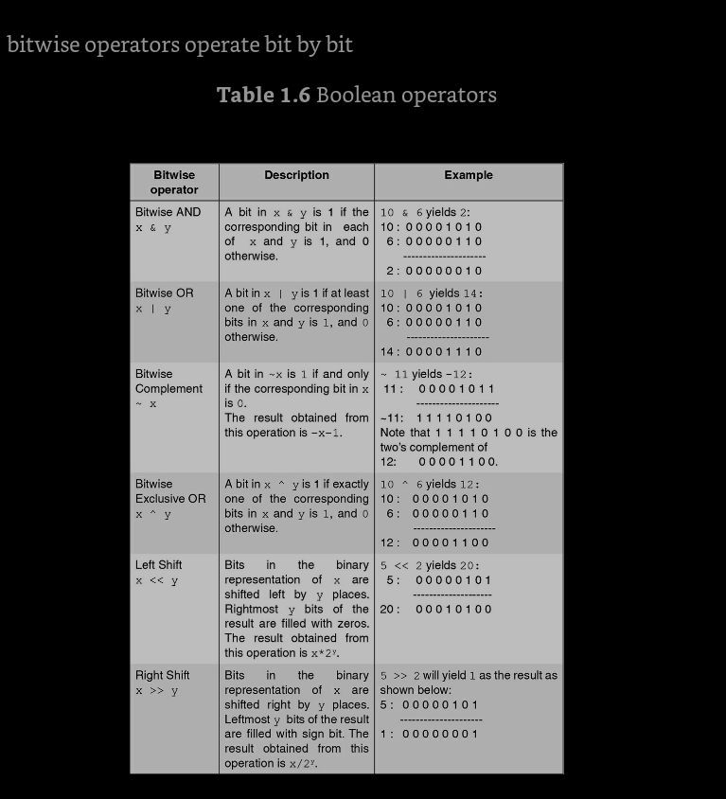

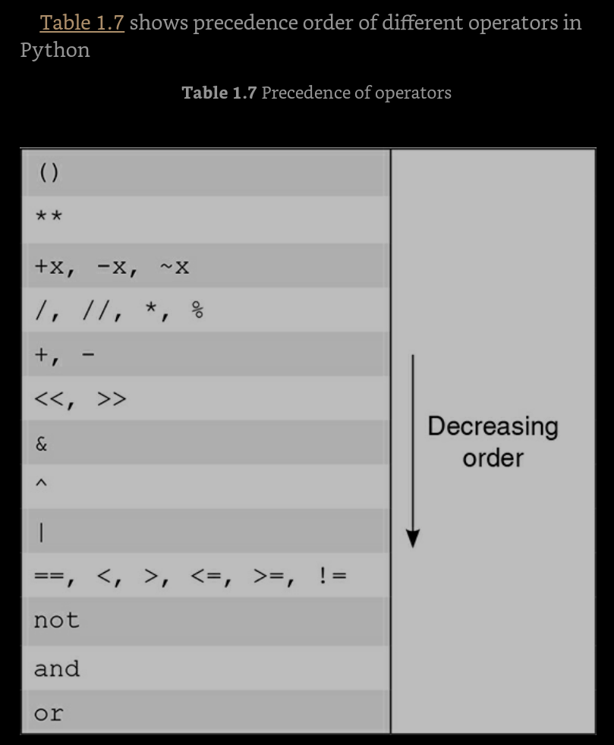

First one are the arithmetic then comes the

bitwise

Relational

Logical

This is the preference of operators

***Variables and Assignment Statements***

Python associates the variable english with value 57. We can also say that the the variable english is assigned the value 57, or that the variable english refers to value 57. Such a statement that assigns value to a variable is called an assignment statement.

>> english = 57   
a variable is a name given to a value When the above statement is executed, Python associates the variable english with value 57. We can also say that the the variable english is assigned the value 57, or that the variable english refers to value 57. 57. Such a statement that assigns value to a variable is called an assignment statement.(=, here works like the assignment variable) ***variables are called names, and an assignment is called an association or a binding.***  
values are assigned to variables using an assignment statement. The syntax for assignment statement is as follows:  
***variable = expression  
 syntax for assignment statement***

***Rules for naming a variable***-> A variable must begin with a letter or _ (underscore character)   
-> A variable may contain any number of letters, digits, or underscore characters. No other character apart from these is allowed.

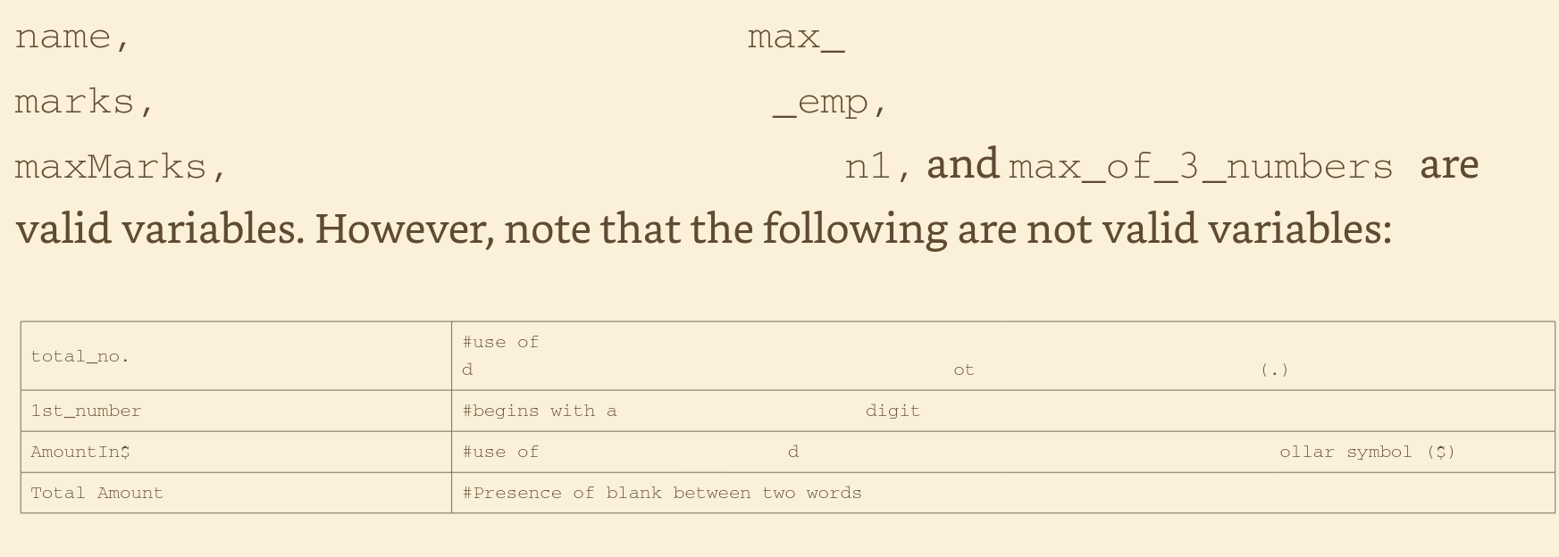  
There are several styles of forming variables, for example:   
total_marks   
TotalMarks  
 totalMarks   
TOTAL_MARKS  
#***python is a case sensitive language***

age and Age are different names  
a=a+5 can be written as a+=5  
Thus, the operator += serves as shorthand notation in assignment statement.  
**> a = a + b + c >>> a = a ** (b + c) can be written as follows, respectively: >>> a += b + c >>> a **= b + c**

**> msg = 'Meeting' >>> day = 'Mon' >>> time = '9' may be replaced by a single statement: >>> msg, day, time = 'Meeting', 'Mon', '9'   
the syntax for an assignment statement may be described as follows: <name1>, <name2>, ..., <nameK> = <expr1>, <expr2>, ..., <exprK>**

**Different variables can also have same value on the right hand side   
x1,x2=0,0**

A variable that is used to hold the value of another variable temporarily is often called **temporary variable.  
*keywords***

Keywords are the reserved words that are already defined by the Python for specific uses. They cannot be used for any other purpose.  
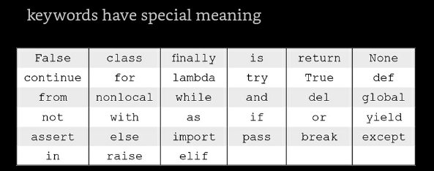

***#fact***

The **exp()** method returns exponential of x: **ex**.

### **Syntax**

Following is the syntax for the **exp()** method −

import math

***math.exp( x )***

The m of math is in lower case

and using the cos and sin and the tan is also done through the math class which is imported using   
***import math***

***math.sin()  
math.cos()  
math.tan()***

***FUNCTIONS IN PYTHON***

***input Function*** The function input enables us to accept an input string from the user without evaluating its value. The function input continues to read input text from the user until it encounters a newline, for example:  
**Making use of a function is called calling the function, or invoking the function.**

The string in the input paranthesis are the arguments

***Next is the eval() functions***Making use of a function is called calling the function, or invoking the function.  
>>> eval('15') 15 >>> eval('15+10') 25

The **value returned by a function may be used as an argument for another function in a nested manner. This is called composition**.

***Print Function***

print('hello') the system will output hello: >>> print('hello') hello  
the **print function does not include any apostrophe marks** as it displays the value of the string that comprises the sequence of characters: hello.

>>> n1 = eval(input('Enter a number: 234   
>>> n1 234   
>>> n2 = eval(input('Enter an arithmetic expression: '))  
 Enter an arithmetic expression: 12.0 + 13.0 * 2  
 >>> n2 38.0

print function  
 >>> print(2, 567, 234)   
2 567 234   
>>> name = 'Raman'   
>>> print('hello', name, '2 + 2 =', 2 + 2)   
hello Raman 2 + 2 = 4

name=input('enter your name')

print('hello',name,'2+2',2+2)

see the variables(string) and the arithmetic equations can be directly concatenated using the **commas**  
while if instead of commas the (+) sign is used then this will show an error of string cannot be concatenated with the another data types

***The backslash character \*** has a special meaning. The character sequence \n serves as a line feed character and transfers the print control to the beginning of the next line.

\n is the new line character  
\t is the tab character

After adding the(\n or\t in the string if it is required to not to ignore the new line charger  
it should be **preceded by another backslash**. **Another way of achieving the same thing is to use R or r** before the string containing escape symbol, for example:  
print('Use \\n for newline') Use \n for newline >>> ***print(R'Use \n for newline')***

***type Function Values*** ***or objects in Python*** **are classified into types or classes**, for example, 12 is an integer, 12.5 is a floating point number, and 'hello' is a string. Python function type tells us the type of a value,

everything needs to be printed before showing   
***round Function***  
The round function **rounds a number up to specific number of decimal places,** for example: rounding to nearest value  
When calling the function round, **the first argument is used to *specify the value to be rounded***, and **the second argument is used to *specify the number of decimal digits desired after rounding.***

print(round(89.625,0))

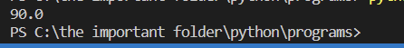

the type casting is done to prevent an concatenation of string with integers which will create errors  
To convert the input strings to equivalent integers, we need to use the function int explicitly (Fig. 2.2): conversion from str to int  
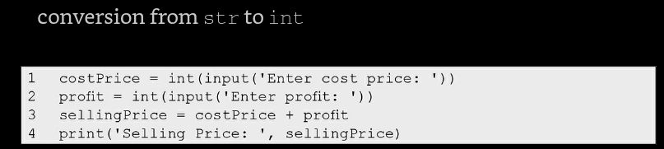

this is the new code  
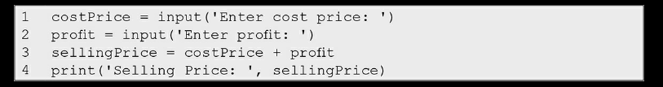

this is the old code  
CP=input('enter the cost price')

P=input('enter the profit made')

#as the input is taken as the string and the strings are added so they just got concatenated like strings in the final SP print equation

SP=CP+P

print('selling price:'+SP) #here the concatenation takes place

so the typecasting can solve the problem either ***write the eval function*** outside the input function or ***the int typecasting*** can also be done

conversion from int to str >>> str(123) '123'  
 >>> float(123)   
123.0  
 >>> int(123.0)   
123  
 >>> str(123.45)  
 '123.45'   
>>> float('123.45')   
123.45

but if try to convert the string to integer then it will show an error  
ValueError: invalid literal for int() with base 10: '123.45'

function **int cannot be used for converting a string** containing **decimal value to its integer equivalent.** We already know that the eval function converts the value of the argument to the appropriate type, for example: >>> eval('50+5') 55

We already know that the **eval function converts the value of the argument to the appropriate type,**

**min and max Functions**The functions max and min are used to find maximum and minimum value respectively out of several values in the parenthesis even the values are the parenthesis.

NOTE->> Note that **the integer** and **floating-point values** are compatible for comparison. ***However, numeric values cannot be compared with string values.***

pow Function The function pow(a, b)computes ab.

**Random Number Generation function and the module**

Python provides **a function random** that generates **a random number in the range [0,1).** Python module random contains this function and needs to be imported for using it.  
this random function generates number

***The usage of the random function***   
import random

if random.random() < 0.5:

    print('Player A plays the first turn.')

else:

    print('Player B plays the first turn.')

The random module provides another **function randint** that randomly chooses an integer in the specified range; for example, **randint(1,n)** will **randomly generate a number in the range 1 to n (both 1 and n included)**.

***all the functions under the random module are***

here are all the functions in the random module of Python:

1. random(): Returns a random float between 0 and 1.
2. seed(a=None, version=2): Initialize the random number generator with a seed value.
3. randrange(stop): Returns a randomly selected element from the range range(stop).
4. randrange(start, stop[, step]): Returns a randomly selected element from the range range(start, stop, step).
5. randint(a, b): Returns a random integer between a and b, inclusive.
6. choice(seq): Returns a randomly selected element from the non-empty sequence seq.
7. choices(population, weights=None, *, cum_weights=None, k=1): Returns a list of k elements from the population sequence with replacement.
8. shuffle(x[, random]): Shuffles the sequence x in place.
9. sample(population, k, *, counts=None): Returns a new list containing k unique elements from the population sequence.
10. random(): Returns a random float between 0 and 1.
11. uniform(a, b): Returns a random float between a and b, inclusive.
12. triangular(low, high, mode): Returns a random float between low and high, with the specified mode value.
13. betavariate(alpha, beta): Returns a random float between 0 and 1, using a beta distribution.
14. expovariate(lambd): Returns a random float between 0 and positive infinity, using an exponential distribution.
15. gammavariate(alpha, beta): Returns a random float between 0 and positive infinity, using a gamma distribution.
16. gauss(mu, sigma): Returns a random float using a Gaussian distribution with mean mu and standard deviation sigma.
17. lognormvariate(mu, sigma): Returns a random float using a log-normal distribution with mean mu and standard deviation sigma.
18. normalvariate(mu, sigma): Returns a random float using a normal distribution with mean mu and standard deviation sigma.
19. vonmisesvariate(mu, kappa): Returns a random float using a von Mises distribution with mean angle mu and concentration kappa.
20. paretovariate(alpha): Returns a random float using a Pareto distribution with shape alpha.
21. weibullvariate(alpha, beta): Returns a random float using a Weibull distribution with shape alpha and scale beta.

***The Math Module***

* There are various operations such as floor, ceil, log, square root, cos, and sin that may be required in different applications.

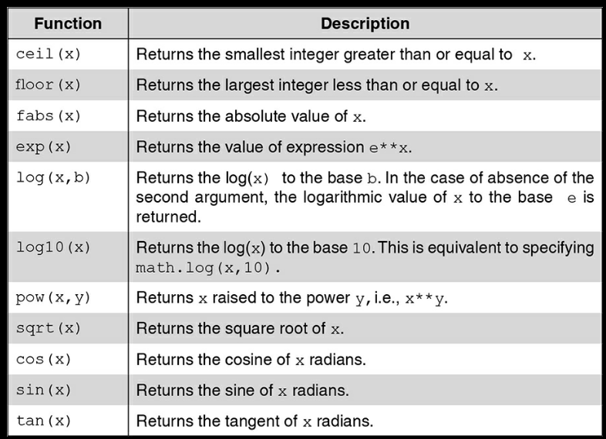

**All these functions are available to be in use for the math module***name of the module, followed by the separator dot, should precede function name*

If we want to **see the complete list of built-in functions**, we can use the **built-in function dir as dir(__builtins__).**

The functions definition starts with word  
def <function_name>():

***Python insists on strict indentation rules***

***The syntax of a function***

def function_name (comma_separated_list_of_parameters):   
statements syntax for function definition

the function name should not be a keyword. **The list of parameters (if any) specifies the information required for using the function**. The statements inside the function have to be indented from the left margin

**It is important to emphasize that apart from the fact that indented code looks elegant, it is also a requirement of Python that the code following a colon must be indented.**

***#FACT->>***

**A script is a Python file** that’s intended to be run directly. When you run it, it should do something. This means that scripts will often contain code written outside the scope of any classes or functions.

A **module** is a Python file that’s intended to be imported into scripts or other modules. It often defines members like classes, functions, and variables intended to be used in other files that import it.

A **package** is a collection of related modules that work together to provide certain functionality. These modules are contained within a folder and can be imported just like any other modules. **This folder will often contain a special __init__ file** that tells Python it’s a package, potentially containing more modules nested within subfolders.

A **library** is an umbrella term that loosely means “a bundle of code.” These can have tens or even hundreds of individual modules that can provide a wide range of functionality. [Matplotlib](https://realpython.com/python-matplotlib-guide/) is a plotting library. The Python Standard Library contains hundreds of modules for performing common tasks, like [sending emails](https://realpython.com/python-send-email/) or reading JSON data.

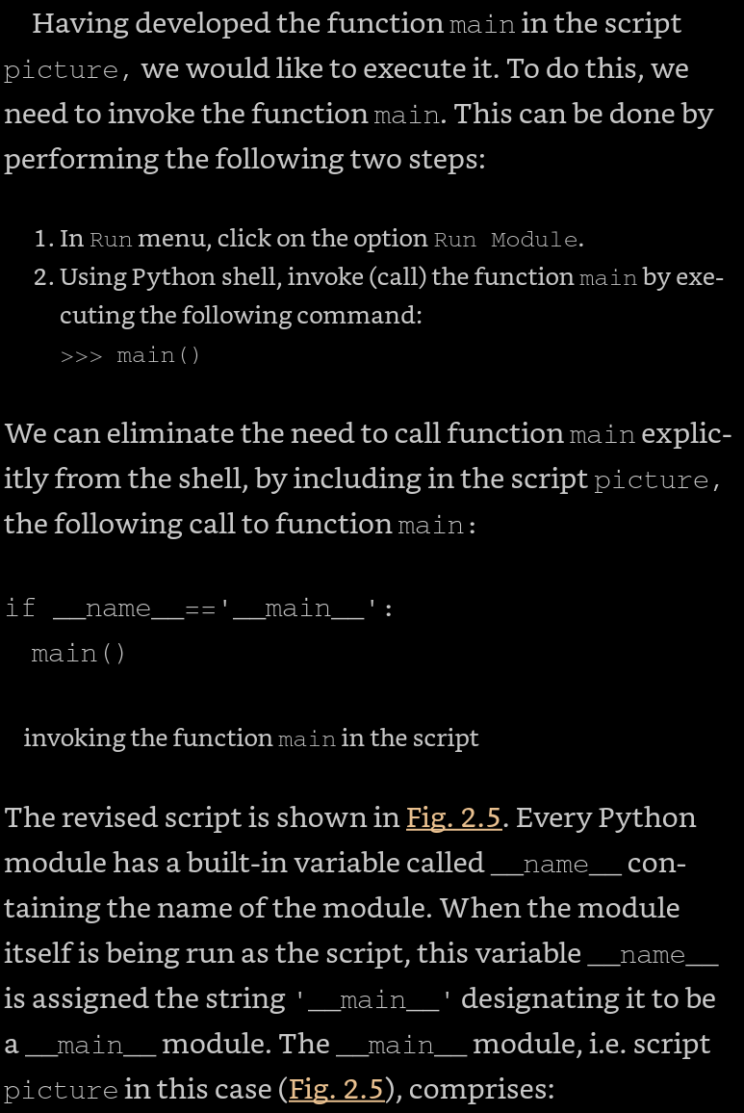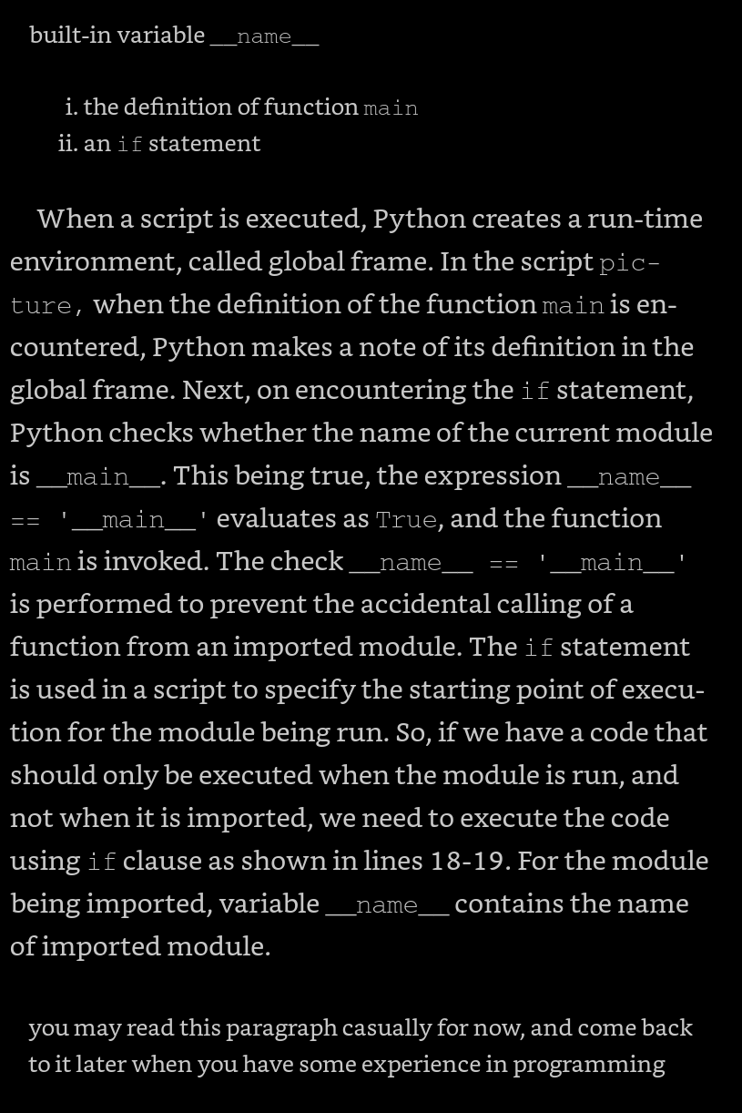

Every Python module has it’s __name__ defined and if this is ‘__main__’, it implies that the module is being run standalone by the user and we can do corresponding appropriate actions

If you import this script as a module in another script, the __name__ is set to the name of the script/module

Python files can act as either reusable modules, or as standalone programs.

If __name__ == “main”: is used to execute some code only if the file was run directly, and not imported.

The **function that calls another function is called the caller function** and the **function that is being called is the callee function/called function**

**#FACT -> a blank line can be printed using the following statement**

***Print()***

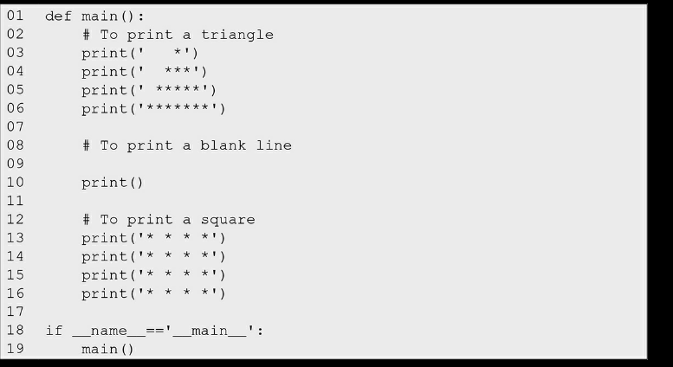 this is fig 2.5

We **can make the above program more elegant** by first developing independent functions to print a square and a triangle and then **making use of these functions in the main function to print a picture that comprises a triangle and a square** separated by a blank line.

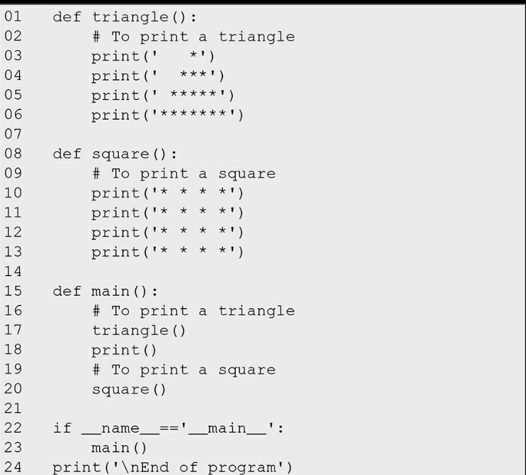this is fig 2.6



in Fig. 2.6 works as follows: Python makes a note of the definition of functions triangle, square, and main as it sees their definitions.  
As it sees their definitions. As described above, on the execution of the if statement (line 22), the control is transferred to the function main (line 15).

In line 17, the function triangle is called, and the body of function triangle gets executed. As the main function calls the function triangle, it is said to be the caller function, and the function triangle that is called is said to be the callee function or called function.

So in this way the control goes to the function which is being called and all its statements are executed   
after execution of the square function at line 20 the control comes back to the main function

As **there are no more statements to be executed in the main, the control now moves to the line following the statement that invoked the main function**, i.e., call to print function at line 24 in the global frame, which now executes, and the program comes to an end.

We would like to emphasize that **a function definition appears in a program as a provision** to do something and **can come into action only when invoked** (called).

Function need to be invoked in order to run even if it is defined   
the caller and the called functions need to share some information between themselves.

We can describe this task of computing area of a rectangle as a sequence of three steps:  
1. take length and breadth of the rectangle as inputs   
2. compute the area of the rectangle   
3. print the area of the rectangle Such an informal description of a program (to be developed) is called a pseudocode.

***Functions***

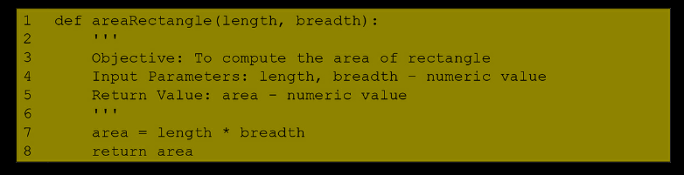

The names length and breadth within parenthesis in the function are called parameters.  
**Lines 2–6 constitute a docstring** describing the function.  
Line 3 describes the overall objective of the function.   
Line 4 describes each of the inputs to the function and the type of value it takes.  
Line 5 indicates that the function would return the area of a rectangle to the calling function.  
**Area of the rectangle is computed in line 7.**Finally, **line 8 is a return statement that returns the area computed in line 7** to the caller function main.

In general, **the return statement returns the value of the expression following the keyword return to the caller function**. **If there is no return statement** in a function, **the function returns the value *None* to the caller function** on the execution of the last statement of the function.

The value being returned may be assigned to a variable.

return statement returns the value of expression following the return keyword in the absence of the return statement, **default value None** is returned

The variables and expressions whose values are passed to the called function are called arguments.  
Values of arguments lengthRect and breadthRect are passed to parameters length and breadth, respectively. These values are used inside the function areaRectangle, for computing area.

While the **parameters length and breadth are called formal parameters,** or **dummy arguments**, **lengthRect and breadthRect used for invoking the function areaRectangle are called actual parameters, or arguments.**

The order of the actual and the formal parameters should be same   
The values of the arguments lengthRect and breadthRect are passed to the parameters length and breadth at the point of call to function areaRectangle. The figure showing the correspondence between arguments and parameters is sometimes called a memory map.  
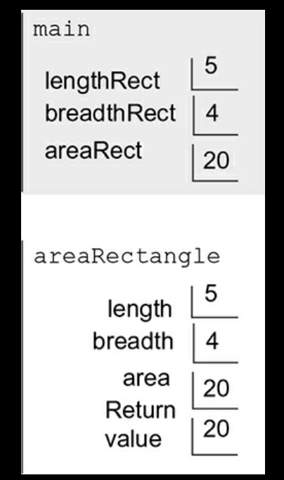this is memory map  
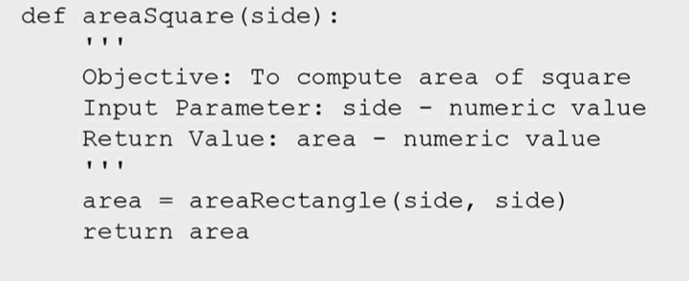

Usage of a rectangle function indirectly through the square function in order to find the area of a square

***The Fruitful function and the void function***

A function that returns a value is often called a ***fruitful function*, for example, the built-in function sin, and abs, and the functions areaRectangle, and areaSquare** A function that does not return a value is called ***a void function.***

***Function help***

function help can be used to provide a description of built in functions. Function help can also be used to provide description of the function dea AQ 1fined by user. All one needs to do is to add a multi-line comment.

This function just retrieve that multiline comment as an output  
Help function output can also be defined for user-defined functions and classes. The docstring(documentation string) is used for documentation. It is nested inside triple quotes and is the first statement within a class or function or a module.

def my_function():

    '''Demonstrates triple double quotes

    docstrings and does nothing really.'''

    return None

# print("Using __doc__:")

print(my_function.__doc__)

print()

print()

print()

# print("Using help:")

help(my_function)

see this is ***the .doc function*** and the other is ***the help function*** ->> both gives the same type of output but with the little bit of difference

***the OUTPUT***

***Demonstrates triple double quotes***

***docstrings and does nothing really.***

***Help on function my_function in module __main__:***

***my_function()***

***Demonstrates triple double quotes***

***docstrings and does nothing really.***

*function help retrieves first multi-line comment from the function definition*

if a particular value for the function parameter is not assigned then the automatic value is 1  
***Default Parameter Values*** The function parameters may be assigned initial values also called default values

**Positional arguments are the arguments which are there in the function definition** but **not given the value for the required operation while calling them**

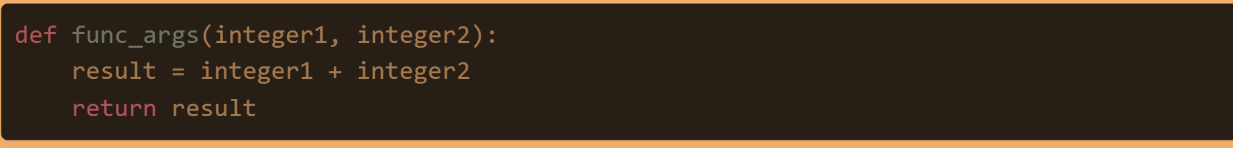

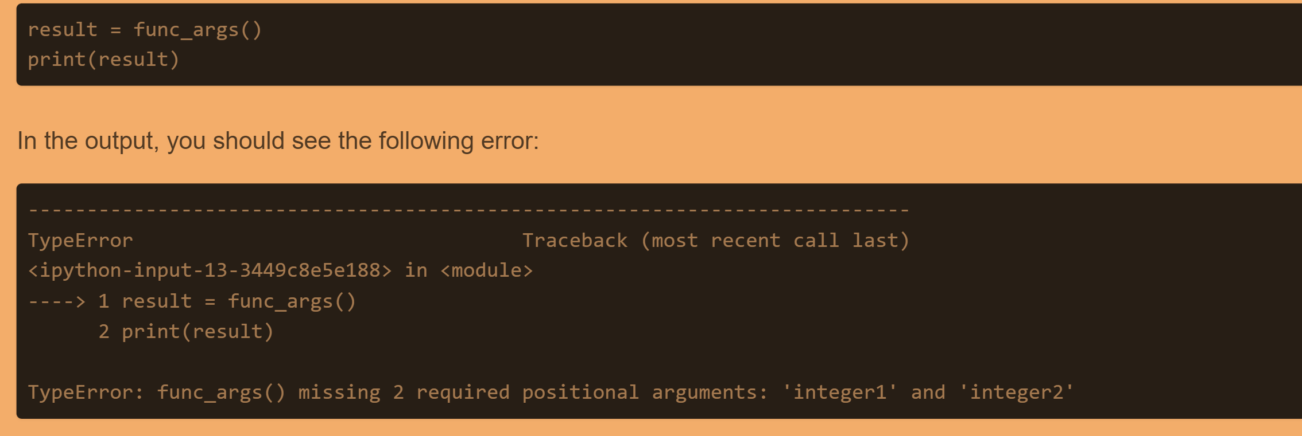



See the functions are not given the required values on which the operation to be done but they are specified in the function definition

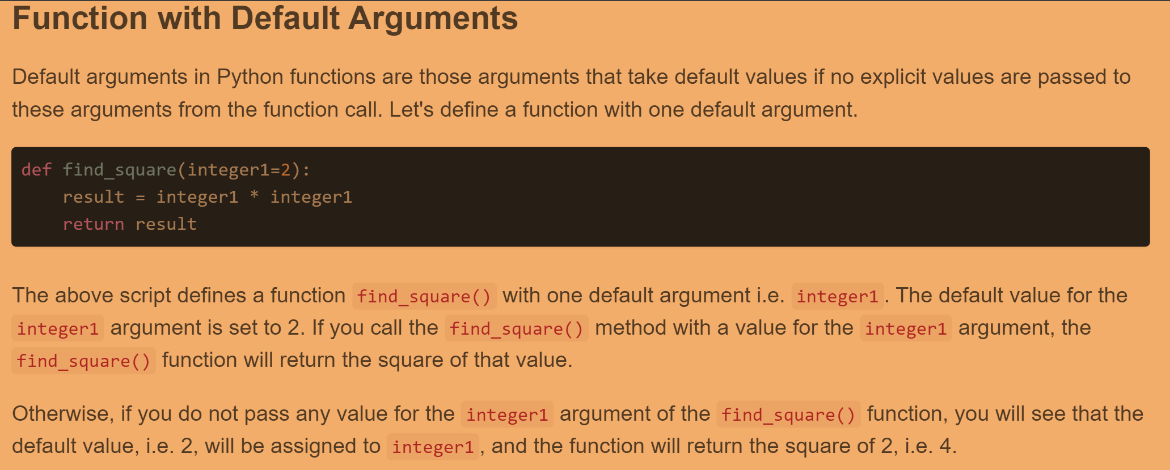

This is all about the default parameter ->> means if a value is not entered by the user while calling the function then the function definition will take the value there inside definition   
rest the default parameters values can be overwritten while calling the function

***the default parameters must not be followed by non-default parameters, for examplenon-default arguments should not follow default arguments in a function definition***

***Keyword Arguments***

The order of arguments always matched the parameters in the function definition. However, Python allows us to specify arguments in an arbitrary order in a function call, by including the parameter names along with arguments.

->> Indeed, in situations involving a large number of parameters, several of which may have default values, keyword arguments can be of great help, for example:

>>> def f(a = 2, b =3, c = 4, d =5, e = 6, f = 7, g = 8, h = 9): ***#the code***return a + b + c + d + e + f + g + h ***#this is the solution*** >>> f(c = 10, g = 20) # the arguments are specified the value like which dummy parameter is being assigned the value   
62

***Importing a user defined module***

The floor,ceil,log all are these function of the maths module whichis imported   
same is the case with the user defined function

To access a function from a user-defined module (also known as program or script that may comprise functions, classes, and variables), we need to import it from that module.

To ensure that the module is accessible to the script, we append to the system's path, the path to the folder containing the module. Once this is done, we can import the module by using an instruction like:

import name-of-the-module ***syntax for importing a module***

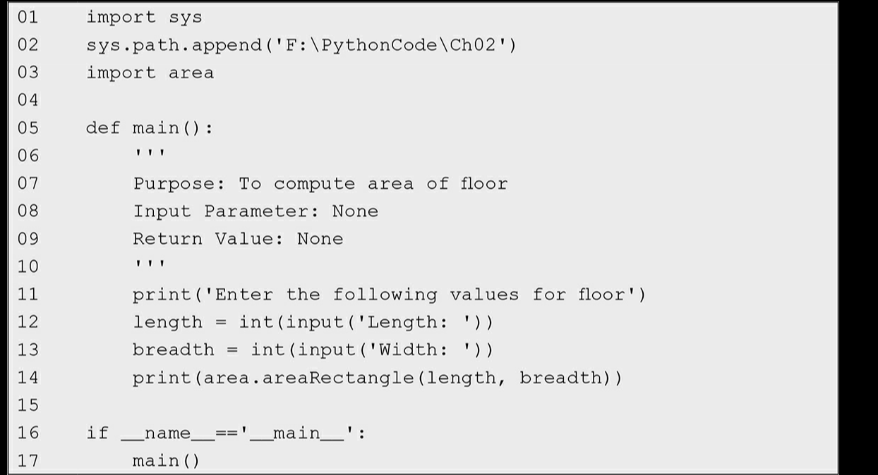

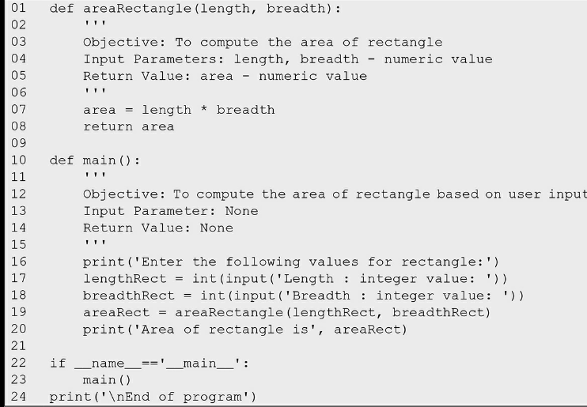

***Assert Statement***

->> The assert statement is used for error checking. we need to make sure that inputs provided by the user are in the correct range. For this purpose, we make use of an assert statement

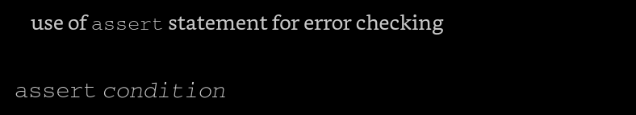

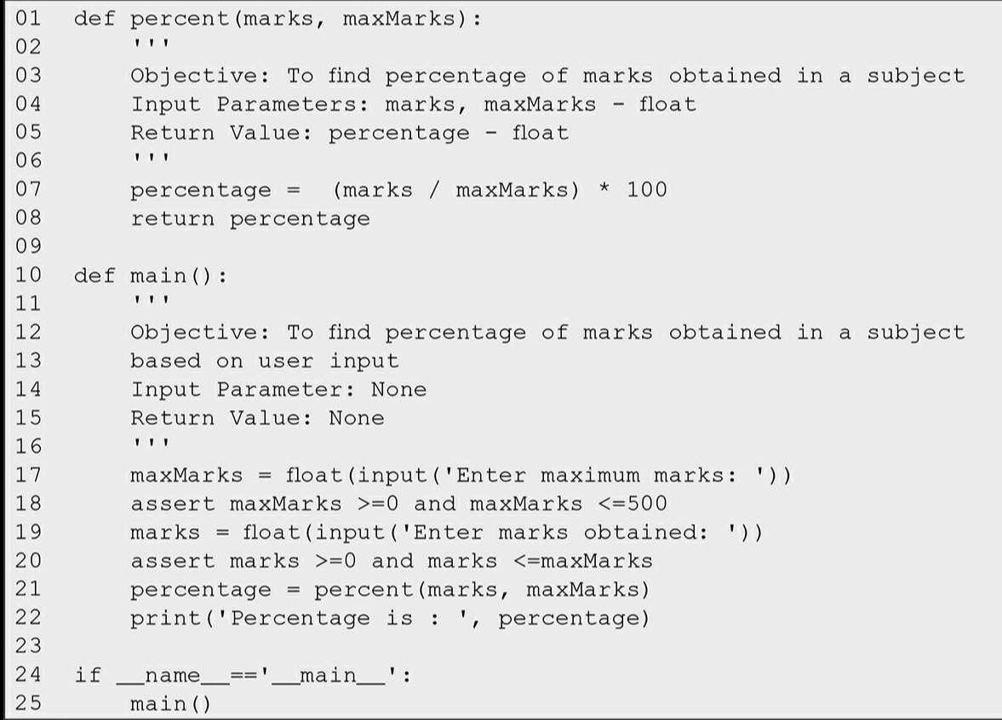



Enter maximum marks: 150  
 Enter marks obtained: 155

The following error comes if the assertion does not hold true

Traceback (most recent call last):   
File "F:/PythonCode/Ch02/percent.py",   
line 25, in <module> main() File "F:/PythonCode/Ch02/percent.py",   
line 20, in main assert marks >=0 and marks <=maxMarks AssertionError

Command line Arguments   
-> open the directory (say, F:\PythonCode\Ch02) containing the file area.py   
->open command prompt window using an option in context menu (opened using shift+right click)   
->***execute the command***: python area.py

***Whenever, we execute a script from command line,*** it **takes name of the script as the first argument followed by other input arguments (if any) in string form and stores them in the list *sys.argv.*** ***We access the arguments stored in argv qqusing indexes argv[0], argv[1], argv[2], etc.***

Since, the number of arguments including the script name should be three, we ensure this using condition len(sys.argv) == 3. We also assume that in the command usually whitespace(s) are used for separating the command line arguments from each other python   
***area1.py 20 10***

see the argument argv[0] will consist of the name of the script and the 20 and 10 are stored in argv[1] and argv[2]

***CONTROL STRUCTURES***

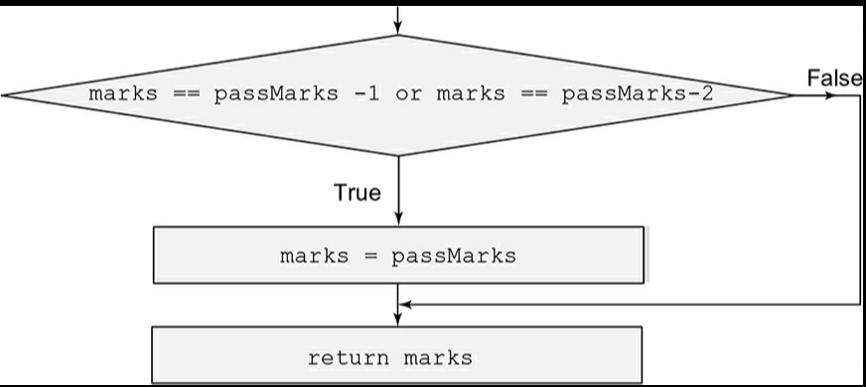

See the moderate function consist of IF loop in a way of diagram

General Form of if Conditional Statement The general form of if conditional statement is as follows:   
syntax for if conditional statement

if < condition >: # the condition is just a Boolean expression  
 < Sequence S of statements to be executed >

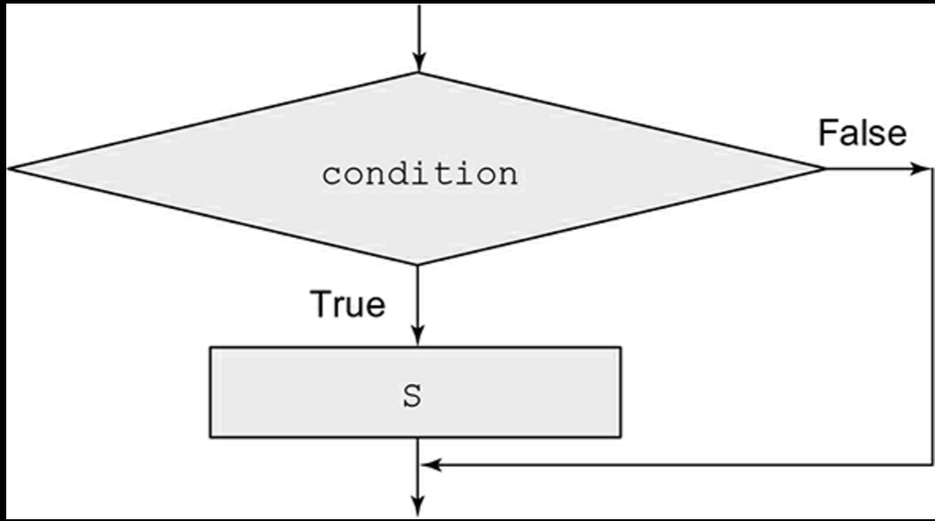  
the follow diagram of IF statement   
The assignment statement in line 8 gets executed only if the condition holds True. Similarly, if the condition specified in line 9 holds True, the assignment statement in line number 10 gets executed.

this is the following flow chart of message validation

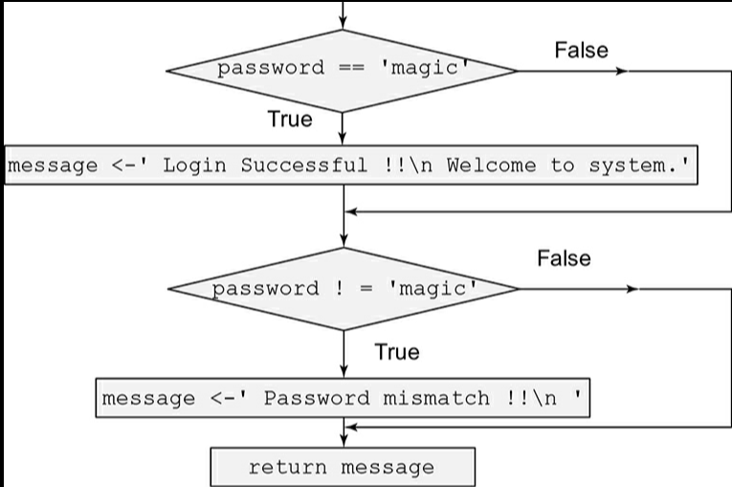

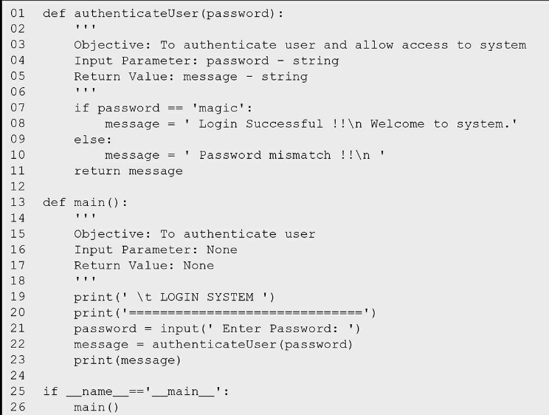

The statement in the line 8 will be executed only if the ***if condition holds true***

**If the condition holds false control is transferred to the assignment statement in line 10 (body of the else part).**

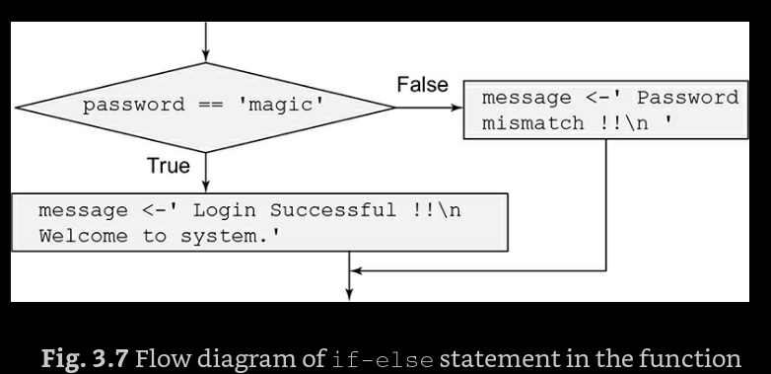

***Conditional Expression***

<expression1> if <condition> else < expression2>

If the condition holds True, the conditional expression yields the value of expression1, otherwise, it yields the value of expression2.   
For example, the following piece of code   
if password == 'magic':   
message = ' Login Successful !!\n '   
else:   
message = ' Password mismatch !!\n '   
***may be replaced by***

**message = ' Login Successful !!\n '  
 if password == 'magic'   
else ' Password mismatch !!\n '**

*use of conditional expression for password validation*

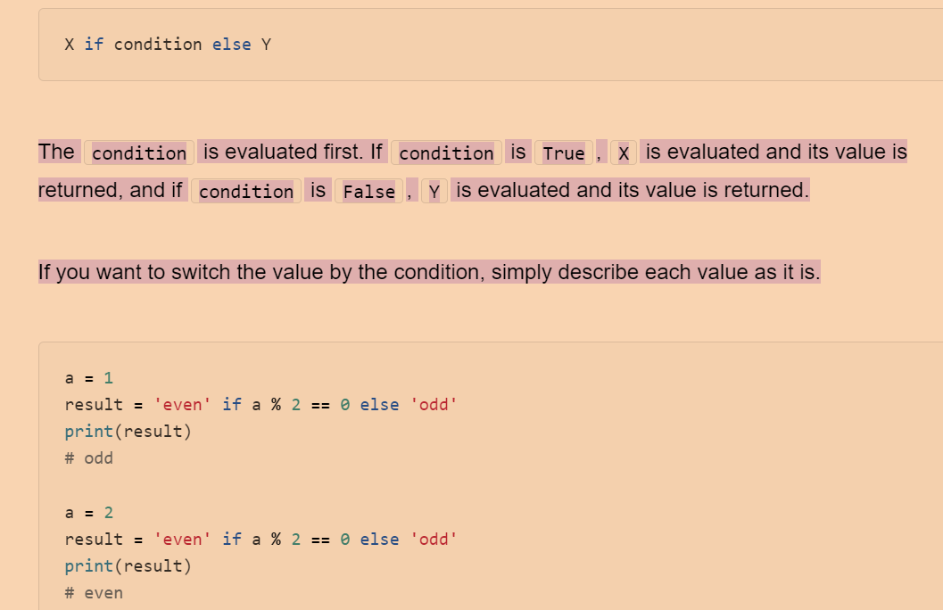

See this i**s the way the conditional expression are written** in python- >> in one line they are written

General Form of IF ELSE Statement

syntax of if-else conditional statement

if < condition >:  
 < Sequence S1 of statements to be executed >   
else:  
 < Sequence S2 of statements to be executed >

***using the multiple if else statements or the elif conditions***

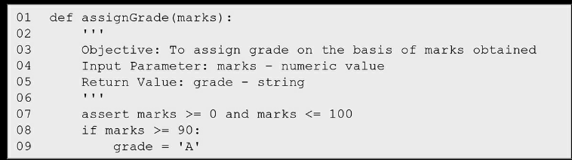  
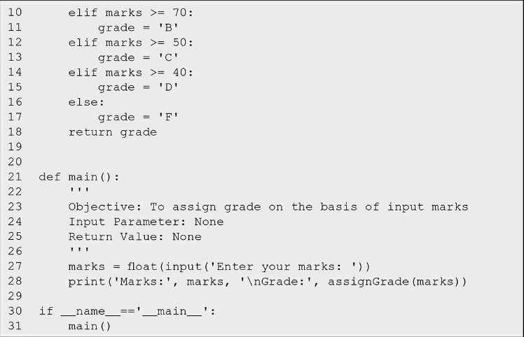

***The syntax of if-elif-else statement***\*\*( the elif and else clauses are optional)

if < condition1 >:  
 < Sequence S1 of statements to be executed >   
elif < condition2 >:  
 < Sequence S2 of statements to be executed >   
elif < condition3 >:   
< Sequence S3 of statements to be executed > . . .   
else:   
< Sequence Sn of statements to be executed >

***nesting of if else statements***

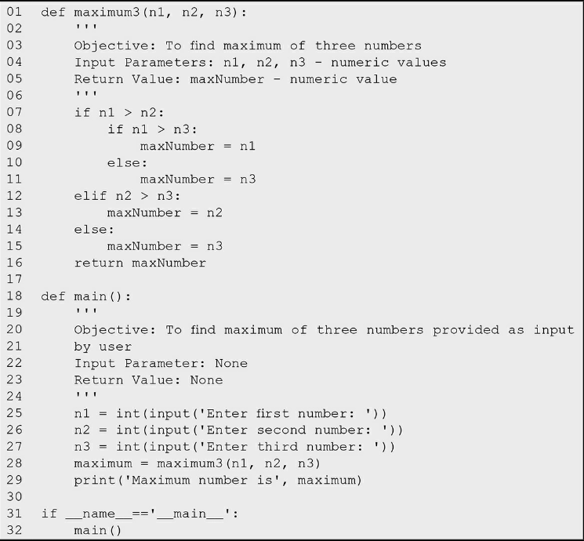



See how the if else and elif are just nested with each other

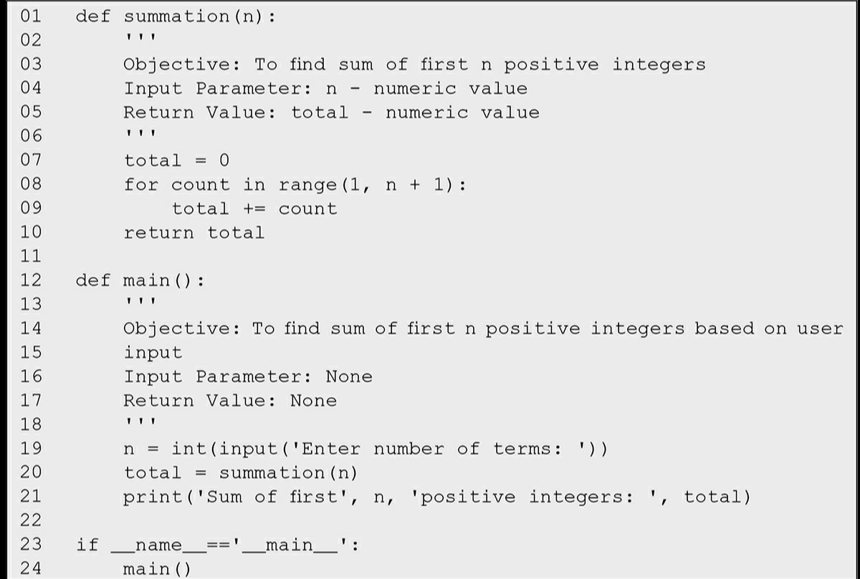

This is the program of ***range function*** used along with the for loop

***The Range function***

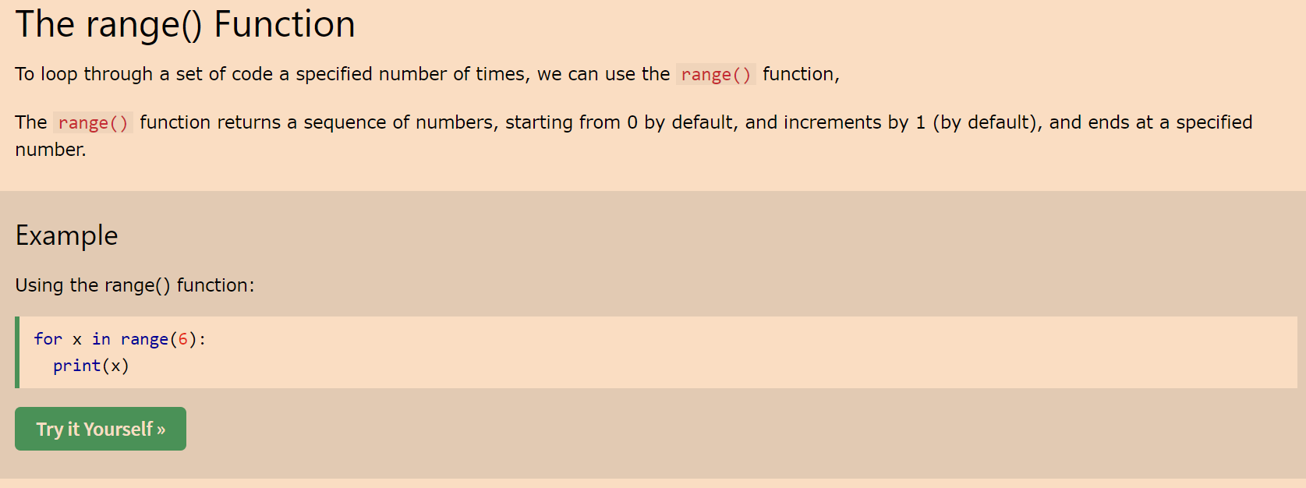

So the value in the brackets are the values of the max so it will be printing from 0(the Default value) to the value of 5  
***The range() function defaults to 0 as a starting value, however it is possible to specify the starting value by adding a parameter: range(2, 6), which means values from 2 to 6 (but not including 6):***

***The range() function defaults to increment the sequence by 1, however it is possible to specify the increment value by adding a third parameter: range(2, 30, 3)***

The Syntax of the Range function  
->> ***Syntax:****range(start, stop, step)*

***Parameter:***

* ***start****: integer starting from which the sequence of integers is to be returned*
* ***stop:****integer before which the sequence of integers is to be returned. The range of integers ends at stop – 1.*
* ***step:****integer value which determines the increment between each integer in the sequence*

#### What is the use of the range function in Python

In simple terms, range() allows the user to generate a series of numbers within a given range. Depending on how many arguments the user is passing to the function, the user can decide where that series of numbers will begin and end as well as how big the difference will be between one number and the next.range() takes mainly three arguments.

* range(stop) takes one argument.
* range(start, stop) takes two arguments.
* range(start, stop, step) takes three arguments.

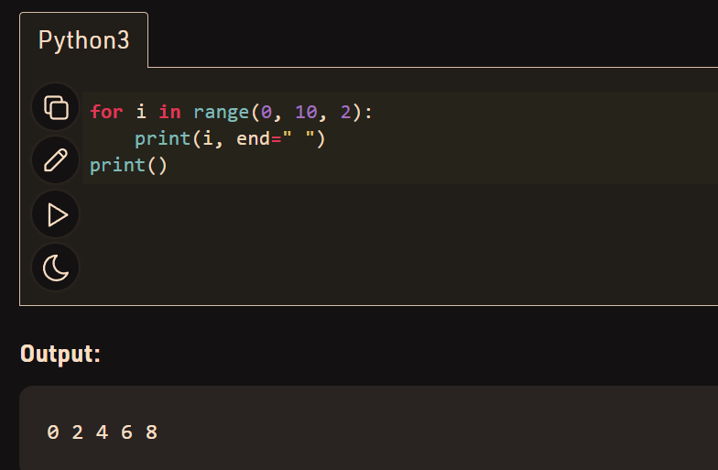

this is the way the range function make a series of the numbers and out of which using the for loop the numbers can be printed

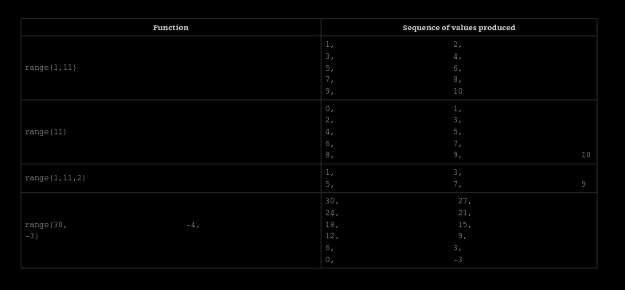

students_heights=input("input a list of students height").split(",")

for i in range(0,len(students_heights)):

    students_heights[i]=int(students_heights[i])# this is the conversion of the numbers present in the list to an Integer

print(students_heights)# this is the printing of the list 1

this is the way the code can be printed using the range and the for lop

when a range is made from one value to the (final value given in the paranthesis -1)   
so when a range is made   
ele **=** range(10)[0]

print("First element:", ele)

ele **=** range(10)[**-**1]// this is because from back the element counting starts from -1

**print**("\nLast element:", ele)

ele **=** range(10)[4]

print("\nFifth element:", ele)

students=input("mention the no of marks of the fice students to get their average").split(",")

sum=0

for m in students:

    sum=sum+int(m)

print(f"the sum of all the marks are {sum}")

averge=sum/len(students)

print(f"the averge of all the marks entered by the students {averge}")

the average is find by the usage by this way also using the for loop and the len functions of the

***loop: repetitive execution of instructions iteration of a loop***

The **for statement in Python provides a mechanism to keep count of the number of times** a sequence of statements has been executed.

While loop is also used for execution of the statements multiple times but in case when prior condition is not known in that case ***while loop is used***

The control statement for is used when we want to execute a sequence of statements (indented to the right of keyword for) a fixed number of times.

***for loop syntax***

**variable refers to the control variable(** like the one which is written after the ***for*** and before ***range)-----***  used for counting, which is set in the beginning to the first value in a sequence of values (e.g., range(10), ‘abcdef’). Subsequently, in each iteration of the loop, the value of the control variable is replaced by the successor value in the sequence.

Normally the output of integers are on left hand side but can become right hand side

***There are four different ways to perform string formatting in Python:***

* ***Formatting with % Operator.***

name = "John"

age = 25

# Using % operator for string formatting

message = "My name is %s and I am %d years old." % (name, age)

print(message)

***the output***

My name is John and I am 25 years old.

You can use different placeholders depending on the type of value you want to insert. Here are some commonly used placeholders:

* %s for strings
* %d for integers
* %f for floating-point numbers
* %x or %X for hexadecimal numbers

You can also specify formatting options, such as the number of decimal places for floating-point numbers or the width of the field. For example:

pi = 3.14159

# Formatting floating-point number with 2 decimal places

formatted_pi = "The value of pi is %.2f" % pi

print(formatted_pi)

The value of pi is 3.14

* Formatting with format() string method.
* Formatting with string literals, called f-strings.
* Formatting with String Template Class
* <https://www.geeksforgeeks.org/string-formatting-in-python/amp/>
* <https://www.geeksforgeeks.org/python-string-format-method/>
* ***This link is about the format function of the string***

***S***o the method one is by the Modulo Operator

The modulo % is also known as the “string-formatting operator”.

**>>> ‘%5d’% 45**

**‘ 45’**

**>>> print(‘%5d’% 45)**

**45**

**>>> print(‘%5d’% 12345)**

**12345**

The **s here means** the **string data type** and the **d here** would means **the integer data type**

**print**('The valueof pi is: %1.5f' **%**3.141592)

# vs.

print('The valueof pi is: {0:1.5f}'.format(3.141592))   
VS  
**print**('The valueof pi is: %1.5f' **%**3.141592)

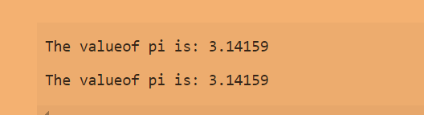

Both has the same output

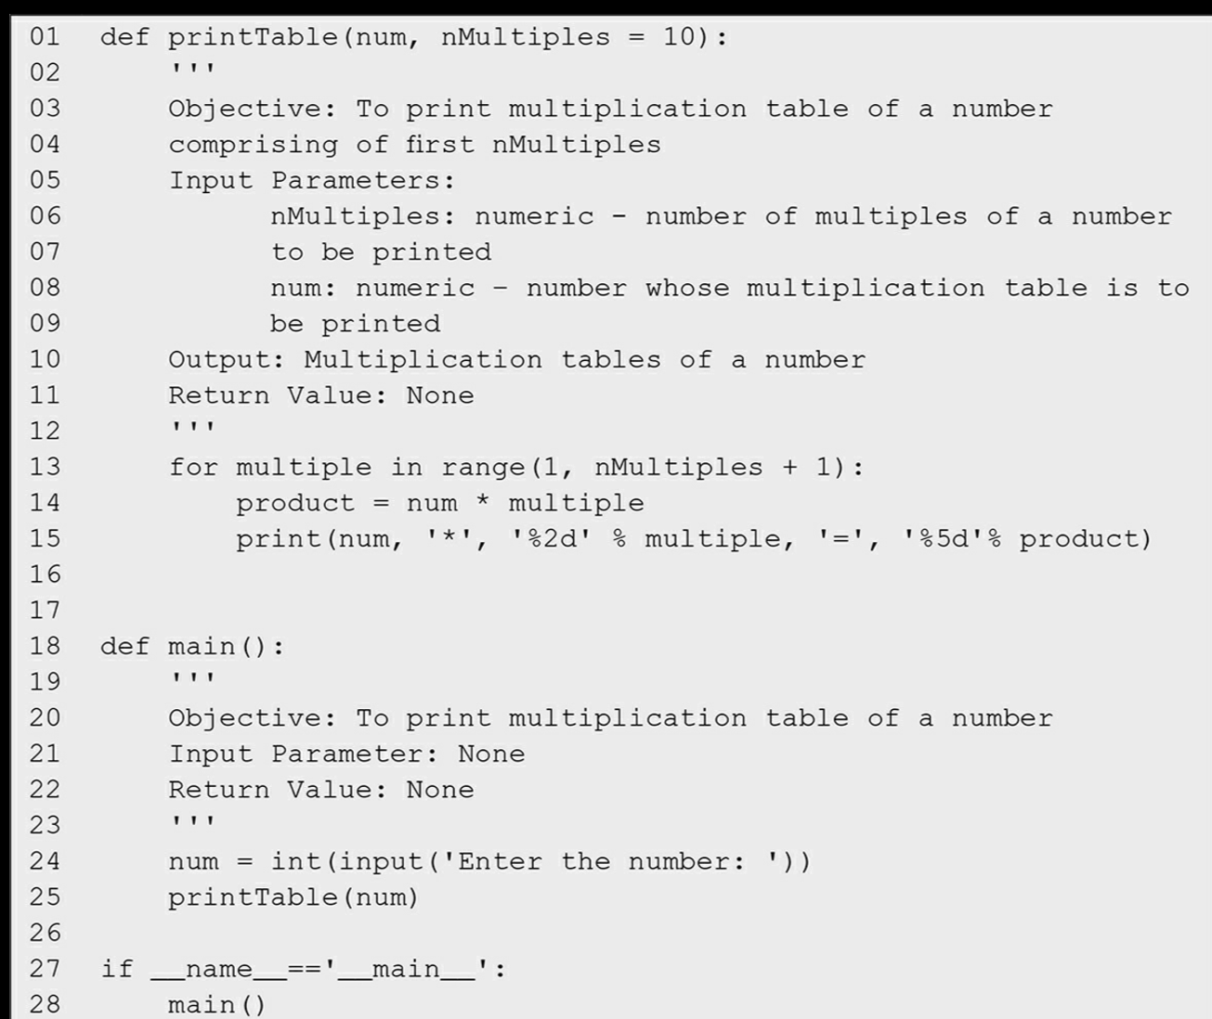

This is the program to print the multiplication table of any number by  
***making a function of the number whose multiplication table is to be find out and its no of multiples***

***The While loop***

The while loop is used for executing a sequence of statements again and again on the basis of some test condition. **If the test condition holds True, the body of the loop is executed,** otherwise the control moves to the statement immediately following the while loop

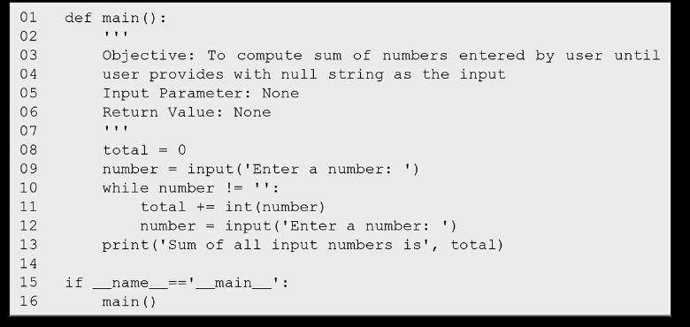

This is the function of while loop in which the number keeps on added unless the empty string is entered  
so the loop continues to execute unless the number entered is an empty string

***The general form of while statement is as follows:***while <test condition>:   
<Sequence of statements S>   
syntax for while loop

The condition is a Boolean expression which either results in true or false

The flow diagram of the while loop   
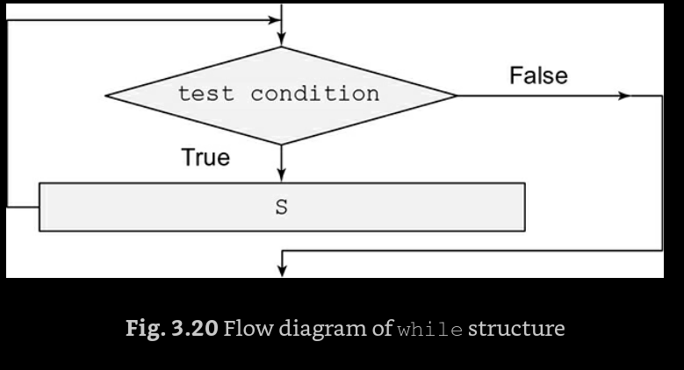

There are also infinite loops which keeps on executing ->> like the screen remains on sleep mode unless a key is entered

***Below is the program of it***  
import time   
while True:  
 try: print('Loop processing....')   
print('Use ctrl+c to break')  
 time.sleep(1)  
 except KeyboardInterrupt:   
print('User interrupted the loop... exiting...')   
break

***The for loop of a code can be written in the while loop***

For count in range(1, n + 1):

total += count

***The revised code is given below:***

count = 1

while count < n+1:

total += count count += 1

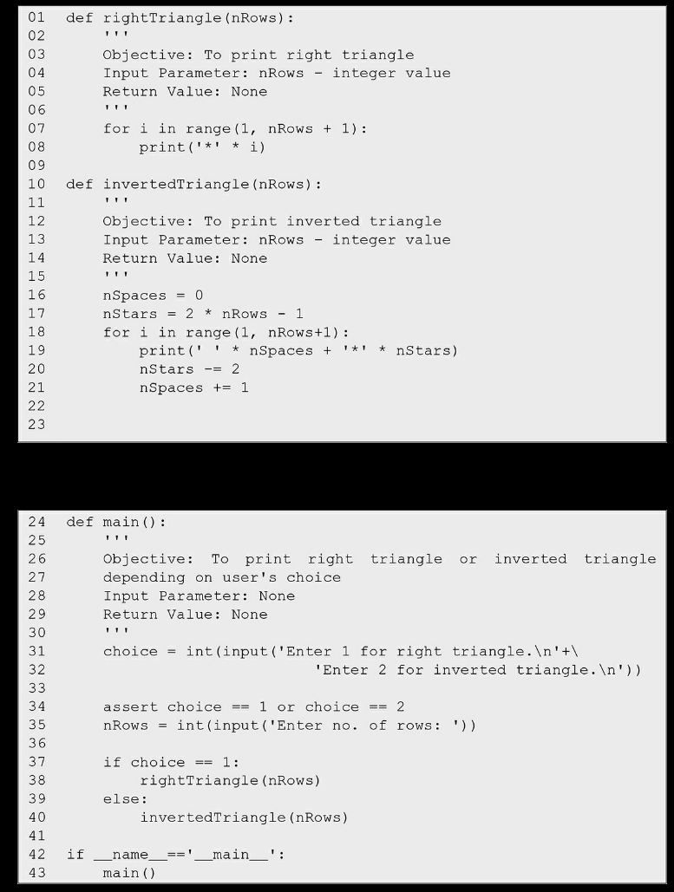

These both are the codes for the right angled triangle making and the inverted triangle making

***Nested Loops***

If I want to print the output of the several calls to print the function on the same line. s we need to use empty string ('') in place of the default newline. This can be achieved using **keyword argument end works with the (, after the format and the printing inverted commas)**

**we we need to use empty string ('') in place of the default newline. This can be achieved using keyword argument end.**

**WRßßßßsàâvh0|Indeed, the code segment**

**>>> for i in range(1,4):   
print('{0: >5}'.format(i*9))** is equivalent to:   
**>>> for i in range(1,4):   
print('{0: >5}'.format(i*9), end = '\n')**

for num in range(1, nTables + 1):   
print('{0: >2}'.format(num),'*',\  
 '{0: >2}'.format(multiple),'=', \   
'{0: >3}'.format(num*multiple),'\t', end = '')  
 print()l

**The character backslash (\) used at the end of second and third line is a line continuation character that can be used for wrapping long lines** i.e. if we wish to extend a statement over multiple lines.

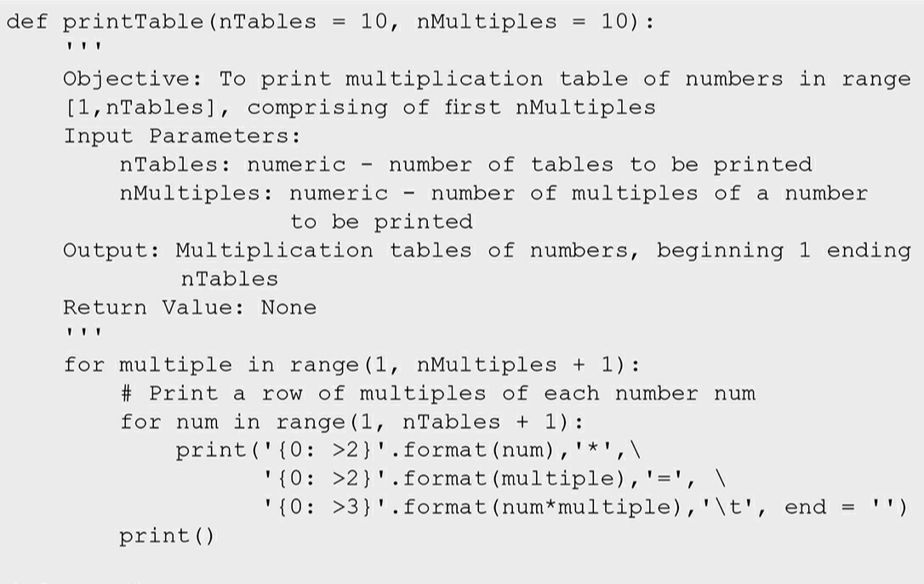

This is the function for making a table of multiples of numbers from 1 to 10

So the nesting can be done upto any level required  
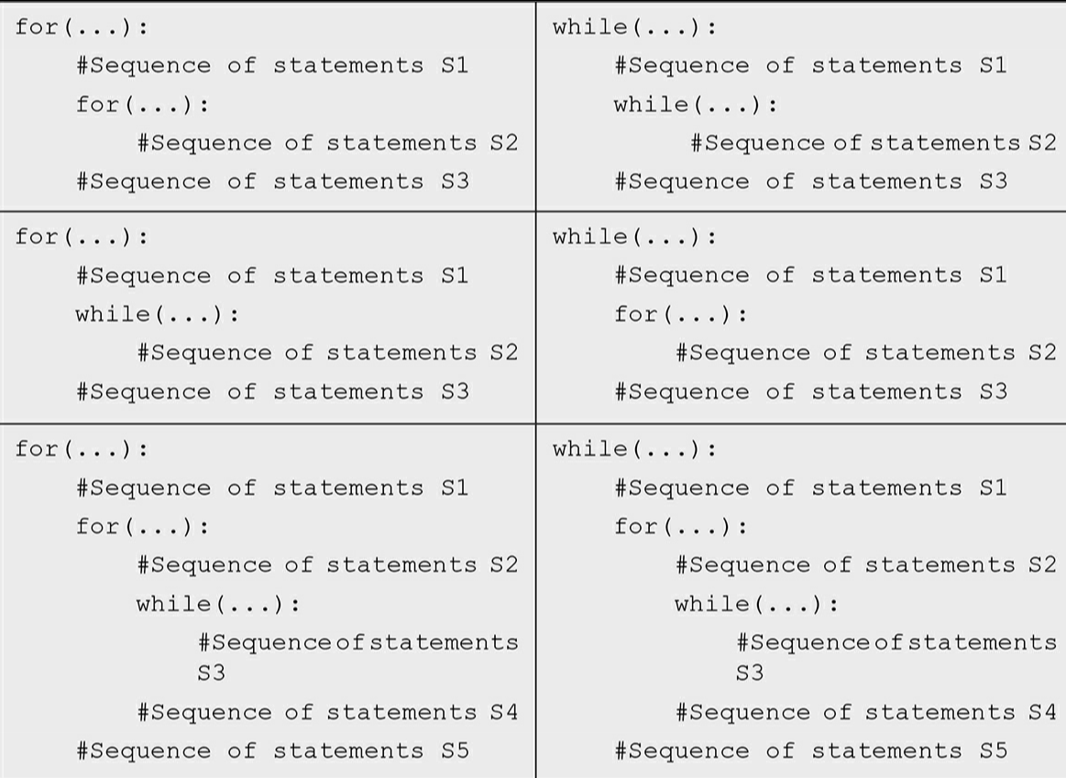

The **break statement enables us to exit the loop** and transfer the control to the statement following the body of the loop.

use break statement to exit the loop   
use continue statement to transfer the control to next iteration of the loop

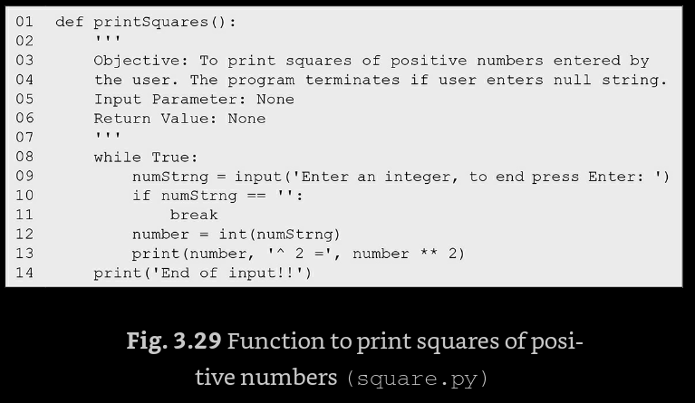 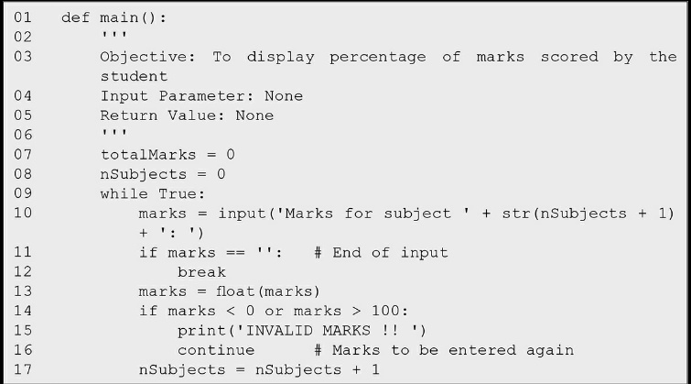

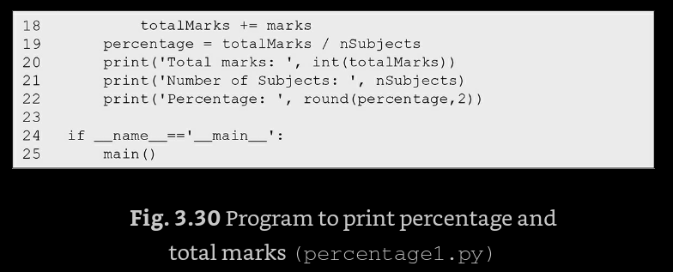

***The pass statement***Sometimes we may want to leave out the details of the computation in a function body, to be filled in at a later point in time.   
The **pass statement lets the program go through this piece of code without executing any code. It is just like a null operation.  
it produces None as the return value.**

Accordingly, the function sellingPrice ignores the value None returned by the function discount (lines 16–17) and returns price (that was passed on to it as an argument) as the selling price.  
the function which has a pass statement returns the argument only indirectly but returns the none directly

***The pass statement executes no code***

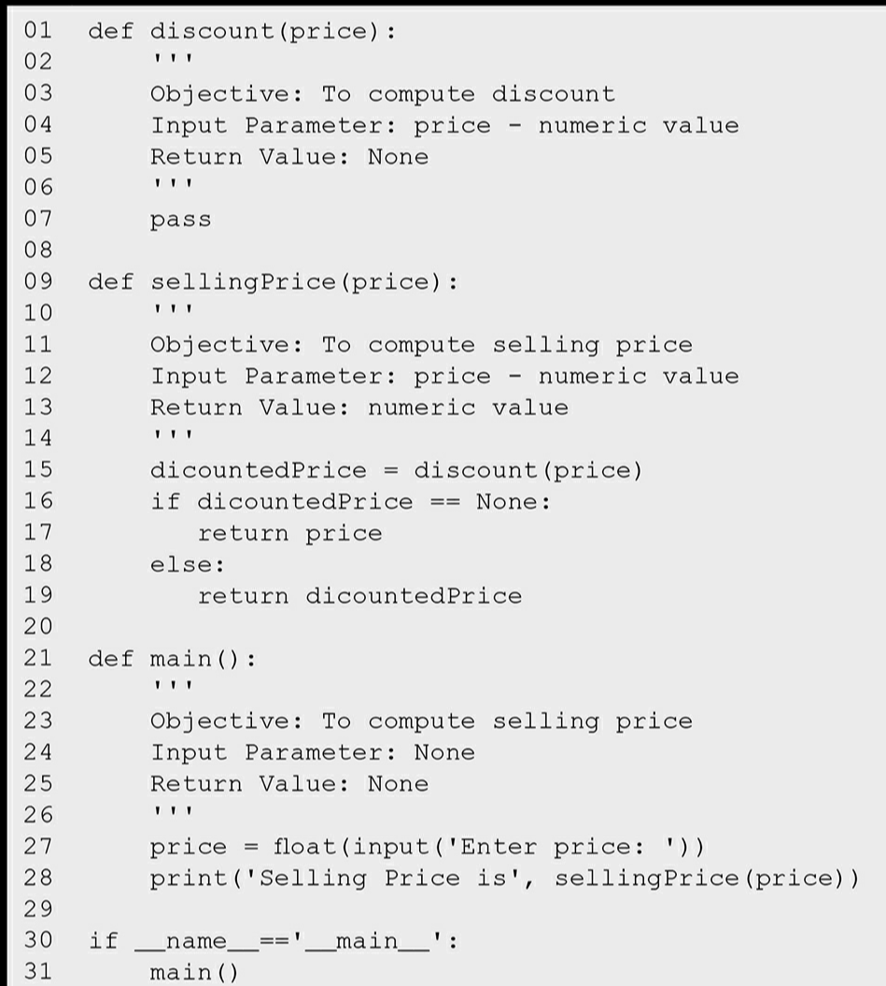

***Sine function***

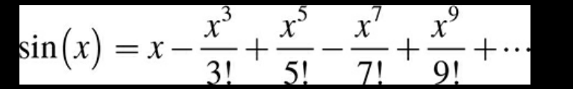

This is the formula of sine function  
In the above series, the first term is x/1. The second term can be computed by multiplying the first term by -x2/(2*3). Similarly, the third term in the series can be computed by multiplying the second term by -x2/(4*5), and so on. In general, we can obtain a new term of the series by multiplying the previous term by -x2 and dividing this product by the product of the next two terms in the sequence 1, 2, 3, 4, 5, 6,

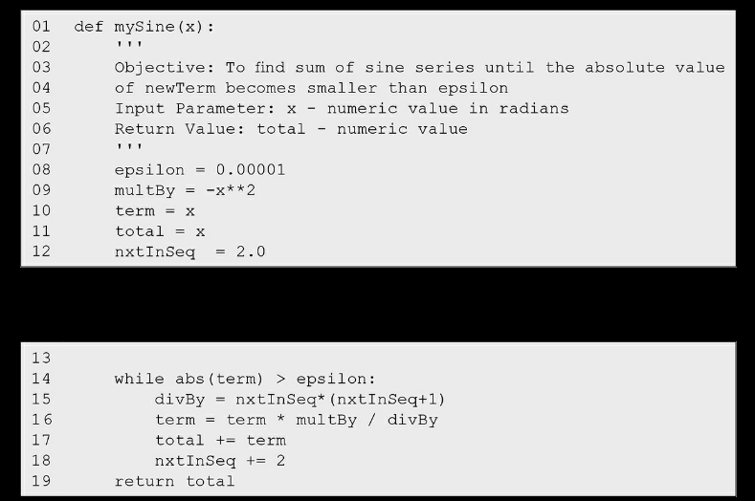

This is the code to make the sine function formula

The else clause after the for and the while loop   
The statements specified in else clause are executed on normal termination of the loop. However, if the loop is terminated forcibly using break statement, then the else clause is skipped.

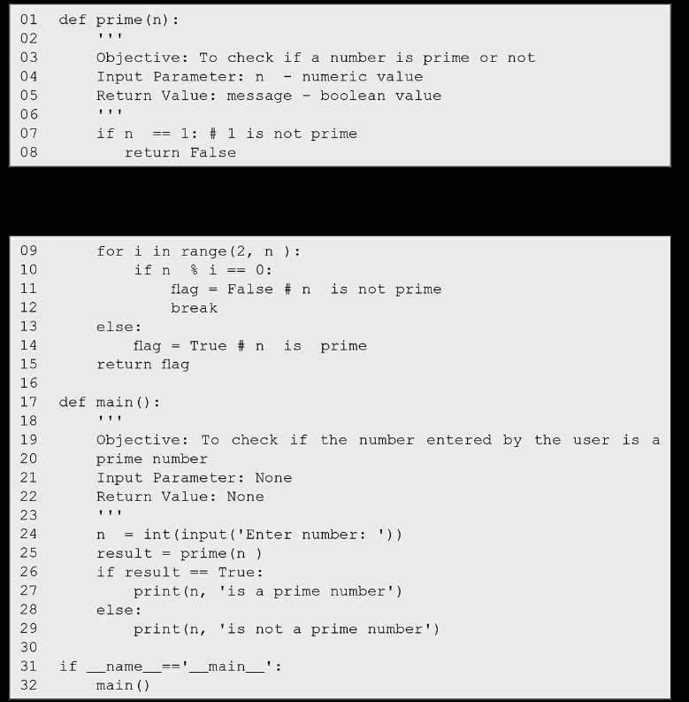

This is the program to check whether the no is prime or not if it is prime (and a case of usage of else clause after the for clause)

***Python Strings***

* To specify a string, we may enclose a sequence of characters between single, double, or triple quotes.

A string may be specified by placing the member characters of the sequence within quotes (single, double or triple). Triple quotes are typically used for strings that span multiple lines.

so whatever is written inside the commas is the string of characters to be printed

Adding an extra space inside the code will bring the error->> means no proper identation

So unwanted spaces should be avoided

a string is a sequence of characters enclosed within quotes  
 >>> message = 'Hello Gita'   
Python function len finds the length of a string.  
 Thus, >>> len(message) 10

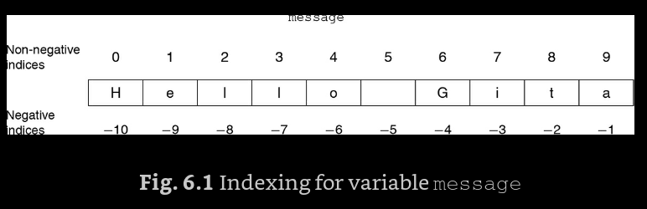  
Note that the indices start with 0 (index for accessing the first character from the left) and end with one less than the length of the string (index for accessing the last character).

indexing for accessing individual characters in a string Python allows negative as well as nonnegative indexes  
 >>> message[0] 'H'  
 >>> message[6] 'G'  
 >>> index = len(message)-1   
>>> message[index]

Similarly, **the value of len(message) being 10**, when index is set equal to len(message)-1,  
 message[index] yields the last character of the string message at index 9,

The negative indices range  
 **from - (length of the string) to -1**. For the string message, the negative indices would range from -10 to -1. Thus, the entire range of valid indices would be {-10, -9, …, -1, 0, 1, …, 9}.  
 Consequently, message[-1] would yield 'a' and message[-index] would yield 'e':

Negative indexes used to access the string from the right

If we try to access an index which is not in the valid index range of a string, IndexError will be generated: attempt to access an invalid index yields error

***Strings in Python are immutable***, i.e., a component of a string cannot be altered, and an attempt to do so would lead to an error: Python strings are immutable

**strings can be concatenated using concatenation *operator (+)*** and can be repeated a multiple number of times using the operator *. string concatenation and repetition



***Strings can be compared using the relational Operator***

**we need to retrieve a substring, also called a slice, from a string. This can be done by specifying an index range. For example, to extract the substring comprising the character sequence having indices from start to end-1, we specify the range in the form start:end**

slicing for retrieving a substring   
>>> message = 'Hello Sita'  
 >>> message[0:5] 'Hello'   
>>> message[-10:-5] 'Hello'

If the value of start or end is not specified, Python assumes 0 as the default value of start, and length of the string as the default value of end, for example: for a slice of string s, default start index is:

0 or -(len(s)) default end index is:

len(s)-1 or -1

>>> message[:5]   
'Hello'  
 >>> message[5:]  
'Sita'   
>>> message[:]  
 'Hello Sita'   
>>> message[:5] + message[5:]   
'Hello Sita'   
>>> message[:15]  
 'Hello Sita'   
>>> message[15:]  
 ''   
>>> message[:15] + message[15:]   
'Hello Sita'

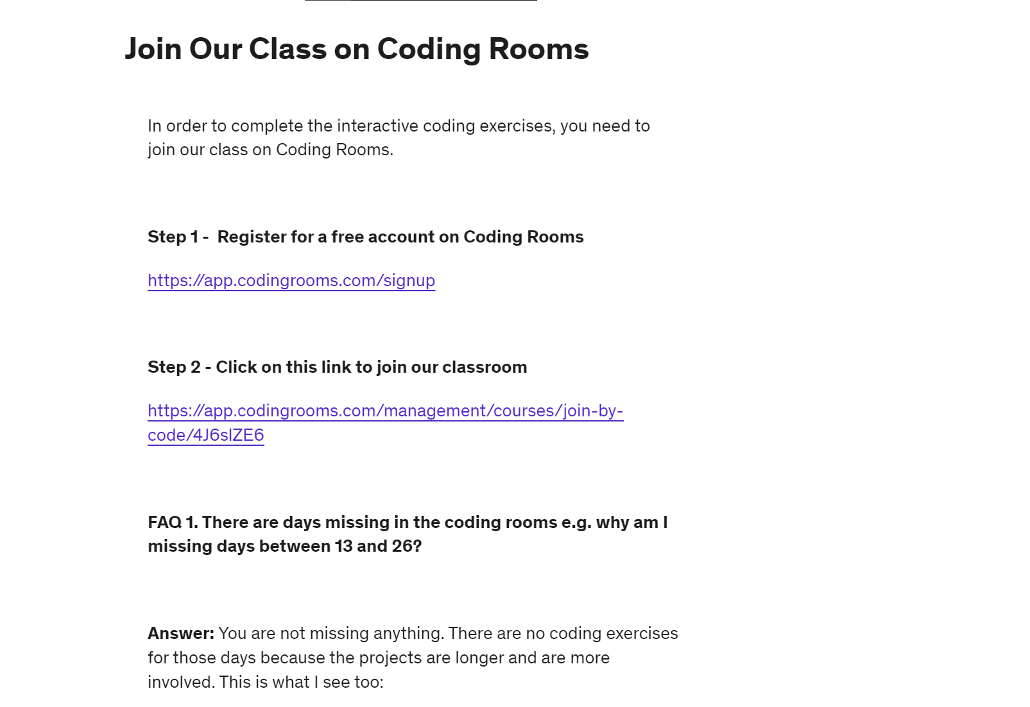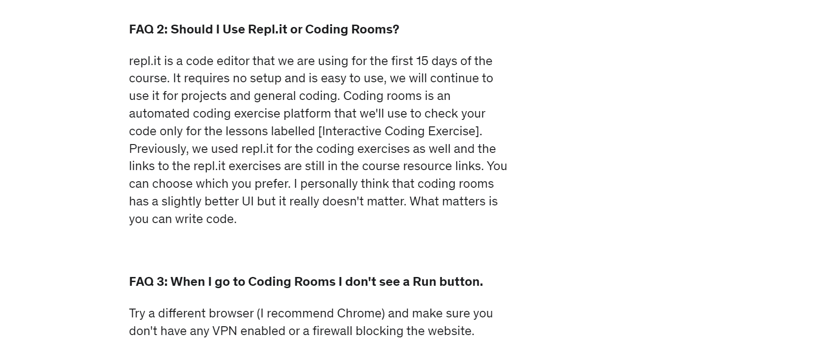

***Slicing in python***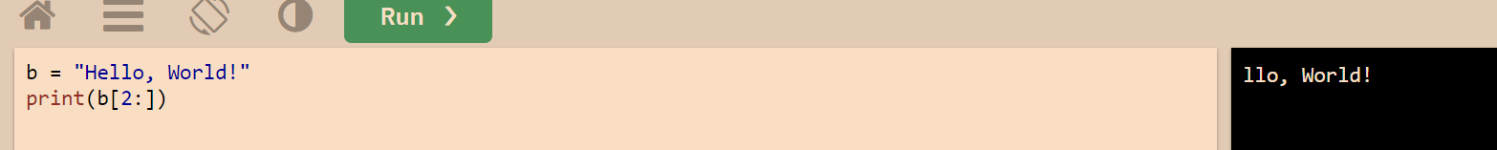



The last index is not included  
it is just the number of the string to be there in the output   




The last index is never included in slicing but the first index is always (and if there is no index is written for the starting then the print is taken from the start

>>> message[:15] + message[15:]   
'Hello Sita'   
***Note that message[:n] + message[n:] always yields message***

Irrespective of the value of n being negative, positive, or even out of range.

Indeed, **values used for defining a slice may be arbitrary integers or even None**,  
for example:   
>>> message[8:20]   
'ta'  
>>> message[6:None]   
'Sita'

**Python also allows us to extract a subsequence of the form start:end:inc.** This subsequence will include every incth element of the sequence in the range start to end-1,   
for example:   
>>> message[0:len(message):2] # see the end of the message us upto the length of the string and the **increment is of +2**   
'HloSt'  
 >>> message[0:len(message):3] # here the increment is of +3  
'HlSa'

The slicing operation discussed above can also be applied to other sequences such as lists and tuples,

***Membership***

The character or a substring is there in the main string can be checked by the ***in operator***   
the ***expression s in str1 yields True or False*** depending on whether s is a substring of str1,

We use **for loop to iterate** on **each element over a sequence** (the sequence caused by the range function , or the string which is a sequence of characters , the list and tuples are all sequence examples )

From a readability perspective, using + operator seems better for few strings. However, if you have to append a lot of string, then you should use the list and join() function.

for ch in 'hello':

    space=ch+' '

    print (space,end='')

see check this out this is one of the way of appending the string (sequence of characters) by just (+) operator and then just printing

<https://www.digitalocean.com/community/tutorials/python-string-append>

(more about string appending in python)

The definition of the function

Ctrl + ( ] ) is the key to do the indentation in the python code

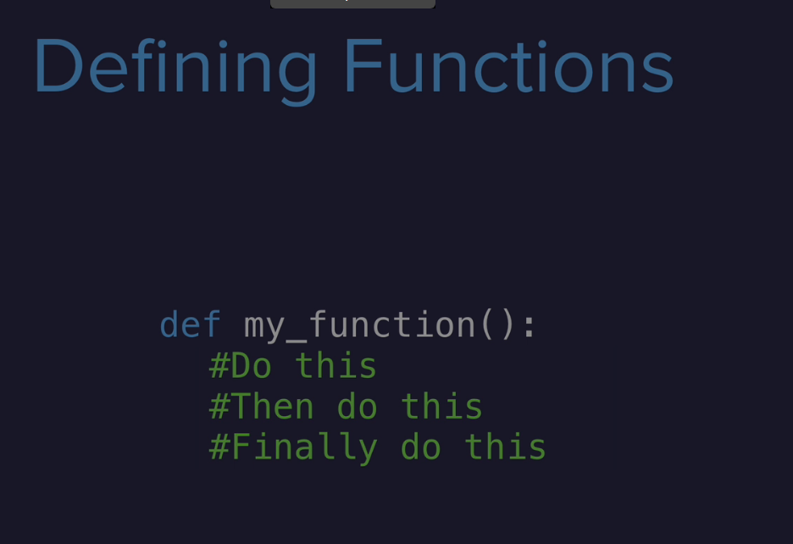

***Built in functions in string***

* ***Count()***

'c' to the string 'Encyclopedia': count(): to count occurrences of a string in another string  
 >>> 'Encyclopedia'.count('c')   
2

>>> vowels = 'aeiou'  
 >>> vowelCount = 0   
>>> for ch in vowels:  
 vowelCount += 'Encyclopedia'.count(ch)   
>>> vowelCount   
4  
# (but there are 5 vowels in the Enclyopedia word why only four is the answer because the ‘E’ is not included in the variable ‘vowels’

* ***Find()***

***the find function actually prints the index no of the string which is to be find***

colors = 'green, red, blue, red, red, green'

print(colors.find('red'))

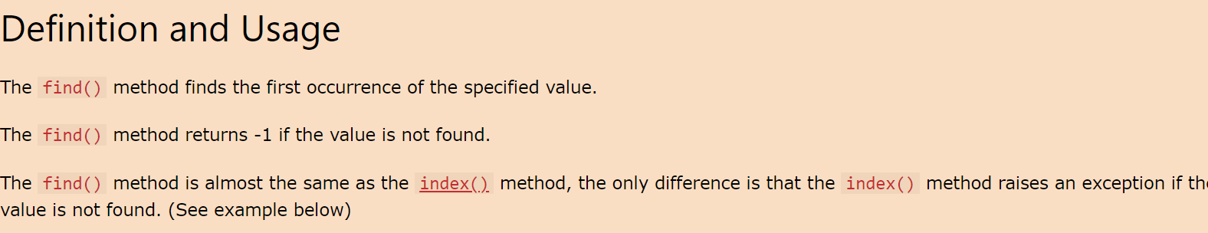

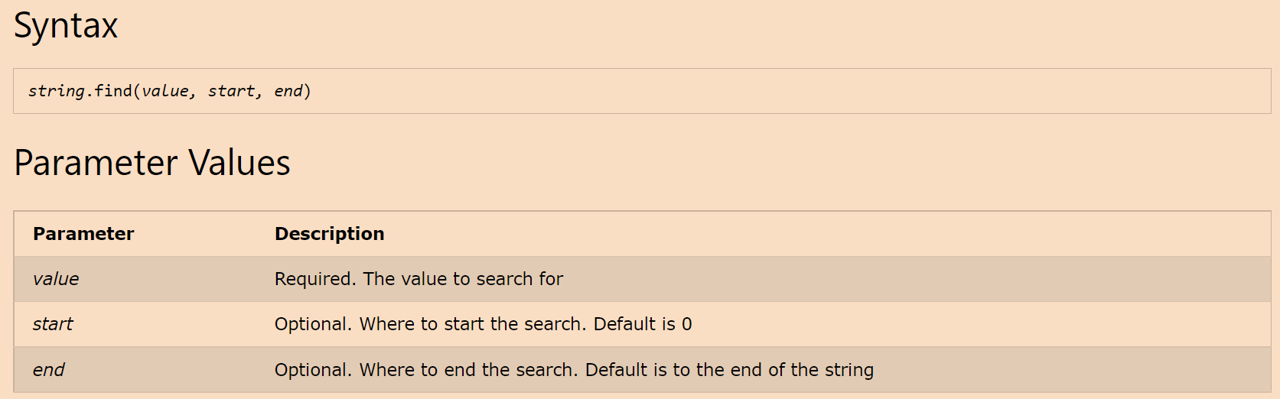

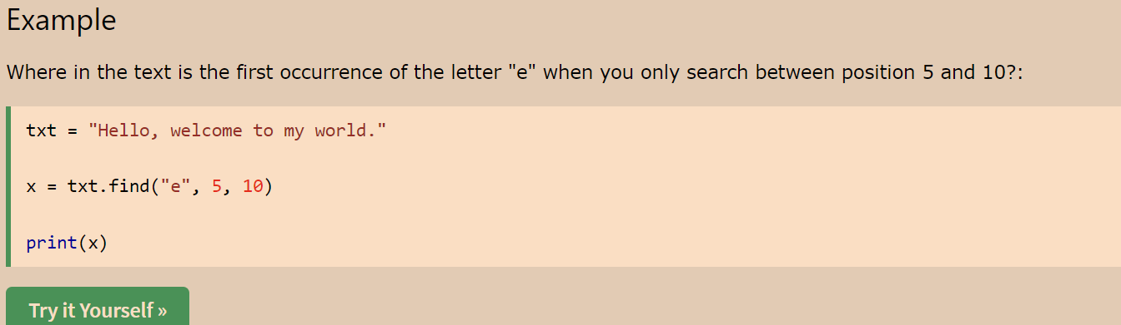

* ***rfind()***

find the last occurrence of a string, we use ***the function rfind*** that **scans the string in reversed order from the right end of the string to the beginning**:

If the function find fails to find the desired substring, it returns -1:

* ***the function capitalize()***

can be used **for converting the first letter of a string to uppercase character** and converting the remaining letters in the string to lowercase (if not already so).

>>> 'python is a Language'.capitalize()   
Python is a language'

* ***function lower and upper***

*Python functions lower and upper are used to convert all letters in a string to lowercase and uppercase, respectively.*

* ***Title()***

can be used to capitalize the first letter of each word in a string and change the remaining letters to lowercase (if not already so):

* ***function swapcase***

Python *function swapcase* may be used to convert lowercase letters in a string to uppercase letters and vice versa, for example:  
>>> 'pYTHON IS PROGRAMMING LANGUAGE'.swapcase()   
'Python is programming language'

* ***Functions islower, isupper, and istitle***

The functions islower and isupper can be used to check **if all letters in a string are in lowercase or uppercase, respectively,**

checking case (lower/ upper) of a string  
 >>> 'python'.islower()  
True   
>>> 'Python'.isupper()   
False

The function istitle returns True **if a string S (comprising atleast one alphabet) is in title case,** for example:   
checking whether the string is in title case   
>>> 'Basic Python Programming'.istitle()   
True   
>>> 'Basic PYTHON Programming'.istitle()   
False   
>>> '123'.istitle()   
False   
>>> 'Book 123'.istitle()   
True

* ***Function replace***

The function replace allows to replace part of a string by another string. It ***takes two arguments as inputs.***The first argument is used to specify the substring that is to be replaced.  
The second argument is used to specify the string that replaces the first string.

>>> message = 'Amey my friend, Amey my guide'  
 >>> message.replace('Amey', 'Vihan')  
 'Vihan my friend, Vihan my guide'

* ***Strip,lstrip,rstrip***

The functions lstrip and rstrip remove whitespaces from the beginning and end, respectively.

We may choose to remove any other character(s) from the begining or end by explicitly passing the character(s) as an argument to the function.

>>> ' Hello How are you! '.lstrip()   
'Hello How are you! '   
>>> ' Hello How are you! '.rstrip()  
 ' Hello How are you!'  
 >>> ' Hello How are you! '.strip()   
'Hello How are you!'

* ***Function split and partition***

The function split enables us to split a string into a list of strings based on a delimiter.  
So this function makes a list out of the string

the ***function split outputs a sequence of strings enclosed in square brackets.*** **A sequence of objects enclosed** in square brackets **defines a list.**

The default delimiter is the white space

function partition divides a string S into two parts based on a delimiter and returns a tuple (discussed in the next chapter) comprising string before the delimiter, the delimiter itself, and the string after the delimiter,   
for example:

* ***partition(): partitioning a string into two parts***

function partition divides a string S into two parts based on a delimiter and returns a tuple (discussed in the next chapter) comprising   
string before the delimiter, the delimiter itself  
and the string after the delimiter.

partition(): partitioning a string into two parts  
 >>> 'Hello. How are you?'.partition('.')  
 ('Hello', '.', ' How are you?')

* ***function join***

Python function join returns a string comprising elements of a sequence separated by the specified delimiter.

joining a sequence of strings   
>>> ' > '.join(['I', 'am', 'ok'])  
 'I > am > ok'   
>>> ' '.join(('I', 'am', 'ok'))  
 'I am ok'   
>>> ' > '.join("'I', 'am', 'ok'")  
 "' > I > ' > , > > ' > a > m > ' > , > > ' > o > k > '"

the sequence comprises three elements, namely, 'I', 'am', and 'ok', which are combined to form the string 'I > am > ok'.  
we use space as a delimiter instead of >.in the second example  
In the third example, each character in the string "'I > am > ok'" is an element of the sequence of characters in "'I > am > ok'".

In the third example, each character in the string "'I > am > ok'" is an element of the sequence of characters in "'I > am > ok'".

* ***Functions isspace, isalpha, isdigit, and isalnum***

enable us to check whether a value is of the desire type.

we can check whether the name entered by a user contains only alphabets as follows:  
Does a string comprises alphabets, digits, or whitespaces only?  
**so the isalpha check whether the given string contains only the alphabets**(even if a white space in found in the string then also it returns false)

*Note that the blank character is not an alphabet.*

* ***functions isdigit and len:***

to check the validity of a mobile number, we may want it to be a string of length 10 comprising of digits only. This can be achieved using function isdigit and len:

this is how the number checking python function works  
Enter mobile no : 1234567890 >>> mobileN.isdigit() and len(mobileN) == 10 True

* ***The function isalnum***

checks whether a string comprises of alphabets and digits only.

> password.isalnum()

True  
# where the password is the variable containing the string which is input by the user by the input function

* ***startswith() and endswith()***

checking whether a string starts or ends with a particular string  
 >>> name = 'Ankita Narain Talwar'   
>>> name.endswith('Talwar')   
True

to find whether a **person's name begins with Dr.**(doctor) we can use the function startswith as follows:  
>>> name = 'Dr. Vihan Garg'   
>>> name.startswith('Dr. ')   
True  
 >>> name = ' Dr. Amey Gupta' #here the starting is done with a space so the return of the function is false   
>>> name.startswith('Dr. ')   
False

* ***function encode and decode***

we need to transform data from one format to another for the sake of compatibility.  
Python function encode that returns the encoded encoded version of a string, based on the given encoding scheme.  
Another function decode (reverse of function encode) returns the decoded string,

encoding and decoding a string

>>> str1 = 'message'.encode('utf32')   
>>> print(str1) b'\xff\xfe\x00\x00m\x00\x00\x00e\x00\x00\x00s\x00\x00\x00s\x00\x00\x00a\x00\x00\x00g\x00\x00\x00e\x00\x00\x00'   
>>> str1.decode('utf32')  
 'message'

**Python String encode()**converts a string value into a collection of bytes, using an encoding scheme specified by the user.  
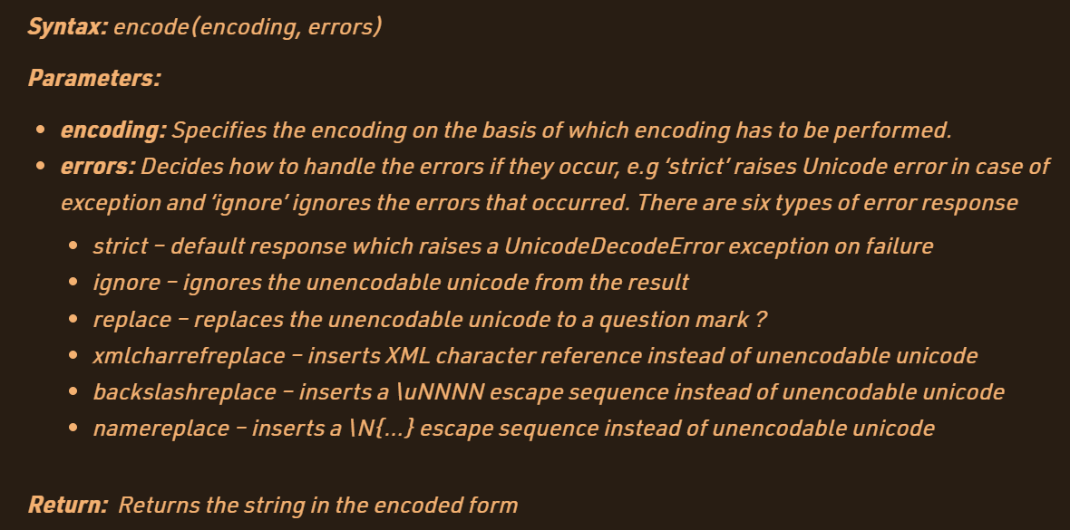

>>>print("¶".encode('utf-8'))  
b'\xc2\xb6'

There are certain encoding schemes supported by Python [String](https://www.geeksforgeeks.org/python-string/) encode() method. We can get the supported encodings using the [Python](https://www.geeksforgeeks.org/python-programming-language/) code below. Like the following

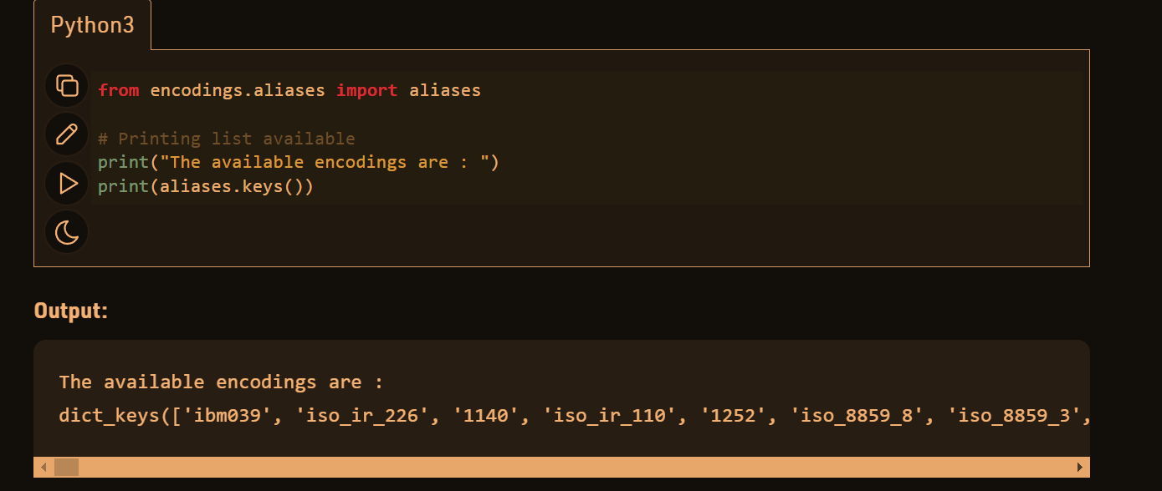

**Character encoding** is the process of assigning numbers to [graphical](https://en.wikipedia.org/wiki/Graphics) [characters](https://en.wikipedia.org/wiki/Character_(computing)), especially the written characters of [human language](https://en.wikipedia.org/wiki/Language), allowing them to be [stored](https://en.wikipedia.org/wiki/Data_storage), [transmitted](https://en.wikipedia.org/wiki/Data_communication), and [transformed](https://en.wikipedia.org/wiki/Computing) using [digital](https://en.wikipedia.org/wiki/Digital_electronics) [computers](https://en.wikipedia.org/wiki/Computer).[[1]](https://en.wikipedia.org/wiki/Character_encoding#cite_note-1) The numerical values that make up a character encoding are known as "[code points](https://en.wikipedia.org/wiki/Code_point)" and collectively comprise a "code space", a "[code page](https://en.wikipedia.org/wiki/Code_page)", or a "[character map](https://en.wikipedia.org/wiki/Character_Map_(Windows))".

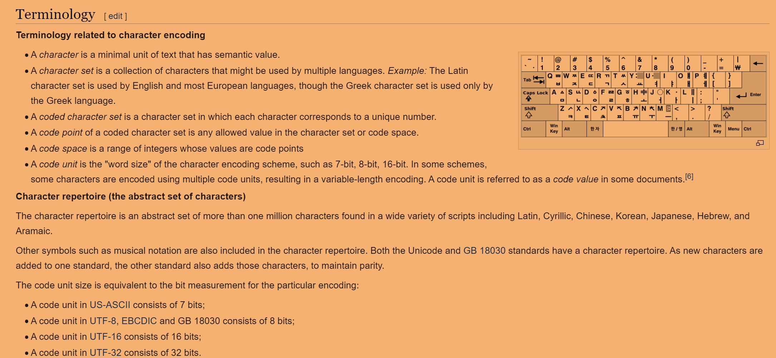

These are the list of the functions of the python strings   
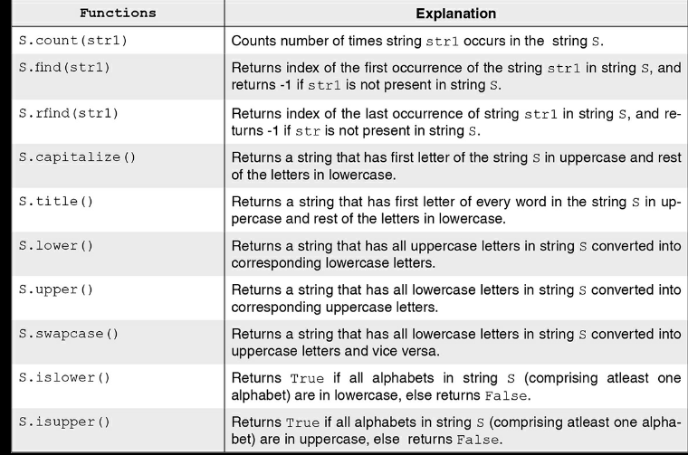

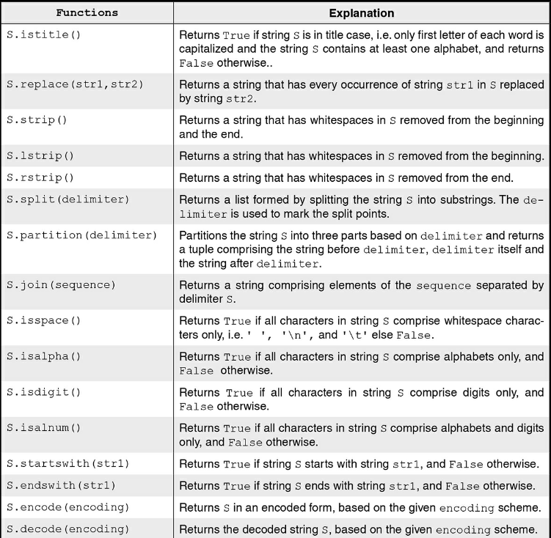

This is the function to check if the strings in two variables contains same type characters  
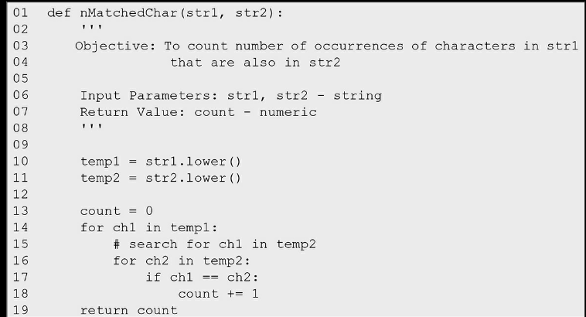

Both are converted to lower case so that the strings upper case and lower case do not caused the inequality

***Counting the no of common characters in the pair of strings***

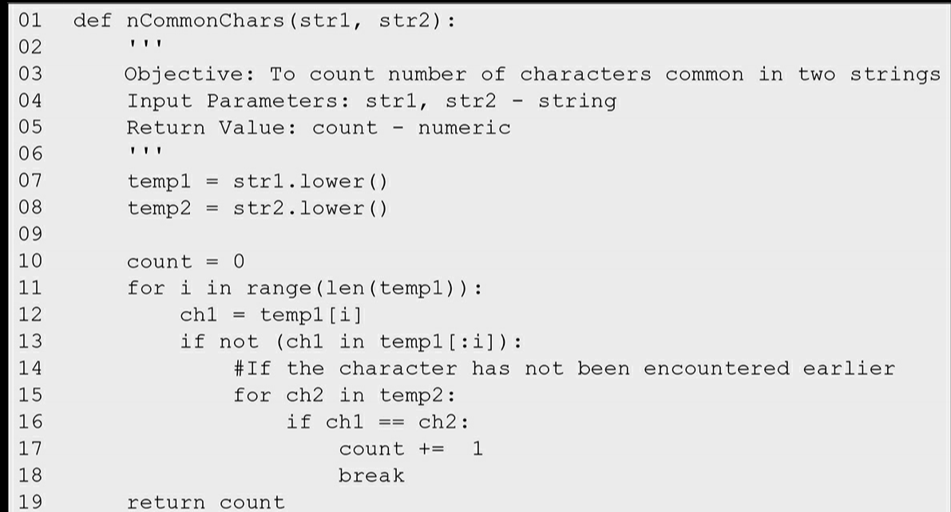

In this slicing is used for the string like below  


***######query***

***Reversing a String***   
In case, the input string is a null string, the reversed string reverseStr will also be a null string.  
In the case of a non-null string, **for each character in the given string, we concatenate by appending(adding/joining aling) it** with the reverseStr  
In the recursive approach (Fig. 6.5), we concatenate the reverse of the string left after removing first character i.e. str1[1:], with the first character of the string str1, recursively, until empty string is left. 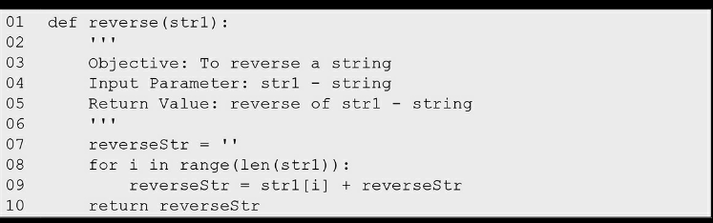

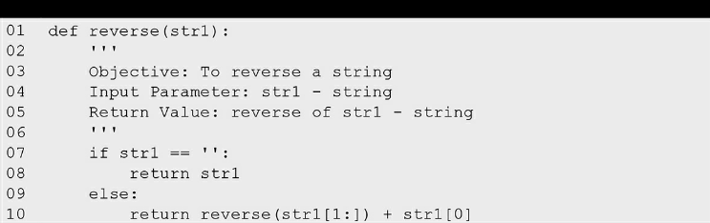  
***some Important Definitions***

**Alphabet**: An alphabet is a non-empty set of symbols, denoted by ∑.  
**String**: A string is a **finite sequence of symbols** chosen from the alphabet ∑. **An empty string** '' containing **no symbols** is called null string and is often **denoted by λ or ε.**The **length of a string** is defined as the **number of symbols** in the string. **The length of the null string** is defined to be **zero**.

**Language:**  
It is the set of strings (words) defined over the alphabet ∑ that conforms to some predefined pattern, or rule(s).  
discuss a class of languages called regular languages. A regular language is described by a regular expression  
regular expressions: used to define regular languages

Each symbol of the alphabet defines a regular language, comprising the symbol itself. Thus, for the alphabet ∑ = {0,1}, 0 is a regular expression denoting the language {0}. Similarly, 1 is a regular expression denoting the language {1}.

if r is regular expression, L(r) denotes the language described by r.

λ or ε is a regular expression that denotes the language comprising the null string only.

Thus, L(ε) = {''}. The language containing no word, not even λ is called null or empty language {}, and is denoted by the regular expression φ. If r and s are regular expressions, r|s is also a

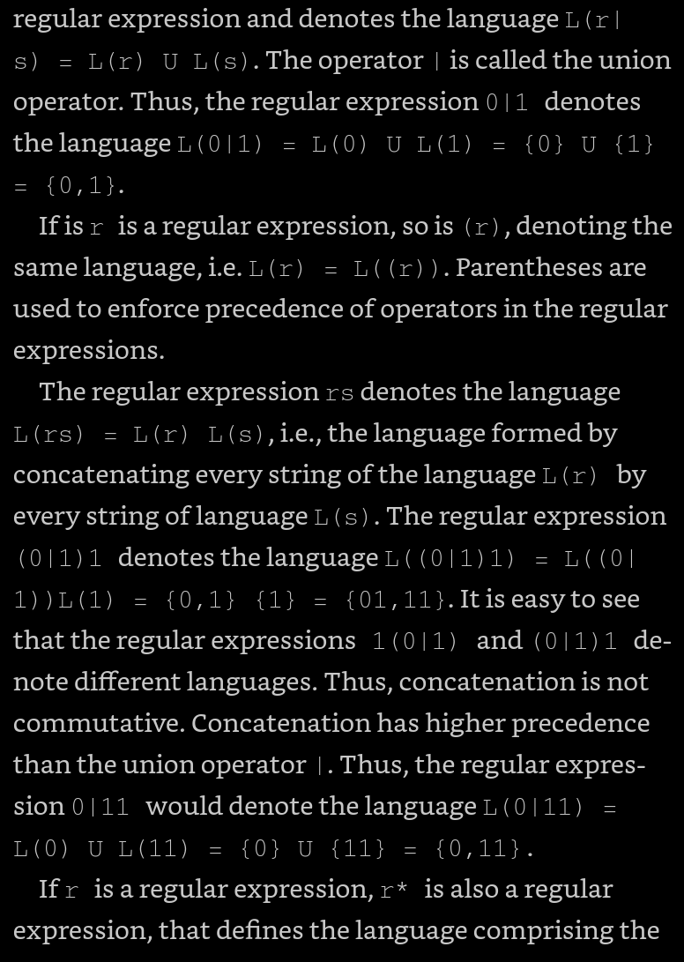 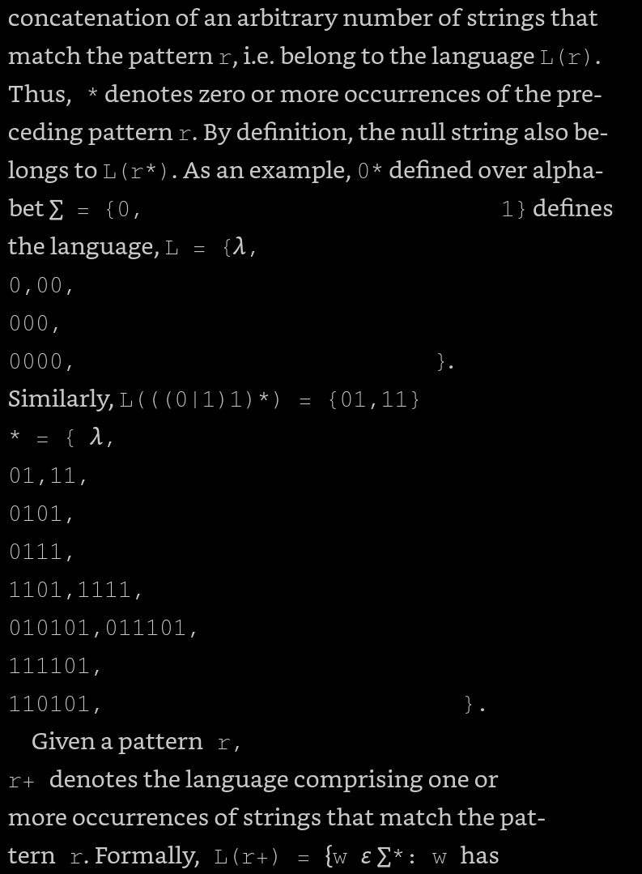

Learn from location 3630 to 3712 to be read

***The list ->> the mutable and immutable objects***

**Elementary forms of data such as numeric and Boolean are called scalar data types.**  
**A list** is an ordered **sequence of values.** It is a **non-scalar type**.

**Values stored in a list** can be of any type such as **string, integer, float, or list**, for example, a list may be used to store the names of subjects:

list: a comma separated ordered sequence of values, enclosed in square brackets

**>>> subjects=['Hindi', 'English', 'Maths', 'History']**Note that the elements of a list are enclosed in square brackets, separated by commas. Elements of a list are arranged in a sequence beginning index 0, just like characters in a string.so the list is also considered as a sequence

In Fig. 7.1, we show the representation of the list subjects as in PythonTutor.  
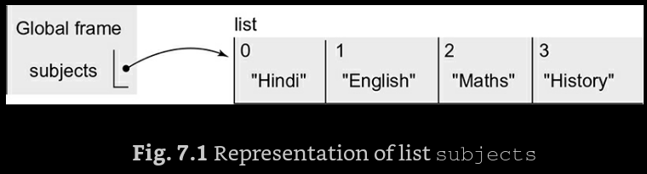

let us invoke **the function id that returns object identifier for the list object** subjects:  
>>> id(subjects)   
57135752

if I say the temporary(a variable name for the list ) is = to subjects(list)

>>> temporary = subjects   
>>> id(temporary)  
 57135752

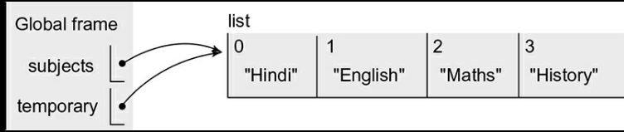

**So different variables may refer to the same list** object as shown in the above example

This method of accessing an object by different names is known as ***aliasing.***

aliasing: to access objects using different names **lists are mutable**

temporary[0] = 'Sanskrit'   
>>> print(temporary) ['Sanskrit', 'English', 'Math', 'History']

>>> print(subjects) ['Sanskrit', 'English', 'Math', 'History']   
>>> print(id(subjects), id(temporary))  
 57135752 57135752

***So changing the list by using the one variable (say the temporary ) the changes are happening in the another variable referring to the same list***

>>> subjectCodes = [['Sanskrit', 43], ['English', 85] , ['Maths', 65], ['History', 36]]

two-dimensional list: **list of lists( which is already containing the list** that represent each pair of subject and subject code as a list, and form a list of such lists like the above

A list of lists such as subjectCodes, each of whose elements itself is a list, is called a two-dimensional list.

Thus, subjectCodes[1] being a list, its components may be accessed as  
 subjectCodes[1][0] and subjectCodes[1][1]:  
 >>> subjectCodes[1]   
['English', 85]  
 >>> print(subjectCodes[1][0],subjectCodes[1][1])   
English 85   
As expected, subjectCodes[1] yields the list  
['English', 85],   
i.e. element at index 1 of the list subjectCodes.  
As subjectCodes[1] is itself a list, subjectCodes[1][0] and subjectCodes[1][1] yield elements of the list subjectCodes at indices 0 and 1, i.e. 'English' and 85, respectively.

In general, when we write subjectCodes[i][j], the first index i yields the list subjectCodes[i] in subjectCodes, and the second index j yields the element subjectCodes[i][j] within the list subjectCodes[i].

A list may contain a different types of elements   
As another example, we may like to store name, address, and mobile number of a person in the list details:

A list In python is equivalent to structure in C++

***heterogeneous list: list with values of different types***

>>> details = eval(input('Enter details of Megha: '))   
Enter details of Megha: ,  
>>> details ['Megha Verma', 'C-55, Raj Nagar,Pitam Pura, Delhi - 110034', 9876543210]

The ***eval function*** subsequently apply the function eval for transforming the raw string to a list: use of eval ***for converting raw string to a list.***

***Example***

details=eval(input("enter the details of megha "))

print(details)

print(details[1])

***check this output***

So the input function if includes and starts with (***[***) then it makes a list automatically but it should

***Summary of List Operation***

In Table 7.1, we describe some functions and operations on lists with the help of the following lists:  
>>> list1 = ['Red', 'Green']   
>>> list2 = [10, 20, 30]

These are the functions of the list   
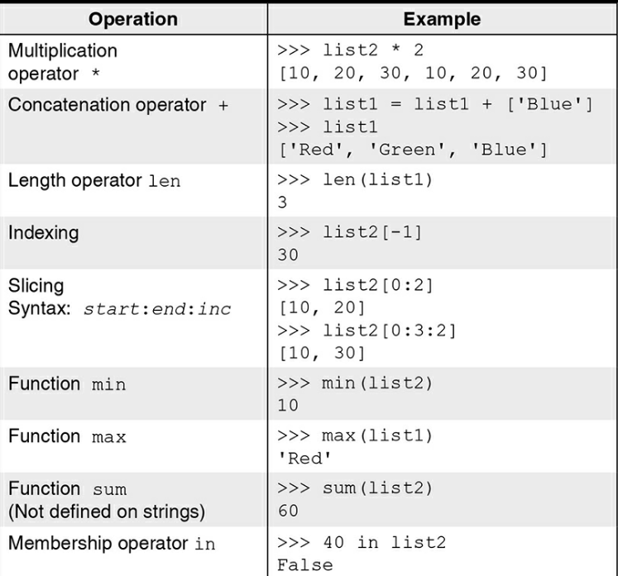

The membership ***operator in*** may be used in a for loop for sequentially iterating over each element in the list,  
iterating over the elements of a list  
 >>> students = ['Ram', 'Shyam', 'Gita', 'Sita']  
 >>> for name in students:   
print(name)   
Ram   
Shyam  
Gita   
Sita

given a list of marks in a subject,  
 let us find the number of students who have obtained marks >= 75.  
 >>> marksList = [78, 32, 89, 99, 56]   
>>> count = 0  
 >>> for marks in marksList:   
 if marks >= 75:   
 count += 1   
>>> count 3

***List Function***

The function list takes a sequence as an argument and returns a list. For example, given a string of vowels 'aeiou', we can convert it to the list of vowels.

converting a sequence to a list   
>>> vowels = 'aeiou'  
 >>> list(vowels)   
['a', 'e', 'i', 'o', 'u']

***Functions append, extend, extend, count, remove, index, pop, and insert***

***Append:***  
The function append insert the object passed to it at the end of the list, for example:  
 inserting an object at the end of a list

>>> a = [10, 20, 30, 40]  
 >>> a.append(35)   
>>> a [10, 20, 30, 40, 35]

***extend:***The function extend **accepts a sequence as an argument** and **puts the elements of the sequence at the end of the list**, for example:

*inserting a sequence of objects at the end of a list*

example  
inserting a sequence of objects at the end of a list   
>>> a = [10, 20, 30]   
>>> a.extend([35,40])  
 >>> a [10, 20, 30, 35, 40]   
>>> a.extend('abc')  
 >>> a [10, 20, 30, 35, 40, 'a', 'b', 'c']

***count:***

count: The function count **returns the count of the number of times the object passed as an argument** appears in the list

>>> a = [10, 20, 30, 10, 50, 20, 60, 20, 30, 55]  
>>> a.count(20) 3

***pop:***The function pop returns the element from the list whose index is passed as an argument, while removing it from the list, for example:

*removing and returning the element with the given index*

>>> a = [10, 20, 30, 10, 50, 20, 60, 20, 30, 55]   
>>> a.pop(3)  
 10  
 >>> a.pop(3)   
50   
>>> a [10, 20, 30, 20, 60, 20, 30, 55]

***Remove:***

remove: The function remove takes the value to be removed from the list as an argument, and removes the first occurrence of that value from the list, for example:

removing the given element from the list

>>> a.remove(20)   
>>> a   
[10, 30, 20, 60, 20, 30, 55]

Next, suppose we have two lists, names – the list of the names of students and rollNums – the list of corresponding roll numbers:

>>> names = ['Ram', 'Shyam', 'Sita', 'Gita', 'Sita']   
>>> rollNums = [1, 2, 3, 4, 5]

To remove a student, 'Shyam' from the lists, we cannot apply the function remove as we do not know the roll number of 'Shyam'. However, since there is a correspondence between student names and their roll numbers, knowing the index of a student in the list names will solve the problem.

Python function index can be used for finding the index of a given value in the list.

index(): to determine index of an element

>>> rollNums.pop(names.index('Shyam'))  
 2  
 >>> names.remove('Shyam')   
>>> print(names, rollNums)   
['Ram', 'Sita', 'Gita', 'Sita'] [1, 3, 4, 5]

***Del:***

The del operator is used to ***remove a subsequence of elements (start:end:increment)*** from a list, for example:  
deleting elements in the given index range  
 deleting an object

>>> a = [10, 20, 30, 20, 60, 20, 30, 55]   
>>> del a[2:6:3]  
 >>> a [10, 20, 20, 60, 30, 55]   
>>> del a   
>>> a Traceback (most recent call last): File "<pyshell#14>", line 1, in <module> a NameError: **name 'a' is not defined**

**Note that on execution of statement del a,** *name a no more refers to the list object.*

Informally, we may say that the object a has been deleted or a has been deleted.

attempt to access a deleted object leads to an error

***function Insert***

The insert function can be used to insert an object at a specified index. This function takes two arguments: the index where an object is to be inserted and the object itself,   
for example:   
inserting an object at the specified index

>>> names = ['Ram', 'Sita', 'Gita', 'Sita']   
>>> names.insert(2, 'Shyam')   
>>> names ['Ram', 'Sita', 'Shyam', 'Gita', 'Sita']

***Function Reverse***

The function reverse reverses the order of the elements in a list, for example:

reversing the order of elements in the list

>>> names = ['Ram', 'Sita', 'Sita', 'Anya']  
 >>> names.reverse()   
>>> names   
['Anya', 'Sita', 'Sita', 'Ram']

***Function Sort and reverse***

The function sort can be used to arrange the elements in a list in ascending order.  
For example, the names of students in the list names can be arranged in an ascending order using the function sort:  
 sorting the elements of the list  
 >>> names = ['Ram', 'Sita', 'Sita', 'Anya']   
>>> names.sort()   
>>> names ['Anya', 'Ram', 'Sita', 'Sita']

**If we wish to sort the list of names in descending order,**we may **use the argument reverse = True** while invoking the function sort:

use keyword argument **reverse = True** for sorting the elements of a list in descending order.

>>> names =['Ram', 'Sita', 'Sita', 'Anya']  
>>> names.sort(reverse = True)  
 >>> names ['Sita', 'Sita', 'Ram', 'Anya']

we need to **sort objects in a list based on key values** obtained **by applying a function to the objects** in the list. For example, we may like to sort the strings in a list, based on their length.   
To achieve this, we need to provide an argument of the form key = function

sorting the list according to the specific criteria   
>>> names = ['Ram', 'Sita', 'Purushottam', 'Shyam']   
>>> names.sort(key = len)  
 >>> names ['Ram', 'Sita', 'Shyam', 'Purushottam']

***List Functions***

Many of these functions **such as append, reverse, sort, extend, pop, remove, and insert modify the list**. Functions such as **count and index do not modify the list**. The **function dir can be used to output the list of all the attributes** including the functions that can be applied to a particular type.

**dir(list)** outputs the list including all the functions that can be applied to objects of the type list. **dir(str)** outputs the list including all the functions that can be applied to objects of the type str.

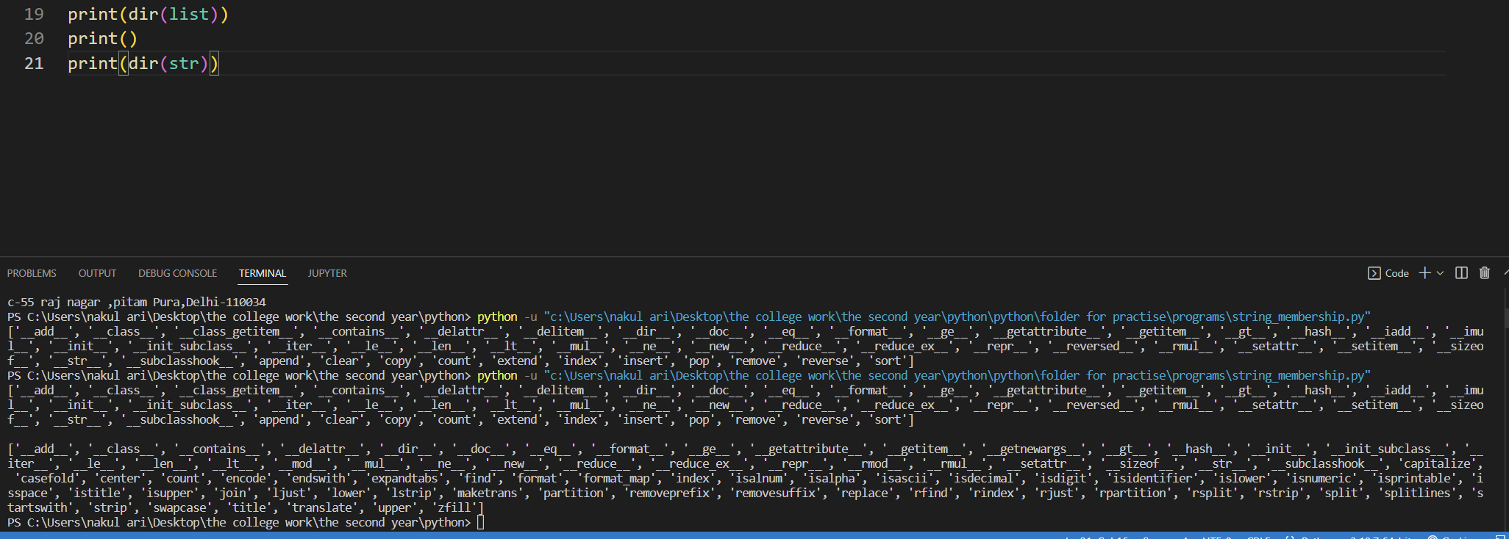

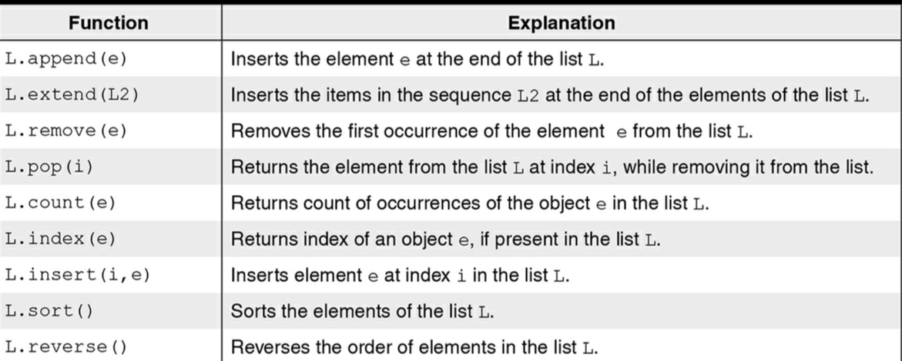

***List Comprehension***

List comprehension provides a shorthand notation for creating lists.  
example 1->>

we want to create a list that contains cubes of numbers ranging from 1 to 10.

***Method 1->***this, we may create an empty list, and use a for-loop to append the elements to this list:  
>>> cubes =[]  
 >>> end = 10  
 >>> for i in range(1, end + 1):   
 cubes.append(i ** 3)   
>>> print(cubes)  
 [1, 8, 27, 64, 125, 216, 343, 512, 729, 1000]

***Method 2->***

a simple one line statement can be used for achieving the same task.   
shorthand notation for creating a list of cubes  
 >>> cubes = [**x**3** for x in range(1, end + 1)]   
The expression [x**3 for x in range(1, end + 1)] creates a list containing cube of each element in the range (1, end + 1).

***Another example of list composition (list within a list)***

We wish to create a list comprising the students in the list lst whose height exceed or equal a threshold:

>>> lst = [['Rama', 160], ['Anya', 159], ['Mira',158], ['Sona', 161]]   
>>> threshold = 160

The desired list can be easily created using comprehensions:   
  
>>> tall = [**x** for x in lst if x[1] >= threshold] #we need to give a variable at the starting of the list   
>>> print(tall)   
[['Rama', 160], ['Sona', 161]]

***Another example***

given a list s1 of alphabets and another list s2 of numbers, we wish to create a cross product of s1 and s2.  
 Each element of the list crossProduct is a two-element list of the type [alphabet, number].   
This is easily achieved using comprehensions:

list comprehension for computing cross product of two lists

>>> s1 = ['a', 'b', 'c']  
 >>> s2 = [3, 5]   
>>> crossProduct = [[x, y] for x in s1 for y in s2]  
 >>> crossProduct [['a', 3], ['a', 5], ['b', 3], ['b', 5], ['c', 3], ['c', 5]]

***Lists as Arguments***

In the following figure .The function listUpdate updates the list a (line 10) by replacing the object a[i] by value.  
The main function invokes the function listUpdate with the arguments lst, 1, and 15 corresponding to the formal parameters a, i, and value.

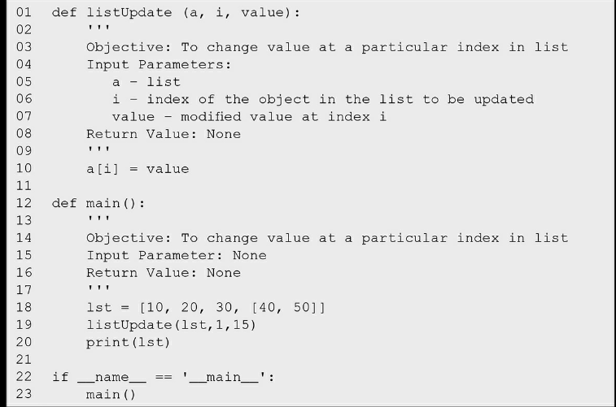



In the picture the list is passed as argument

And updation of list element occurs.  
As arguments are passed by reference, during execution of the function listUpdate, an access to the formal parameter a means access to the list lst created in the main function. Consequently, when we update the list a in the function listUpdate, it results in the corresponding update of the list lst

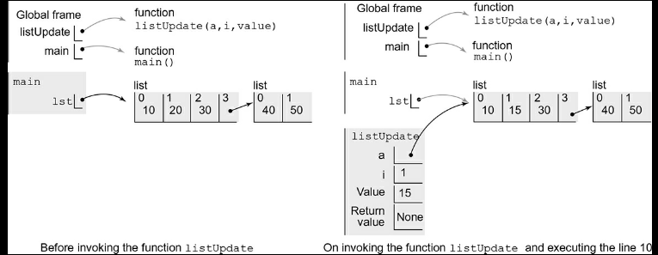  
arguments are passed by reference

list is a sequence of values.  
To be more precise, a list comprises a sequence of references to values (objects).

***7.1.10 Copying List Objects***

list is a sequence of values. To be more precise, a list comprises a sequence of references to values (objects).  
We have seen earlier that if the name list1 refers to a list, **the assignment of list1 to another name, say, list2 does not create a new list.**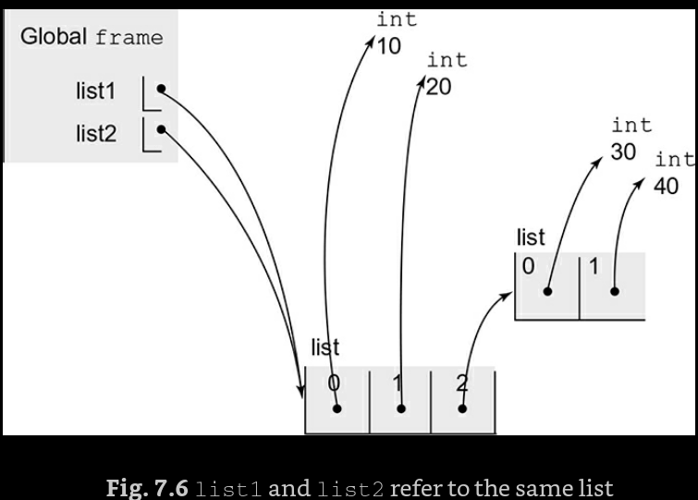

assigning a list to another name does not create another copy of the list, instead it creates another reference

As the names list1 and list2 refer to the same list object (Fig. 7.6), any changes made in the list will relate to both the names list1 and list2,  
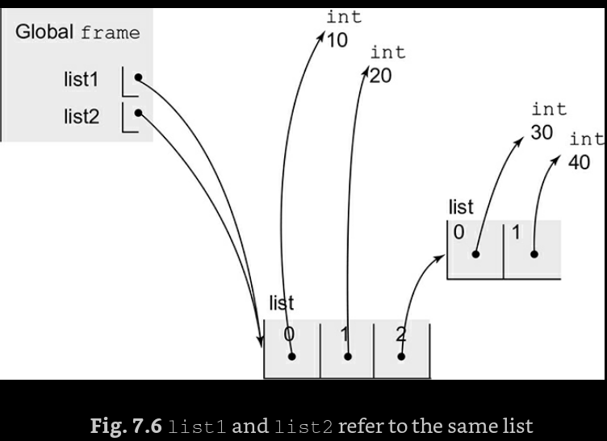

However, sometimes we need to create a copy of the list as a distinct object. To create another instance of the list object having different storage, we need to import the copy module and invoke the function copy.copy():

copy(): to create a copy of the list elements excluding the nested objects

>>> import copy  
 >>> list1 = [10, 20, [30, 40]]   
>>> list3 = copy.copy(list1)

**Note that the copy function creates a new copy list3 of the list1. Consequently, on modifying list1[1], list3[1] remains unaltered:**

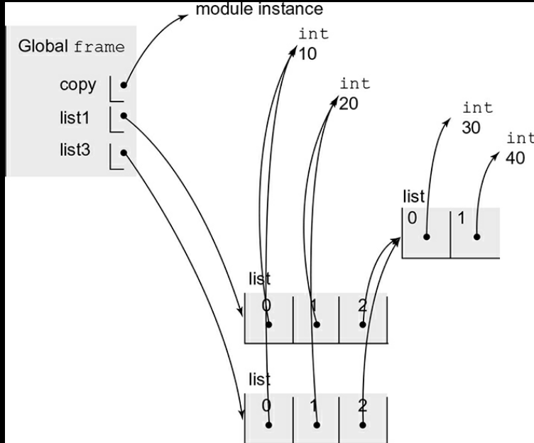

However, the copy function creates a shallow copy i.e. it does not create copies of the nested objects.  
means it makes a new instance of the same list even of the nested objects but do not make like a separate instance >> means if I change the nested list elements then the new list formed out of the copy function will also make the copy of the nested elements (but on changing the nested elements from one list will also make changes in other nested elements of the list(formed from the copy function)

Thus, list1[2] and list3[2] refer to the same nested list [30, 40]. Next, let us modify list1[2][0] in sub-list list1[2] of list list1 to value 35.  
>>> list1[2][0] = 35  
 >>> list1 [10, 25, [35, 40]]   
>>> list3 [10, 20, [35, 40]]

As discussed above, since list1[2] and list3[2] refer to the same sub-list at index 2 (Fig. 7.9), when we modify the list list1[2], the modification is also visible in the list list3[2].

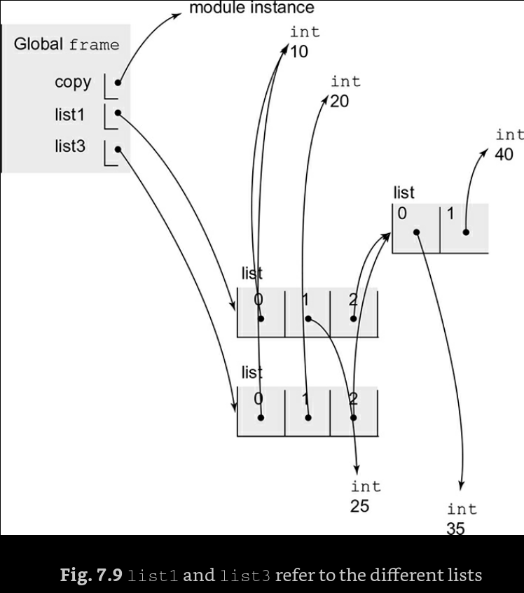

IN ORDER to make the copy of the deep objects of the list(the elements of the list within the list)   
then we use the function deepcopy of the copy module:   
deepcopy(): to create a copy of a list including copies of the nested objects at all level   
>>> import copy  
 >>> list1 = [10, 20, [30, 40]]   
>>> list4 = copy.deepcopy(list1)

Now that list1 and list4 are distinct objects having the nested lists list1[2] and list4[2] as distinct objects.  
modifying the value of list1[2][0] to 35 does not affect the object list4[2] [0] of list4 which remains unaltered

>>> list1[2][0] = 35   
>>> list1 [10, 20, [35, 40]]  
 >>> list4 [10, 20, [30, 40]]

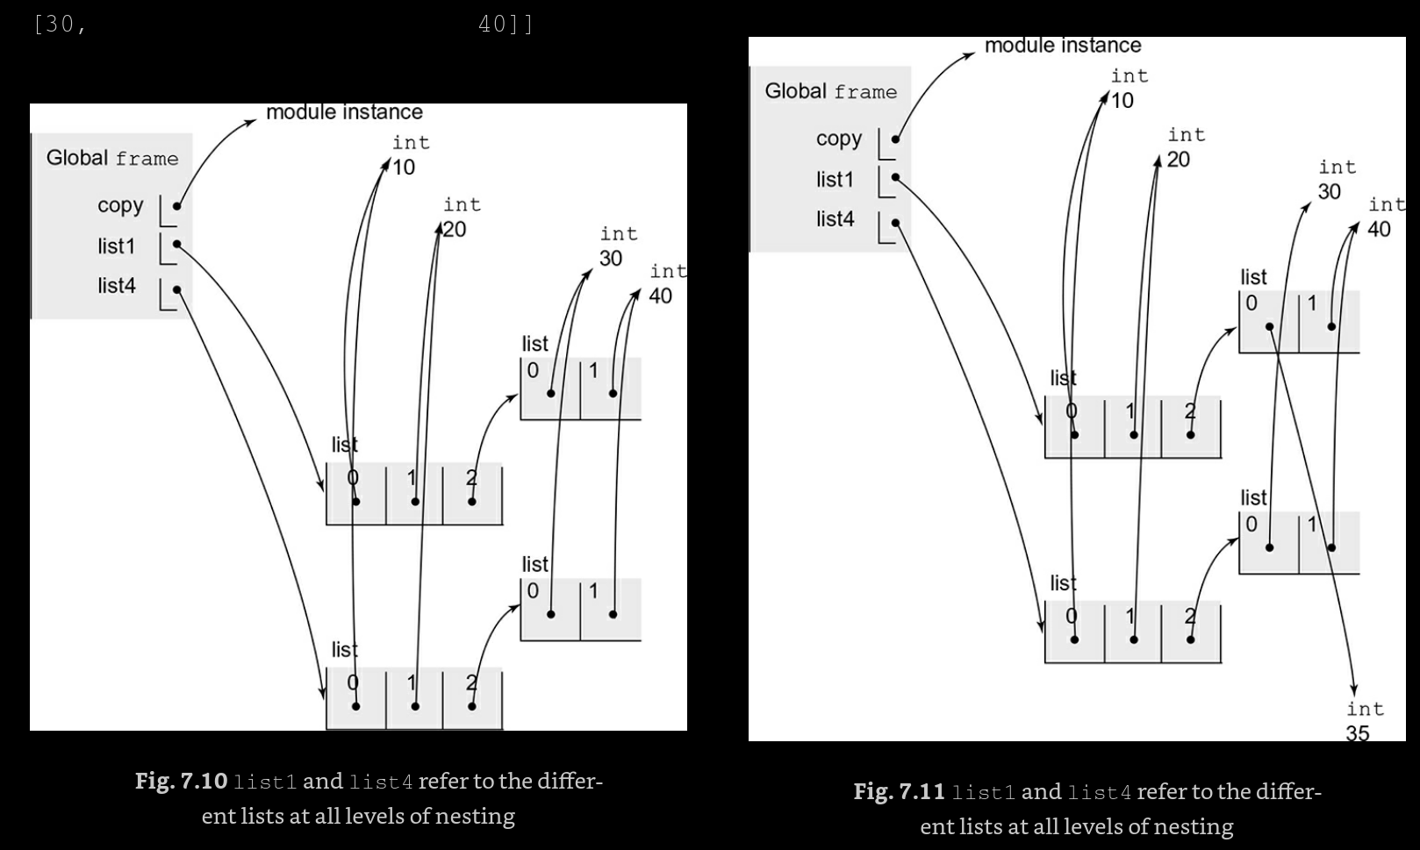

#NOTE  
the Lambda Functions   
**Python Lambda Functions** are anonymous function means that the function is without a name. As we already know that the *def* keyword is used to define a normal function in Python. Similarly, the *lambda* keyword is used to define an anonymous function in Python

the following is the syntax  
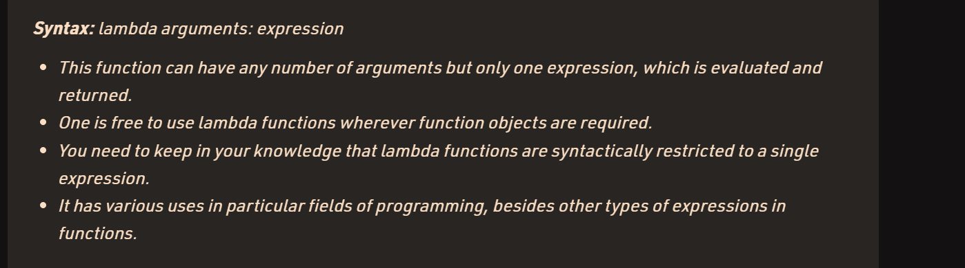

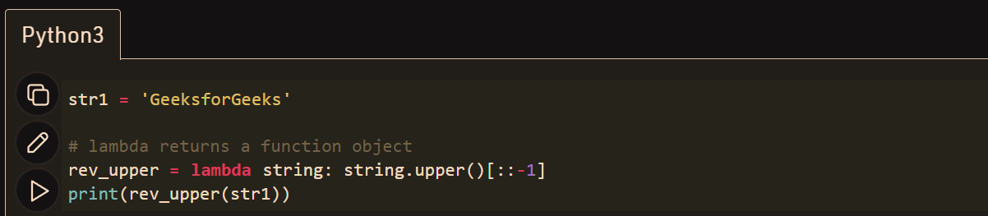

we defined a lambda function(**rev_upper**) to convert a string to it’s upper-case and reverse it.

Another example of the lambda function is   
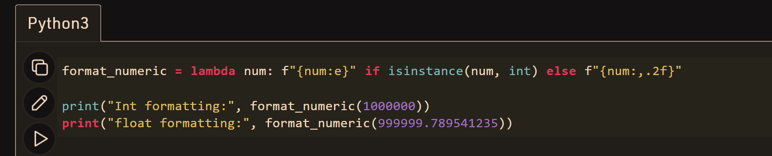



The marked one is the conditional Expression( in green)

The **num** is the argument and the lambda is the part of the Syntax

This output means the e-6 (the e+06)

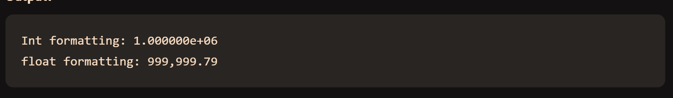

##### ***Python isinstance() Function->>* logical Operator** Example

### Definition and Usage

The isinstance() function r**eturns True if the specified object is of the specified type**, otherwise False.

If the type parameter is a tuple, this function will return True if the object is one of the types in the tuple.



Check if the number 5 is an integer:  
x = isinstance(5, int)  
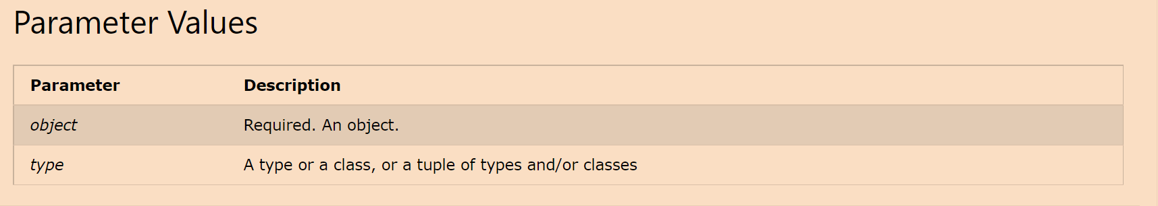

#### Returns the value as true or False another example **Example**

Check if y is an instance of myObj:

class myObj:  
  name = "John"  
  
y = myObj()  
  
x = isinstance(y, myObj)

lambda functions automatically return an expression. They cannot contain statements. return None is a statement and therefore cannot work. None is an expression and therefore works.

so there is no return statement in the lambda function

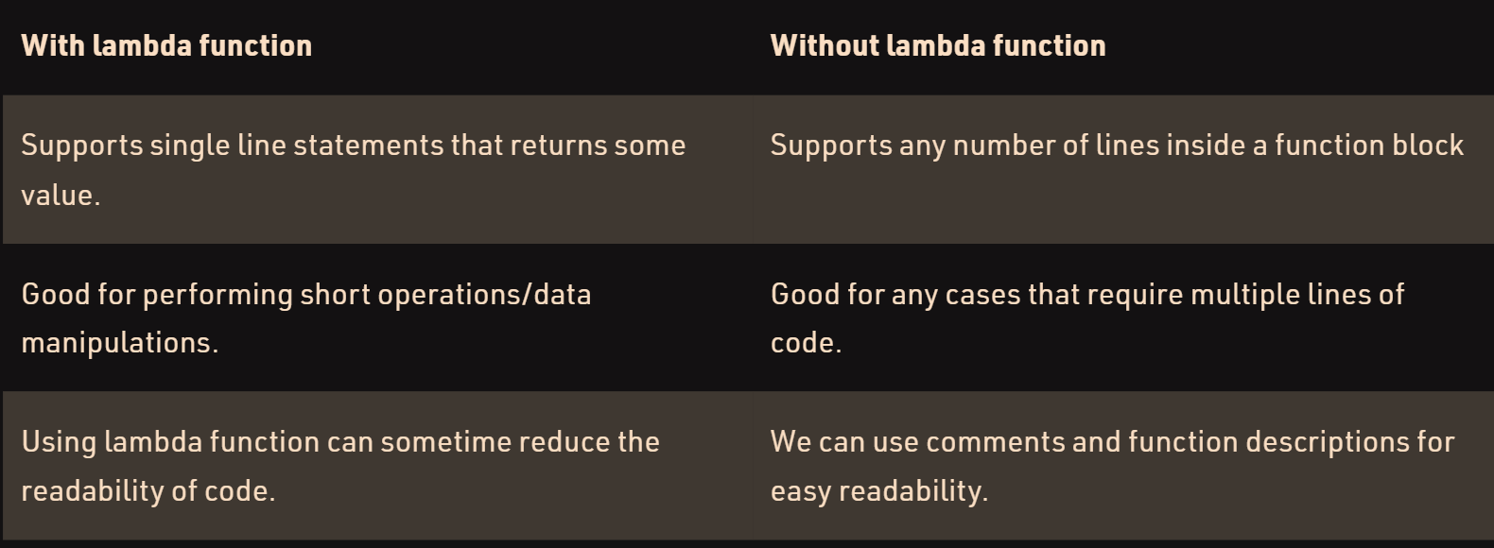

Max **=** **lambda** a, b : a **if**(a > b) **else** b

print(Max(1, 2))

If the function you need doesn’t exist, you need to write it. One way to write small functions is to use the lambda statement. lambda takes a number of parameters and an expression combining these parameters, and creates a small function that returns the value of the expression:

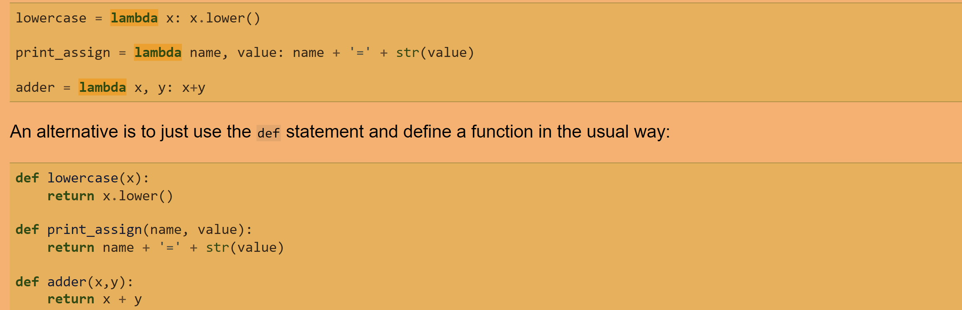

is_even_list = [lambda arg=x: arg * 10 for x in range(1, 5) ]

# iterate on each lambda function

# and invoke the function to get the calculated value

for item in is_even_list:

print(item())

see in the above code in the syntax once the argument is written after writing the lambda and then (: ) is typed   
and then expression is written and for some no of times the expression need to be calculated then the for /while loop is used

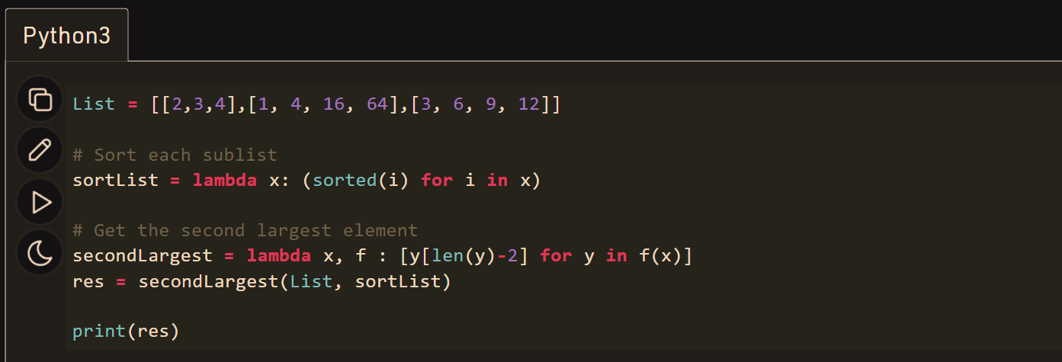

***EXAMPLE*** define a lambda function that takes a number x as an input parameter and returns the cube of it. The following statement defines a lambda function and assigns it the name cube. The function cube can now be used as usual:

lambda expression to compute the cube of a number   
>>> cube = lambda x: x ** 3   
>>> cube(3) 27

***Map, Reduce and filler Operations on a sequence***The function map is used for transforming every value in a given sequence by applying a function to it.   
It takes two input arguments: the iterable object (i.e. object which can be iterated upon) to be processed and the function to be applied, and **returns the map object obtained by applying the function to the list** as follows: mapping each value in the sequence by applying the function result = map(function, iterable object)

**map()** function returns a map object(which is an iterator) of the results after applying the given function to each item of a given iterable (list, tuple etc.)

***Syntax of Map in Python***

The syntax of the Python map() function is:

map(function, iterables)

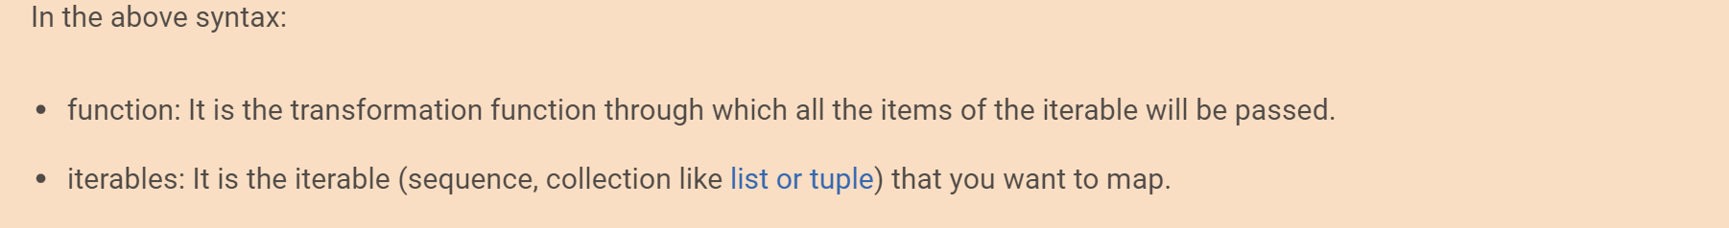

**NOTE :** The returned value from map() (map object) then can be passed to functions like list() (to create a list), set() (to create a set) .

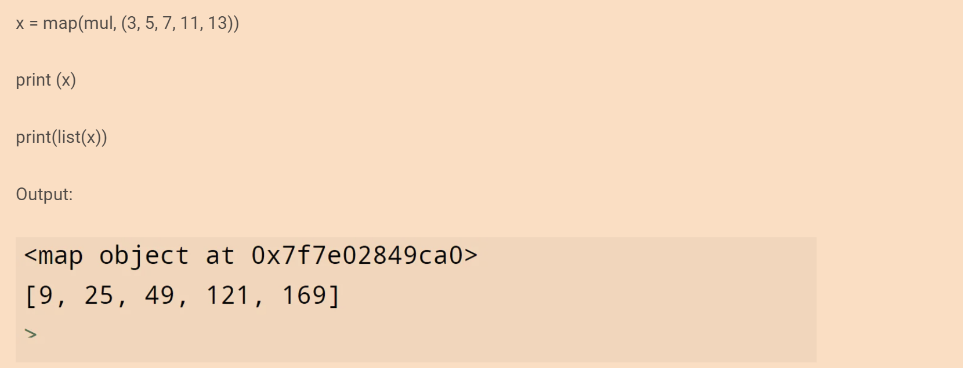

see the object map is returned by the print function

***see the input function can be any***The input function can be any cal lable function, including built-in functions, [lambda functions](https://www.simplilearn.com/tutorials/python-tutorial/lambda-in-python), user-defined functions, classes, and methods.

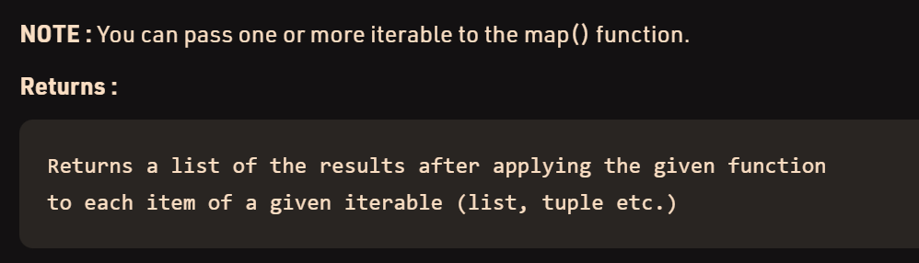

The example is the following   
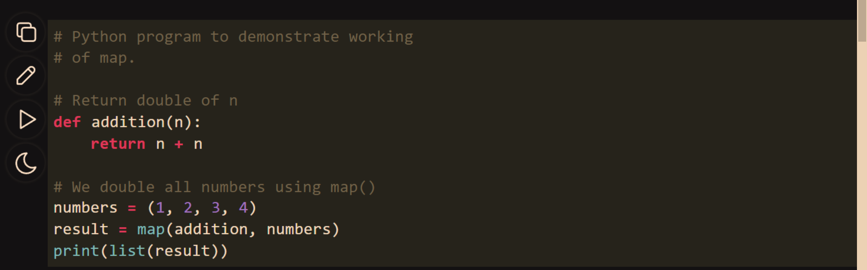

***The normal syntax is   
result = map(function, iterable object)***

***The Reduce function***

The reduce(fun,seq) function is used to**apply a particular function passed in its argument to all of the list elements**mentioned in the sequence passed along.This function is defined in **“functools” module.**

**Working :**

* At first step, first two elements of sequence are picked and the result is obtained.
* Next step is to apply the same function to the previously attained result and the number just succeeding the second element and the result is again stored.
* This process continues till no more elements are left in the container.
* The final returned result is returned and printed on console.

Seems like for loop for the elements in the list(sequence)

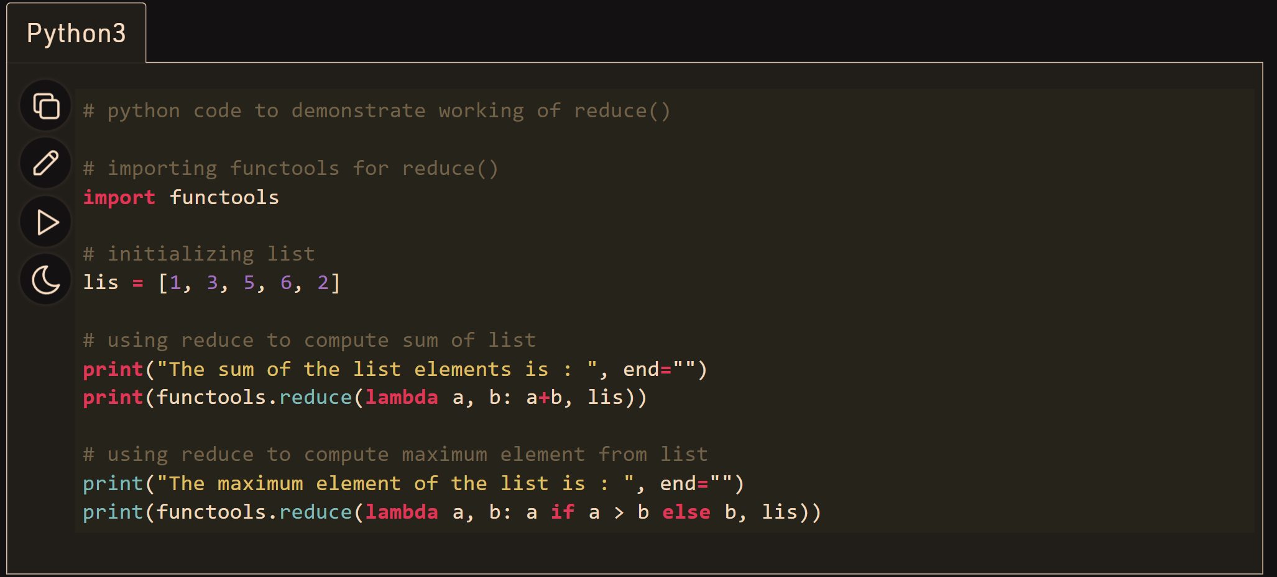

It takes two arguments: a function, and a iterable object, and **applies the function on the iterable object to produce a single value:**computing sum of cubes of all elements in the list  
>>> lst = [1, 2, 3, 4, 5]  
>>> lstCubes = list(map(lambda x: x ** 3, lst))   
>>> import functools  
>>> sumCubes = functools.reduce(lambda x, y: x + y, lstCubes)  
>>> sumCubes   
225

***WORKING***The sum may be computed by adding two values at a time, and then summing over the sums obtained in the first step, and so on. Thus, the sum of the elements of the list [1, 2, 3, 4, 5, 6, 7, 8] may be computed as (((1+2) + (3+4)) + ((5+6) + (7+8))).

***Filter Function***

If we want compute the sum of cubes of only those elements in the list lstCubes that are even.   
Thus, we need to filter the even elements from the list lstCubes and before applying the function reduce.   
**Python provides the function filter** that   
takes a function and a iterable object as the input parameters and returns only those elements from the iterable object for which function returns True  
In the following statement, the filter function returns an iterable object of even elements of the list lstCubes, which is assigned to variable evenCubes.

filtering elements from a list satisfying the given condition   
>>> evenCubes = list(filter(lambda x: x%2 == 0, lstCubes))   
>>> evenCubes   
[8, 64]   
>>> sumEvenCubes = functools.reduce(lambda x, y: x + y, evenCubes)   
>>> sumEvenCubes   
72

Alternatively, the sum of odd cubes may be computed as follows:  
>>> sumEvenCubes = functools.reduce(lambda x, y: x + y, filter(lambda x: x%2 == 0, lstCubes))  
>>> sumEvenCubes

72   
The functions map, reduce, and filter are often used to exploit the parallelism of the system to distribute computation to several processors.

***Sets***

an unordered collection of objects without any duplicates.  
An object of type set may be created by enclosing the elements of the set within curly brackets. The set objects may also be created by applying the set function to lists, strings, and tuples.   
set: a comma separated unordered sequence of values enclosed within curly braces

***set(): to convert a sequence to a set***

>>> {1,2,3}   
{1, 2, 3}  
 >>> vowels = set('aeiou')   
>>> vowels  
 {'e', 'a', 'o', 'u', 'i'}   
>>> vehicles = set(['Bike', 'Car', 'Bicycle', 'Scooter'])  
 >>> vehicles {'Scooter', 'Car', 'Bike', 'Bicycle'}  
 >>> digits = set((0, 1, 2, 3, 4, 5, 6, 7, 8, 9))   
>>> digits {0, 1, 2, 3, 4, 5, 6, 7, 8, 9}

The elements of a set are required to be immutable objects.

Therefore, whereas objects of types such as int, float, tuple, and str can be members of a set, a list cannot be a member of a set.

Unlike lists, we cannot access elements of a set through indexing or slicing.  
Also, we cannot apply + and * operators on sets.

using the ***membership operator in***, we can iterate over elements of a set:

elements of a set must be immutable set type does not support indexing, slicing, + operator, and * operator iterating over elements of the set

***The functions min, max, sum, and len work for sets in the same manner as defined for lists.***

>>> for v in vowels:  
 print(v, end = ' ')   
e a o u i

>>> min(digits)   
0   
>>> max(digits)   
9  
>>> sum(digits)   
45   
>>> len(vehicles)   
4

***Set Functions***

add, update, remove, pop, and clear  
we wish to **add an element 'Bus' to the set vehicles.** It can be **done using the function add.** To include new elements in a set, we use update function. The input argument to the update function may be an object such as list, set, range, or tuple, for example:

adding elements to a set  
 >>> vehicles.add('Bus')  
 >>> vehicles {'Car', 'Bike', 'Bicycle', 'Bus', 'Scooter'}  
 >>> vehicles.update([' Truck', 'Rickshaw', 'Bike'])  
 >>> vehicles {'Car', 'Bike', 'Bicycle', 'Rickshaw', 'Bus', 'Truck', 'Scooter'}

***It is important to point out that an attempt to add a duplicate value ('Bike' in the above case) is just ignored by Python.***

Duplicate Elimination  
>>> heavyVehicles = {'Truck', 'Bus', 'Crane'}  
An element may be removed from a set using the function remove, for example: removing an element from the set

removing an element from the set   
>>> heavyVehicles.remove('Crane')   
>>> heavyVehicles {'Bus', 'Truck'}   
>>> heavyVehicles.remove('Car')   
Traceback (most recent call last): File "<pyshell#432>", line 1 heavyVehicles.remove('Car') KeyError: 'Car'

an attempt to remove an element from a set, which is not a member of the set, yields an error.

Although the function pop is defined for objects of type set, the element removed by the function pop is unpredictable.  
the pop function just remove element (but is the random element )

>>> heavyVehicles = {'Truck', 'Bus', 'Crane'}  
 >>> heavyVehicles.pop()   
'Bus'

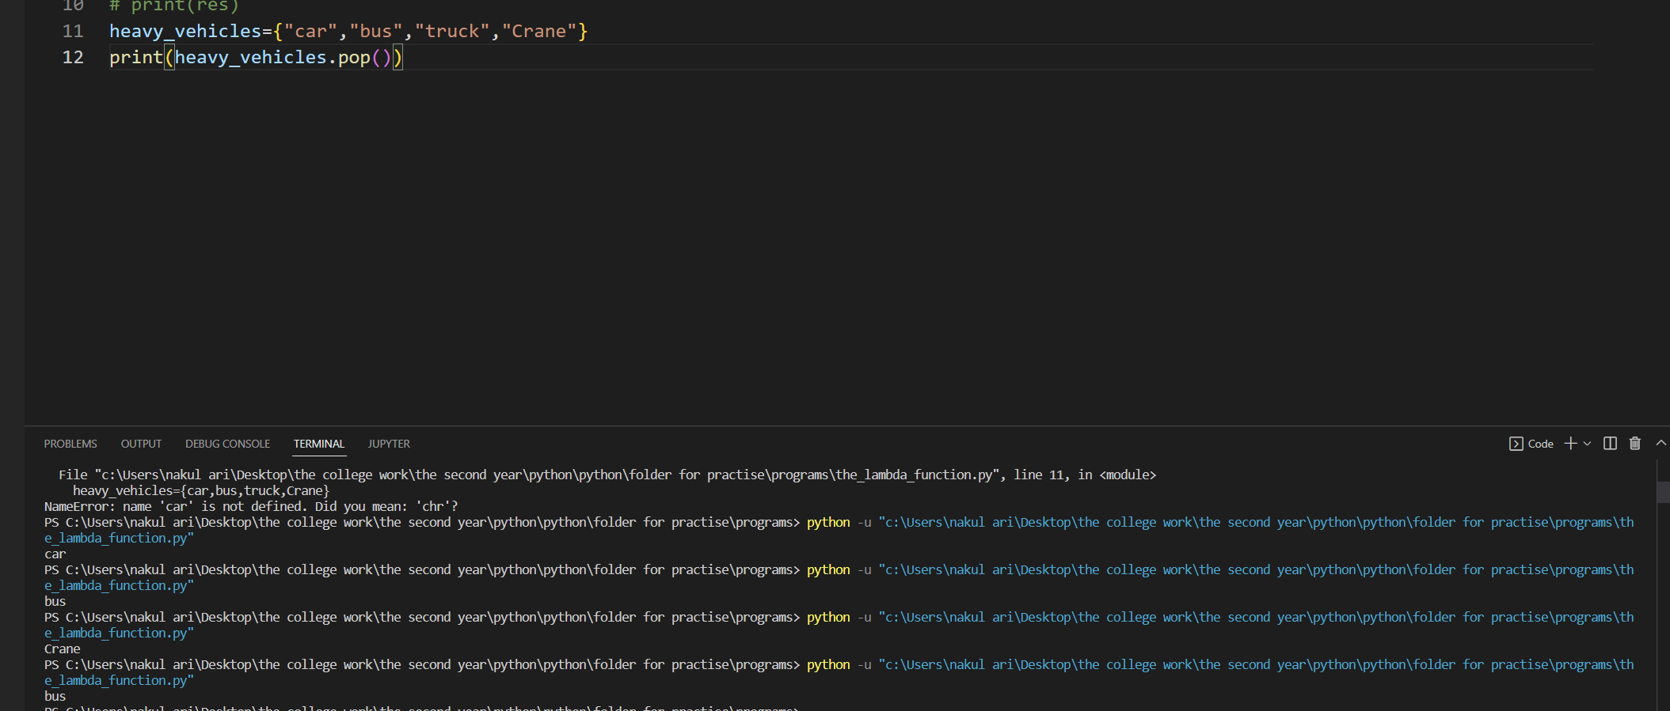



See random deletion of the elements from the set

To remove all the elements of a set, without deleting the set object, we use the clear function:   
removing all elements of a set

>>> heavyVehicles.clear()  
 >>> heavyVehicles   
set()

**Func**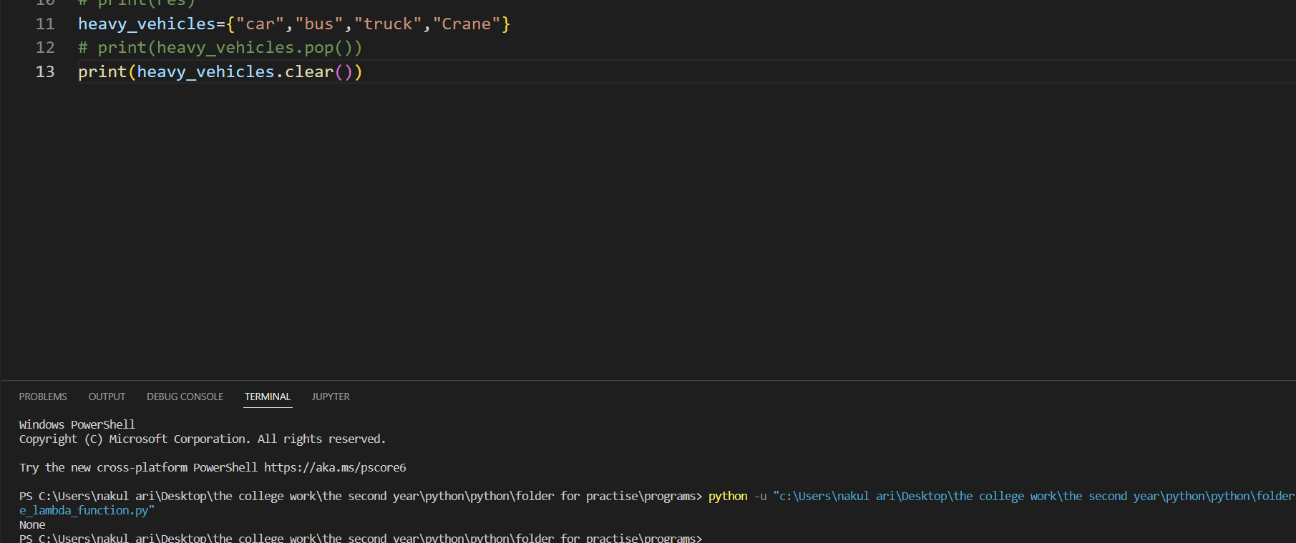



***Functions of SET***

union, intersection, difference, and symmetric_difference

>>> fruits = {'Apple', 'Orange', 'Tomato', 'Cucumber', 'Watermelon'}   
>>> vegetables = {'Cucumber', 'Potato', 'Tomato', 'Watermelon', 'Cauliflower'}

we take union of the above two sets. union of two sets   
>>> eatables = ***fruits.union* #(union)**  
>>> eatables {'Orange', 'Tomato', 'Cucumber', 'Watermelon', 'Cauliflower', 'Apple', 'Potato'}

>>> eatables = ***fruits | vegetables* #(union using operator)**  
 >>> eatables {'Orange', 'Tomato', 'Cucumber', 'Watermelon', 'Cauliflower', 'Apple', 'Potato'}

fruits = {'Apple', 'Orange', 'Tomato', 'Cucumber', 'Watermelon'}

vegetables = {'Cucumber', 'Potato', 'Tomato', 'Watermelon', 'Cauliflower'}

eatables=fruits.intersection(vegetables)

print(eatables)

this is the way the intersection works

we take intersection of sets fruits and vegetables   
using either ***the function intersection*** or ***the intersection operator ( & )*** as follows: intersection of two sets

>>> fruitsAndVegetables = ***fruits.intersection(vegetables)***>>> fruitsAndVegetables {'Tomato', 'Cucumber', 'Watermelon'}   
>>> fruitsAndVegetables = ***fruits & vegetables***(intersection operator)  
>>> fruitsAndVegetables

{'Tomato', 'Cucumber', 'Watermelon'}

we find the fruits which are not vegetables by taking difference of the two sets,   
**either using the function difference or using the difference operator:**   
set difference

>>> **onlyFruits = fruits.difference(vegetables)**>>> onlyFruits {'Orange', 'Apple'}  
>>> onlyFruits = ***fruits – vegetables*** this is the usage of the difference operator   
>>> onlyFruits {'Orange', 'Apple'}

>>> onlyVegetables = vegetables.difference(fruits)  
 >>> onlyVegetables   
{'Cauliflower', 'Potato'}  
>>> onlyVegetables = vegetables - fruits   
>>> onlyVegetables   
{'Cauliflower', 'Potato'}

The functions set.intersection, set.union, and set.difference can be applied to two or more sets to carry out intersection, union, and difference operations on sets:   
>>> digits1 = {0, 1, 2, 3}  
 >>> digits2 = {2, 4, 5, 6}  
 >>> digits3 = {0, 7, 8, 9, 2}   
>>> set.union(digits1, digits2, digits3)  
 {0, 1, 2, 3, 4, 5, 6, 7, 8, 9}   
>>> set.intersection(digits1, digits2, digits3)  
 {2}   
>>> set.difference(digits1, digits2, digits3)  
 {1, 3}

The function set.difference works by taking the union of all sets except the first one and subtracting the union from the first set.

In Python, you can find the symmetric difference of two or more sets by using the set symmetric_difference() method or the symmetric difference operator ( ^ ).

***Function Copy***

We make use of the function copy to create a separate copy of a set so that changes in one copy are not reflected in the other:  
**the copy makes a copy ->> so making some changes to one copy does not affect the other**

copying the elements of a set  
 >>> digits = {0, 1, 2, 3, 7, 8, 9}  
 >>> digits2 = digits.copy()  
 >>> digits.update({4, 5, 6})  
 >>> digits  
 {0, 1, 2, 3, 4, 5, 6, 7, 8, 9}  
 >>> digits2   
{0, 1, 2, 3, 7, 8, 9}

see no changes occurred in digits2 when the digits was updated

Taneja Sheetal. Python Programming: A modular approach . Pearson Education. Kindle Edition.

***Subset and Superset***

subset and superset operations   
>>> multiples2 = {2, 4, 6, 8, 10, 12, 14}   
>>> multiples4 = {4, 8, 12}  
 >>> isSubset = multiples4 <= multiples2   
>>> isSubset   
True   
>>> isSuperset = multiples2 >= multiples4   
>>> isSuperset  
True

***List of Functions***

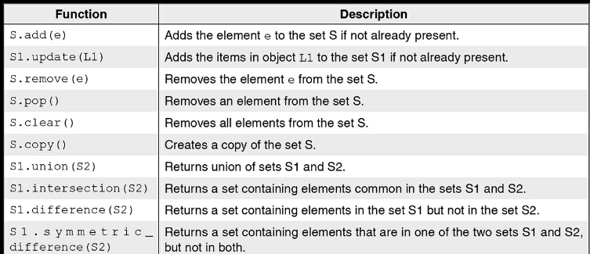

given two numbers n1 and n2, we wish to find their common factors. To check whether a number i is a factor of another number, say num, we only need to find the remainder num % i.  
If the remainder is zero, then i is a factor of num, otherwise, i is not a factor of num.  
***We also note that a common factor cannot exceed smaller of the two numbers, say n1 and n2.***To represent the collection of common factors as a set. We also note that a common factor cannot exceed smaller of the two numbers, say n1 and n2.

For each number i in range(1, min(n1,n2) + 1), we include it in the set if it is a factor of each of n1 and n2.

commonFactors = {i for i in range(1, min(n1+1, n2+1)) if n1%i == 0 and n2%i == 0}

the Union and the intersection operators are not supported in lists in python  
but ***Python can convert the list to sets***

so then those functions can be applied

***It is important to emphasize that   
a list should be converted to sets only when the order of elements in the list is not important.  
Also, transforming a list into the set will remove repeating elements.,   
we define the functions union, intersection, and difference for lists.

***Tuples***

A tuple is a non-scalar type defined in Python. Just like a list, a tuple is an ordered sequence of objects.  
***like a list, a tuple is an ordered sequence of objects. However, unlike lists, tuples are immutable,*** i.e. elements of a tuple cannot be overwritten.

A tuple may be specified by enclosing in the parentheses, the elements of the tuple (possibly of heterogeneous types), separated by commas.

tuple: a comma separated ordered sequence of values enclosed in parenthesis

>>> t1 = (4, 6, [2, 8], 'abc', {3, 4})   
>>> type(t1)   
<class 'tuple'>

If a tuple comprises a single element, the element should be followed by a comma to distinguish a tuple from a parenthesized expression

***singleton tuple: comma required after the element***

>>> (2)   
2  
 >>> (2,)  
(2,)

Another notation for tuples is just to list the elements of a tuple, separated by commas:  
>>> 2, 4, 6   
(2, 4, 6)

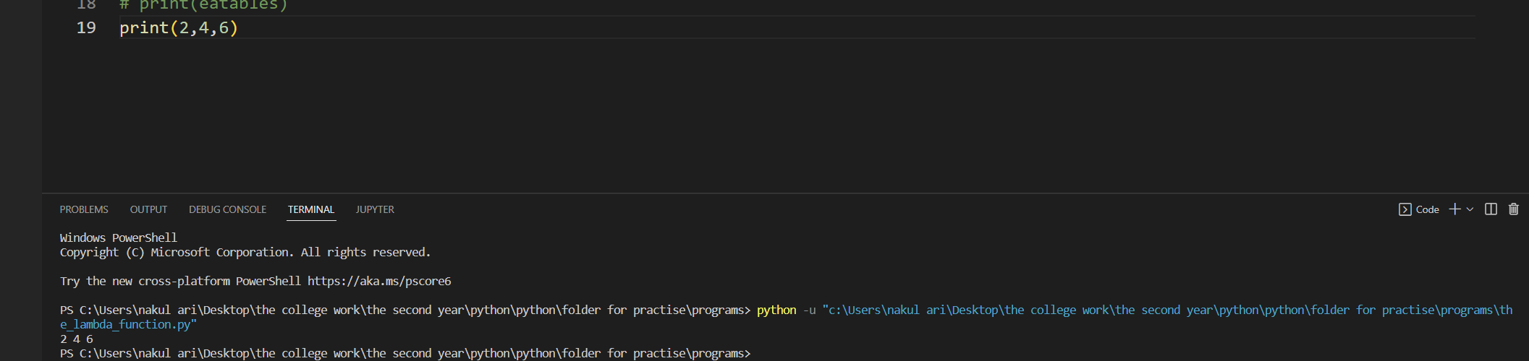

Tuples being immutable, an attempt to modify an element of a tuple yields an error:  
***tuples are immutable***

>>> t1[1] = 3 Traceback (most recent call last): File "<pyshell#61>", line 1, in <module> t1[1] = 3 TypeError: 'tuple' object does not support item assignment

This error shows up when the tuple is tried to be modified

However elements of a tuple may be mutable  
>>> t1 = (1, 2, [3, 4])   
>>> t1[2][1] = 5   
>>> t1 (1, 2, [3, 5])

Just like the above tuple contains an element which is actually a list

***Summary of Tuple Operations***

>>> t1 = ('Monday', 'Tuesday')   
>>> t2 = (10, 20, 30)

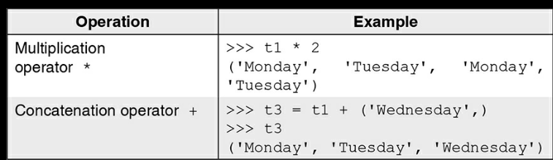  
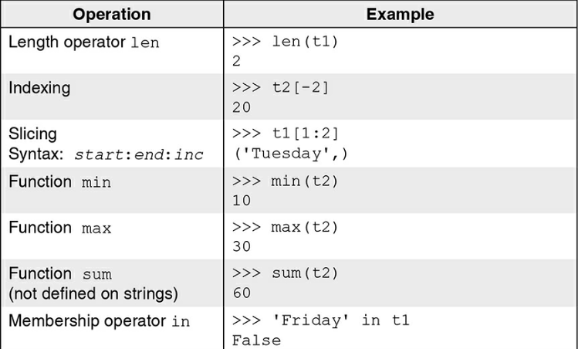

The function tuple can be used to convert a sequence to a tuple .  
converting a sequence to a tuple

>>> vowels = 'aeiou'  
>>> tuple(vowels)  
 ('a', 'e', 'i', 'o', 'u')  
 >>> tuple([4,10,20])   
(4, 10, 20)   
>>> tuple(range(5))   
(0, 1, 2, 3, 4)

The **function zip is used to produces a zip object (iterable object)**,  
whose ith element is a tuple containing ith element from each iterable object passed as argument to the zip function.

**producing a list of tuples containing corresponding element from each iterable object.**

The zip() function returns a zip object, which is an iterator of tuples where the first item in each passed iterator is paired together, and then the second item in each passed iterator are paired together etc.

If the passed iterators have different lengths, the iterator with the least items decides the length of the new iterator.



This is how it is   
  
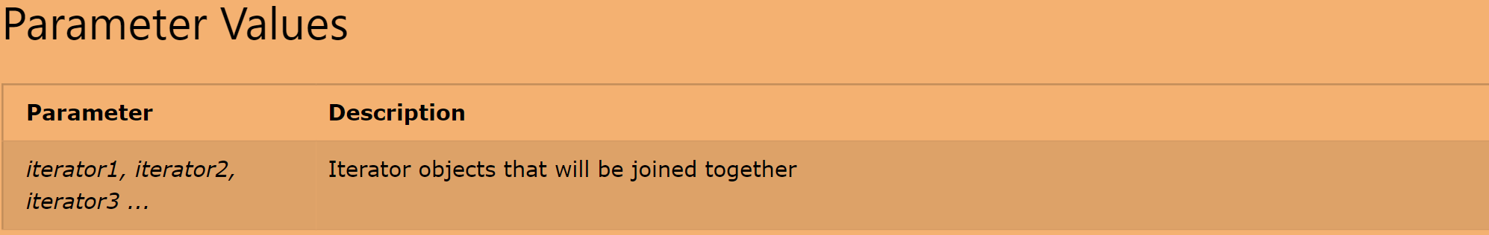

>>> colors = ('red', 'yellow', 'orange')   
>>> fruits = ['cherry', 'banana', 'orange']   
>>> quantity = ('1 kg', 12, '2 kg')   
>>> fruitColor = list(zip(colors, fruits))   
>>> fruitColor [('red', 'cherry'),('yellow', 'banana'), ('orange', 'orange')]  
>>> fruitColorQuantity = list(zip(fruitColor, quantity))   
>>> fruitColorQuantity  
 [(('red', 'cherry'), '1 kg'), (('yellow', 'banana'), 12), (('orange', 'orange'), '2 kg')]   
>>> list(zip(colors, fruits, quantity))   
[('red', 'cherry', '1 kg'), ('yellow', 'banana', 12), ('orange', 'orange', '2 kg')]

***The function count*** is used to find the number of occurrences of a value in a tuple, for example:  
counting number of occurrences of a value in a tuple

>>> age = (20, 18, 17, 19, 18, 18)  
 >>> age.count(18)   
3

The **function index is used to find the index of the first occurrence of a particular element in a tuple**, for example:  
finding index of the first occurrence of an element in the tuple

>>> age.index(18)   
1

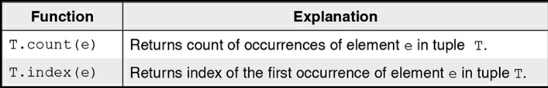

***Dictionary***

Unlike lists, tuples, and strings, a dictionary is an unordered sequence of key-value pairs.  
Indices in a dictionary can be of any immutable type and are called keys.  
Beginning with an empty dictionary, we create a dictionary of month_number-month_name pairs as follows:

**Dictionary in Python** is a collection of keys values, used to store data values like a map, which, unlike other data types which hold only a single value as an element.

dictionary: a comma separated unordered sequence of key-value pairs enclosed in curly braces

>>> month = {}  
 >>> month[1] = 'Jan'  
 >>> month[2] = 'Feb'  
 >>> month[3] = 'Mar'   
>>> month[4] = 'Apr'   
>>> month   
{1: 'Jan', 2: 'Feb', 3: 'Mar', 4: 'Apr'}  **# Key and value in a key-value pair in a dictionary are separated by a colon.**  
>>> type(month)  
 <class 'dict'>

Further, **the key:value pairs in a dictionary are separated by commas** and are **enclosed between curly parentheses.**we define another dictionary comprising vegetable-price pairs:

>>> price = {'tomato':40, 'cucumber':30, 'potato':20, 'cauliflower':70, 'cabbage':50, 'lettuce':40, 'raddish':30, 'carrot':20, 'peas':80}   
  
>>> price['potato']   
20

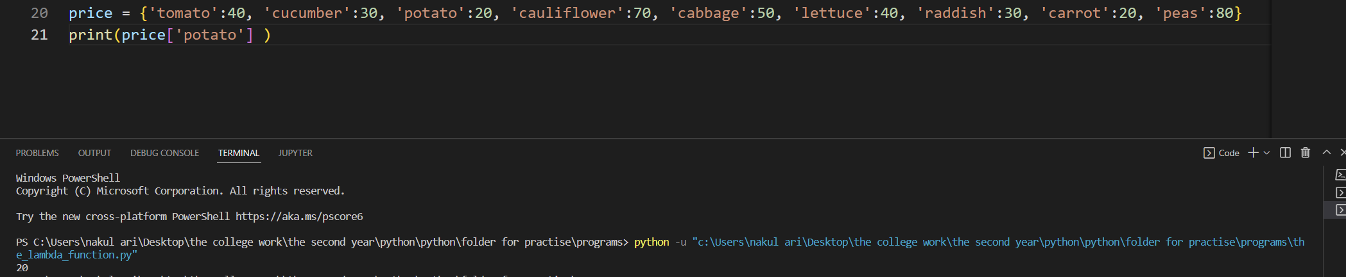  
>>> price['carrot']   
20   
  
>>> price.keys()   
dict_keys(['tomato', 'cucumber', 'potato', 'cauliflower', 'cabbage', 'lettuce', 'raddish', 'carrot', 'peas'])

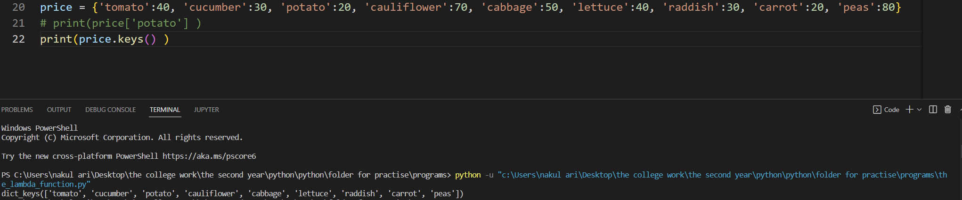  
>>> price.values()   
dict_values([40, 30, 20, 70, 50, 40, 30, 20, 80])

>>> price.items()  
dict_items([(' tomato', 40), ('cucumber', 30), ('potato', 20), ('cauliflower', 70), ('cabbage', 50), ('lettuce', 40), ('raddish', 30), ('carrot', 20), ('peas', 80)])

Note that the search in a dictionary is based on the key. Therefore, in a dictionary, the keys are required to be unique.  
However, the same value may be associated with multiple keys.

In particular, in the dictionary price of vegetable-price pairs, we have already noted that whereas the names of vegetables are unique throughout the dictionary, the prices may be duplicated

(price['potato'] == price['carrot'] and price['tomato'] == price['lettuce']).   
The functions keys, values, and items return objects comprising of keys, values, and key-value tuples in the dictionary respectively.

If required, a function such as list or tuple may be applied to the output of the functions keys, values, and items to obtain a list or tuple of keys, values, or key-value tuples.

keys in a dictionary are immutable, lists cannot be used as keys.  
However, values associated with keys can be mutable objects and thus, may be changed at will.

keys: must be unique values: may be duplicated

keys(): return an object of keys

values(): return an object of values

items(): return an object of key-value tuples  
 keys are immutable  
 >>> price['tomato'] = 25

Keys in a dictionary may be of heterogeneous types, for example:

>>> counting = {1:'one', 'one':1, 2:'two', 'two':2}

***Dictionary Operations***

digits = {0:'Zero', 1:'One', 2:'Two', 3:'Three', 4:'Four', 5:'Five', 6:'Six', 7: 'Seven', 8:'Eight', 9:'Nine'}

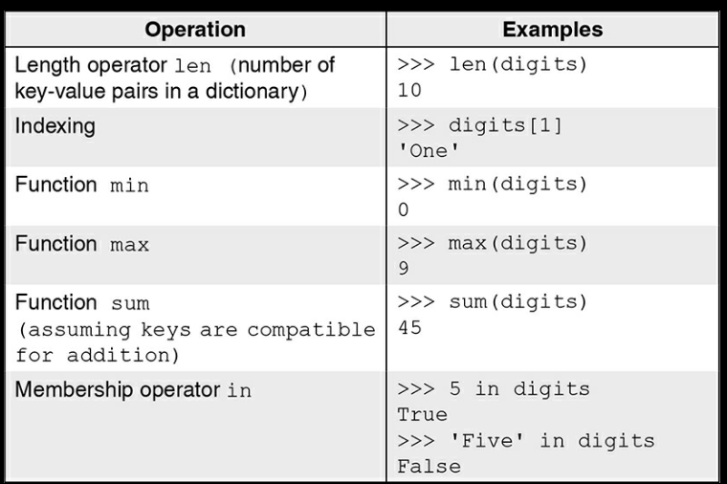

some operations that can be applied to a dictionary and illustrate these operations using a dictionary of digit-name pairs:

Next, consider a dictionary of winter months:   
>>> winter = {11:'November ', 12: 'December', 1:'January', 2:'February'}   
Membership operation in, and functions min, max and sum apply only to the keys in a dictionary.  
Thus, applying these operations on the dictionary winter is equivalent to applying them on winter.keys() as shown below:  
min, max, sum, and in apply to keys in a dictionary   
>>> 2 in winter, min(winter), max(winter), sum(winter)   
(True, 1, 12, 26)  
 >>> 2 in winter.keys(),min(winter.keys()), max(winter.keys()), sum(winter.keys())  
(True, 1, 12, 26)

***Deletion***We may remove a key-value pair from a dictionary using del operator, for example:   
removing a key-value pair   
>>> del winter[11]  
 >>> winter {12: 'December', 1: 'January', 2: 'February'} To delete a dictionary,   
we use del operator:

deleting an entire dictionary

>>> del winter  
To remove all the key–value pairs in a dictionary, we use the clear function. Note that while assigning an empty dictionary {} creates a new object, the **function clear removes all key-value pairs** from an existing dictionary:

Note that while assigning an empty dictionary {} creates a new object, the function clear removes all key-value pairs from an existing dictionary:

clear(): to remove all key-value pairs

>>> winter = {11:'November ', 12: 'December', 1:'January', 2:'February'}   
>>> months = winter   
>>> months.clear()   
>>> months, winter   
({}, {})

**What happens above**

Note that as the names winter and months refer to the same dictionary object, on applying clear function to months, the dictionary winter also becomes empty.

***Function Get***

The function get is used to extract the value corresponding to a given key,  
retrieving value corresponding to a key  
>>> passwords = {'Ram':'ak@607', 'Shyam':'rou.589', 'Gita':'yam@694'}   
>>> passwords.get('Ram',-1) 'ak@607'

The first parameter is used to specify the key and the second parameter is used to specify the value to be returned in case the key is not found in the dictionary. In case, the second parameter is not specified, the system returns None,

***get() returns second argument if the key is not present in the dictionary***

>>> passwords.get('Raman', -1)  
-1   
>>> print(passwords.get('Raman'))  
None

***Function Update***

The function update is used to insert in a dictionary, all the key–value pairs of another dictionary, for example:  
  
***inserting key-value pairs***

>>> morePasswords = {'Raman':'vi97@4', 'Kishore':'23@0jsk'}   
>>> passwords.update(morePasswords)   
>>> passwords   
{'Ram': 'ak@607', 'Shyam': 'rou.589', 'Gita': 'yam@694', 'Raman': 'vi97@4', 'Kishore': '23@0jsk'}

***Function Copy***

To create a shallow copy of a dictionary object, we make use of the copy function.  
creating shallow copy of a dictionary

>>> newPasswords = morePasswords.copy()   
>>> id(newPasswords), id(morePasswords)   
(54782832, 54781104)

***List of Functions***

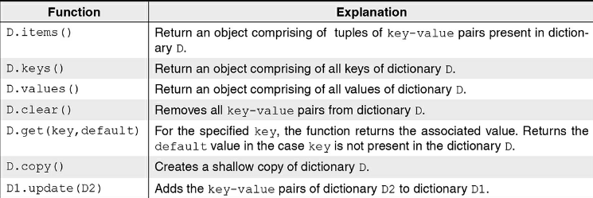

we list some of the built-in functions that can be applied to objects of dict type. Whereas many of these functions such as update and clear modify a dictionary, functions such as items, keys, values, and get do not alter a dictionary.

***Inverted Dictionary***

maintaining a dictionary of words and their meanings of the ***form word:meaning.***  
In this dictionary, we wish to find synonyms of a word, i.e. given a word, we wish to find the list of words that have the same meaning.

For this purpose, we would like to build ***an inverted dictionary invDict of meaning:list-of-words.***  
In the function buildInvDict, **we begin with an empty dictionary invDict that uses meaning as the key**. For every key-value pair of word:meaning in the dictionary dict1, if it is the first occurrence meaning, then **meaning:[word] is entered in the inverted dictionary.**

If the key meaning already exists in the inverted dictionary, then word is appended to the list invDict[meaning].  
we use comprehensions to drop the words having only one meaning:

dictionary comprehension for finding synonyms in a dictionary

{meaning: invDict[x] for x in invDict if len(invDict[x])>1}

The complete program appears in Fig. 7.13.

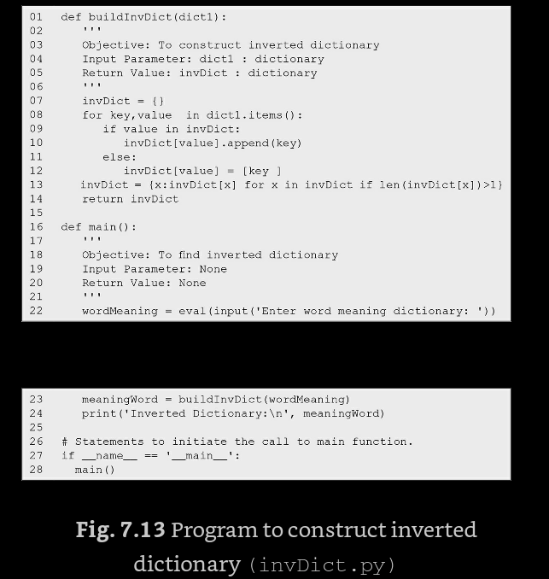

We conclude this section with a sample run of the program invDict (Fig. 7.13).  
>>> Enter word meaning dictionary: {'dubious':'doubtful', 'hilarious':'amusing', 'suspicious':'doubtful', 'comical':'amusing', 'hello':'hi'}  
Inverted Dictionary:  
{'doubtful': ['dubious', 'suspicious'], 'amusing': ['hilarious', 'comical']}

***Files and Exceptions***

Often we want to store data permanently, in the form of files that usually reside on disks, so that it is  
available as and when required. For example, for login application, we would like to validate the user name and password entered by a user against the names and passwords of valid users stored permanently in a file.

By default, Python provides a standard input file and a standard output file to deal with the transitory data.

***The standard input file is read from the keyboard, and the standard output file is displayed on the screen.***

programs necessarily have to deal with exception situations like unavailability of a file we want to read from or an error like division by zero.

files provide a means to store data permanently.

***File Handling***

Files provide a means of communication between the program and the outside world.  
A file is nothing but a stream of bytes, comprising data of interest. Files can be used in any application where data is required to be stored permanently.

Built-in function open() is used for opening the file   
The second argument indicates the mode for accessing the file. A file may be opened in any of the three modes: r (read), w (write), and a (append).

Read mode is used when an existing file is to be read. Write mode is used when a file is to be accessed for writing data in it. While opening a file in the read mode, if the specified file does not exist, it would lead to an error.

BUT in python while opening a file in write mode, if the specified file does not exist, Python will create a new file. However, while opening a file in write mode, if the specified file already exists, this file gets overwritten.

As the name suggests, append mode allows us to write into a file by appending contents at the end of the specified file.

However, if the specified file does not exist, a new file is created. The absence of the second argument in the open function sets it to default value 'r' (read mode).

Successful Execution of the open function returns a file object.  
Failure in opening the file results in error. ***A file may be opened using the following syntax:***

***file is a stream of bytes***open(): to open a file modes for opening a file:

read(r): to read the file

write(w): to write to the file

append(a): to write at the end of the file opening a non-existent file in w or a mode creates a new file with the given name f = open(file_name, access_mode)

by default, a file is opened in read mode

In the following statement, ***the file object returned by the function open has been named f*** and we will be using this name for writing the contents into the file:   
>>> f = open('PYTHON','w')

The default location is not the only way to save the file in the directory  
the absolute path can also be made to save the file name   
***By default, the system creates a file in the default working directory.***

Instead of this relative path name, absolute (full) path name such as F:\PythonCode\Ch09 could also be specified.

***Usage of read and write operation***The functions read and write are used for reading from and writing into the file respectively. To use read/write function, we use the following notation: name of the file object, followed by the dot operator (.), followed by the name of the function.

For example, in the following statement,   
we use write() function to write some text in the file PYTHON.  
 read(): to read a file write():   
to write into a file   
>>> f.write  
('''Python: Python is an interactive programming language. Simple syntax of the language makes Python programs easy to read and write.''')  
130

apart from writing the given data into a file,  
the write function write also returns the number of characters written into the file (130 in the above example).  
Since the file is opened in write mode, Python disallows read operation on it by flagging an error as shown below:

***write function returns the number of characters written in the file.***

reading a file opened for writing yields an error

>>> f.read()   
Traceback (most recent call last): File "<pyshell#0>", line 1, in <module> f.read() io.UnsupportedOperation: not readable

In order to close the read or write operation  
When a file is no longer required for reading or writing,  
it should be closed by invoking the function close as shown below:   
***close(): saves and closes the opened file.***

>>> f.close()

***The function close also saves a file***, which was opened for writing. Once a file is closed, it cannot be read or written any further unless it is opened again and an attempt to access the file results in an I/O input or output error

attempt to read/write a closed file results in an error

>>> f.write  
('Python was developed by Guido Van Rossum in 1991.')  
Traceback (most recent call last): File "<pyshell#21>", line 1, in <module> f.write('Python was developed by Guido Van Rossum  
in 1991.')

***ValueError: I/O operation on closed file.***

To read the contents of the file f, we open the file again, but this time in read mode. Once the file has been opened in read mode, its contents can be read using read function:

>>> f = open('PYTHON', 'r')   
>>> f.read()  
'Python:\nPython is an interactive programming language.\nSimple syntax of the language makes Python programs easy to read and write.'  
>>> f.close()

While writing to the file, we entered a multiline string comprising three lines. When the file is read, the newline character marks the end of each line. Of course, we could have displayed the string using the print function as shown below:  
>>> f = open('PYTHON', 'r')  
>>> print(f.read())   
Python: Python is an interactive programming language. Simple syntax of the language makes Python programs easy to read and write.  
 >>> f.close()   
As seen above, the read() function retrieves the contents of the entire file. More often, we need to read data in smaller chunks. As an alternative, ***we can read a fixed number of bytes from the file by specifying the number of bytes as the argument to read function***For example, reading only first 4 bytes will return Pyth as output.

function read retrieves the content of the entire file

reading fixed number of bytes  
>>> f = open('PYTHON','r')   
>>> f.tell()  
0  
>>> f.read(4)  
'Pyth'  
 >>> f.tell()  
 4

***We have used the function tell to know the current position while reading the file object f.***

>>> f.read(4)   
'on:\n'  
 >>> f.tell()   
9 ***#Note that so far we have read only eight bytes from the input file.***

f.tell()   
shows 9 as the current position in the file.   
This is because the end of line character '\n' is stored by WINDOWS operating system as a pair of characters, namely,  
carriage return character (CR) to transfer control to beginning of line and line feed character (LF) to transfer control to the next line.

Taneja Sheetal; Kumar Naveen. Python Programming: A modular approach . Pearson Education. Kindle Edition.

Taneja Sheetal; Kumar Naveen. Python Programming: A modular approach . Pearson Education. Kindle Edition.

Taneja Sheetal; Kumar Naveen. Python Programming: A modular approach . Pearson Education. Kindle Edition.

Taneja Sheetal; Kumar Naveen. Python Programming: A modular approach . Pearson Education. Kindle Edition.

Taneja Sheetal; Kumar Naveen. Python Programming: A modular approach . Pearson Education. Kindle Edition.

Taneja Sheetal; Kumar Naveen. Python Programming: A modular approach . Pearson Education. Kindle Edition.

Taneja Sheetal; Kumar Naveen. Python Programming: A modular approach . Pearson Education. Kindle Edition.

Taneja Sheetal; Kumar Naveen. Python Programming: A modular approach . Pearson Education. Kindle Edition.

Taneja Sheetal; Kumar Naveen. Python Programming: A modular approach . Pearson Education. Kindle Edition.

Taneja Sheetal; Kumar Naveen. Python Programming: A modular approach . Pearson Education. Kindle Edition.

Taneja Sheetal; Kumar Naveen. Python Programming: A modular approach . Pearson Education. Kindle Edition.

Taneja Sheetal; Kumar Naveen. Python Programming: A modular approach . Pearson Education. Kindle Edition.

Taneja Sheetal; Kumar Naveen. Python Programming: A modular approach . Pearson Education. Kindle Edition.

Taneja Sheetal; Kumar Naveen. Python Programming: A modular approach . Pearson Education. Kindle Edition.

Taneja Sheetal; Kumar Naveen. Python Programming: A modular approach . Pearson Education. Kindle Edition.

Taneja Sheetal; Kumar Naveen. Python Programming: A modular approach . Pearson Education. Kindle Edition.

Taneja Sheetal; Kumar Naveen. Python Programming: A modular approach . Pearson Education. Kindle Edition.

Taneja Sheetal; Kumar Naveen. Python Programming: A modular approach . Pearson Education. Kindle Edition.

Taneja Sheetal; Kumar Naveen. Python Programming: A modular approach . Pearson Education. Kindle Edition.

Taneja Sheetal; Kumar Naveen. Python Programming: A modular approach . Pearson Education. Kindle Edition.

When one operation is going on, then another operation cannot be done

Taneja Sheetal; Kumar Naveen. Python Programming: A modular approach . Pearson Education. Kindle Edition.

Taneja Sheetal; Kumar Naveen. Python Programming: A modular approach . Pearson Education. Kindle Edition.

Taneja Sheetal; Kumar Naveen. Python Programming: A modular approach . Pearson Education. Kindle Edition.

Taneja Sheetal; Kumar Naveen. Python Programming: A modular approach . Pearson Education. Kindle Edition.

Taneja Sheetal; Kumar Naveen. Python Programming: A modular approach . Pearson Education. Kindle Edition.

Taneja Sheetal; Kumar Naveen. Python Programming: A modular approach . Pearson Education. Kindle Edition.

Taneja Sheetal; Kumar Naveen. Python Programming: A modular approach . Pearson Education. Kindle Edition.

Taneja Sheetal; Kumar Naveen. Python Programming: A modular approach . Pearson Education. Kindle Edition.

Taneja Sheetal; Kumar Naveen. Python Programming: A modular approach . Pearson Education. Kindle Edition.

Taneja Sheetal; Kumar Naveen. Python Programming: A modular approach . Pearson Education. Kindle Edition.

Taneja Sheetal; Kumar Naveen. Python Programming: A modular approach . Pearson Education. Kindle Edition.

Taneja Sheetal; Kumar Naveen. Python Programming: A modular approach . Pearson Education. Kindle Edition.

Taneja Sheetal; Kumar Naveen. Python Programming: A modular approach . Pearson Education. Kindle Edition.

Taneja Sheetal; Kumar Naveen. Python Programming: A modular approach . Pearson Education. Kindle Edition.

Taneja Sheetal; Kumar Naveen. Python Programming: A modular approach . Pearson Education. Kindle Edition.

Taneja Sheetal; Kumar Naveen. Python Programming: A modular approach . Pearson Education. Kindle Edition.

Taneja Sheetal; Kumar Naveen. Python Programming: A modular approach . Pearson Education. Kindle Edition.

Taneja Sheetal; Kumar Naveen. Python Programming: A modular approach . Pearson Education. Kindle Edition.

Taneja Sheetal; Kumar Naveen. Python Programming: A modular approach . Pearson Education. Kindle Edition.

Taneja Sheetal; Kumar Naveen. Python Programming: A modular approach . Pearson Education. Kindle Edition.

Taneja Sheetal; Kumar Naveen. Python Programming: A modular approach . Pearson Education. Kindle Edition.

Taneja Sheetal; Kumar Naveen. Python Programming: A modular approach . Pearson Education. Kindle Edition.

Taneja Sheetal; Kumar Naveen. Python Programming: A modular approach . Pearson Education. Kindle Edition.

Taneja Sheetal; Kumar Naveen. Python Programming: A modular approach . Pearson Education. Kindle Edition.

quotes may include double quote marks and vice versa.  
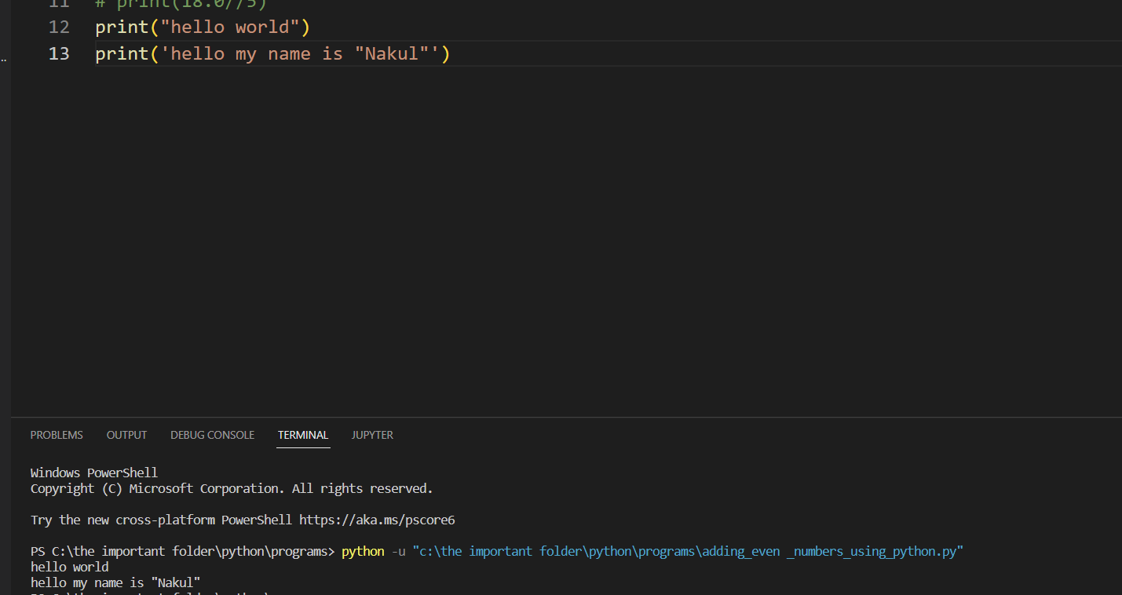

It does not matter that whether the print statement is enclosed inside the double quotes or the single quote

But when the single quotes are to be printed as a string then in that case the print statement is enclosed with the double quotes

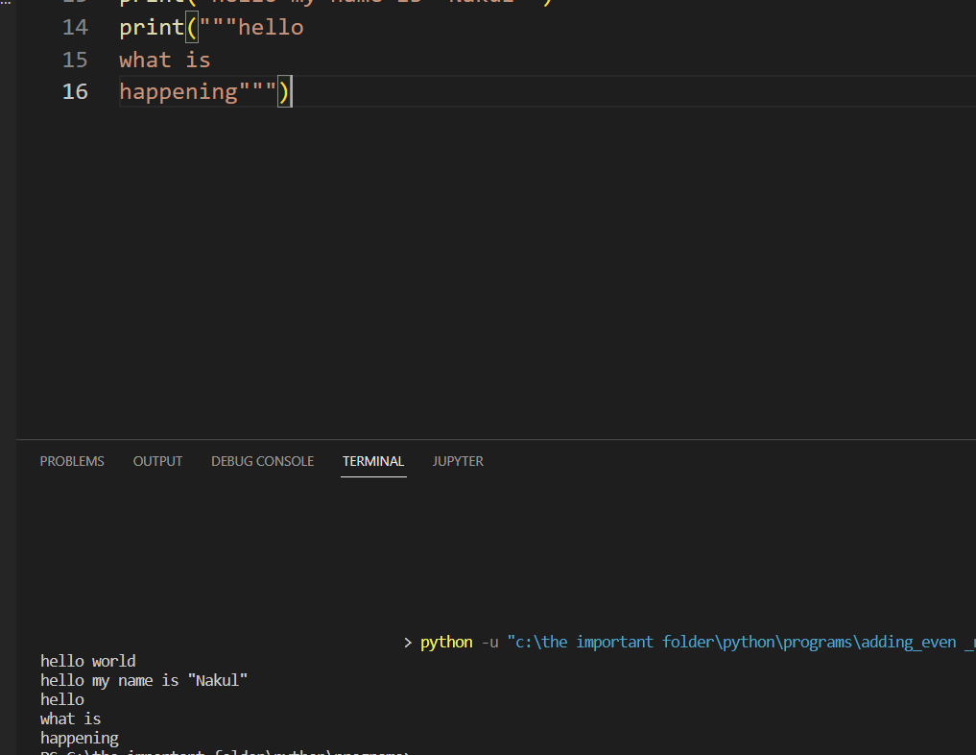

see writing the message using the print with the triple quotes will no longer even require the new line character

When we print a string using the print instruction, the value of the string, i.e. the sequence of characters within quotes is printed.

strings. Let us begin with **the concatenation operator (+)**, which is used to **produce a string by concatenating two strings**; for example, the expression 'hello ' + '!!' yields the string 'hello !!'. Similarly, the expression **'how' + ' are' + ' you?' yields 'how are you?'** (=('how' + ' are') + ' you') as shown below: >>> 'hello ' + '!!' 'hello !!' >>> 'how' + ' are' + ' you?' 'how are you?' escape sequence \n marks a new line use of + as the concatenation operator

***the Concatenation working***

* 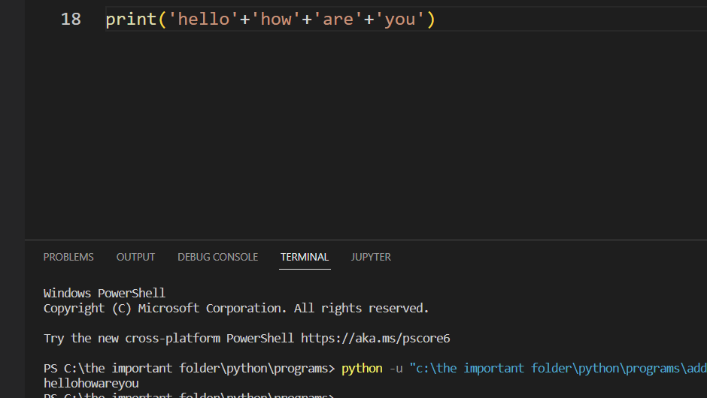



* escape sequence \n marks a new line
* The **operator * (multiplication) is used to repeat a string a specified number of times;** for example, the expression **'hello' * 5 yields the string 'hellohellohellohellohello'**:

>>> 'hello' * 5 'hellohellohellohellohello' use of * operator for repeating a string several times

Even the double quotes can be printed using the single quotes for printing the main statement

When I want to print something a no of times like

Hello world  
Hello world  
Hello world

So then I have to make the print statement as many times the times the output is required

For printing a number to a new line, This can be done by the new line character just like in java or C++ ***(\n)***

OR  
we can concatenate them ->> means we can combine other strings and add it to the other string variable

I can combine two strings using the (+) symbol and then writing the code for it

print(“Hello”+”Angela”)

the output of the above statement is HelloAngela

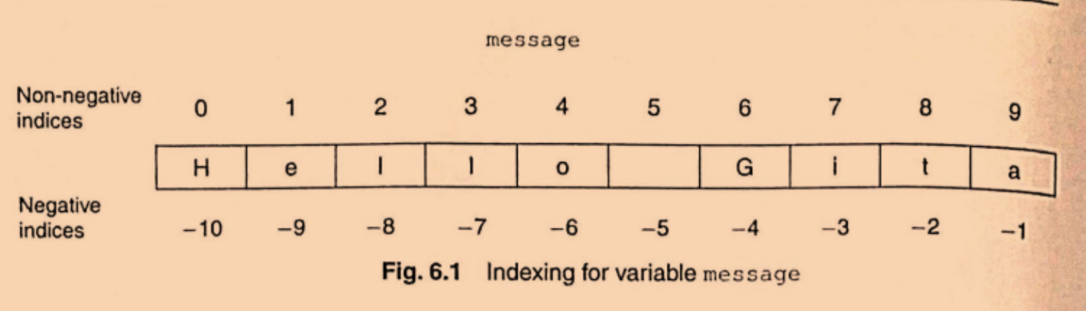

These are the values of the string forward and backward of the string

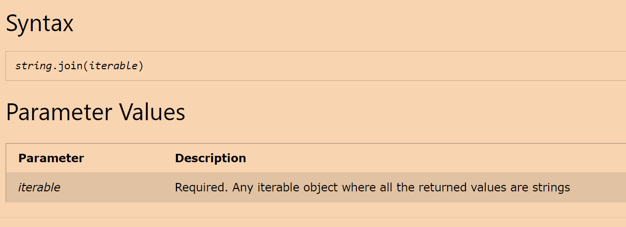

This is the syntax of the (.join) function of the string   
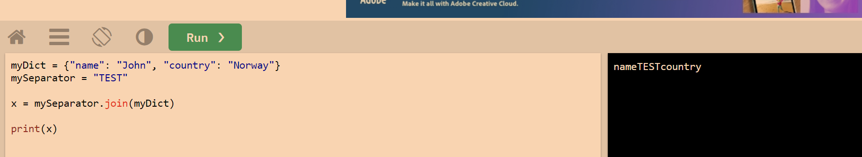

The join function usage like this

***Type Error****: If the iterable contains any non-string values, it raises a TypeError exception.*

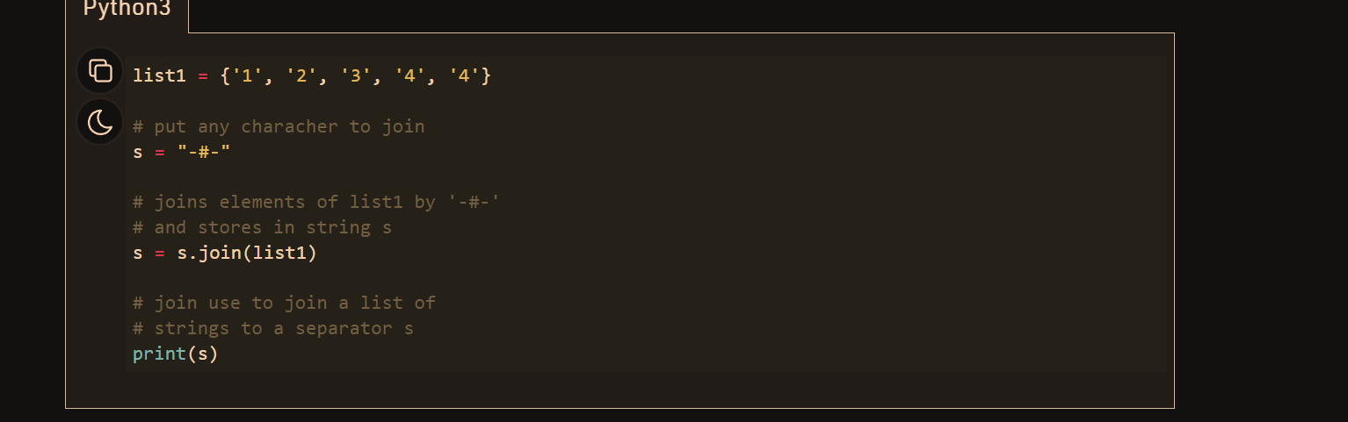

This is how the join function works

between the two strings are the

The Most common error found in Python programming is the Indentation error means leaving or adding redundant spaces

***As python programs work line by line so the errors found in python are first attended which are there in the program at first and then move forward to other programs***

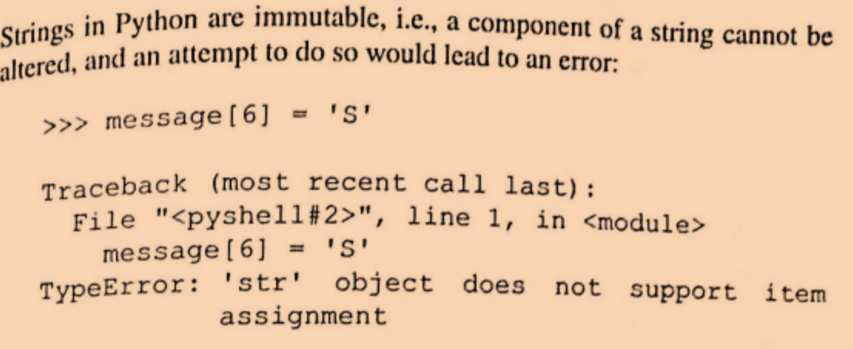  
we cannot change the String’s particular elements re

***Python Input Function***

So if I ask a question in the program regarding like

What is your name then in order to answer this

There need to be a input function which takes the input and then store it

***Input(“what is your name”)***

The output will be

*what is your name<the cursor will be blinking><on writing whatever I want to write >*

*says ->***Nakul**

then the code in the editor as marked above will be replaced by the word Nakul

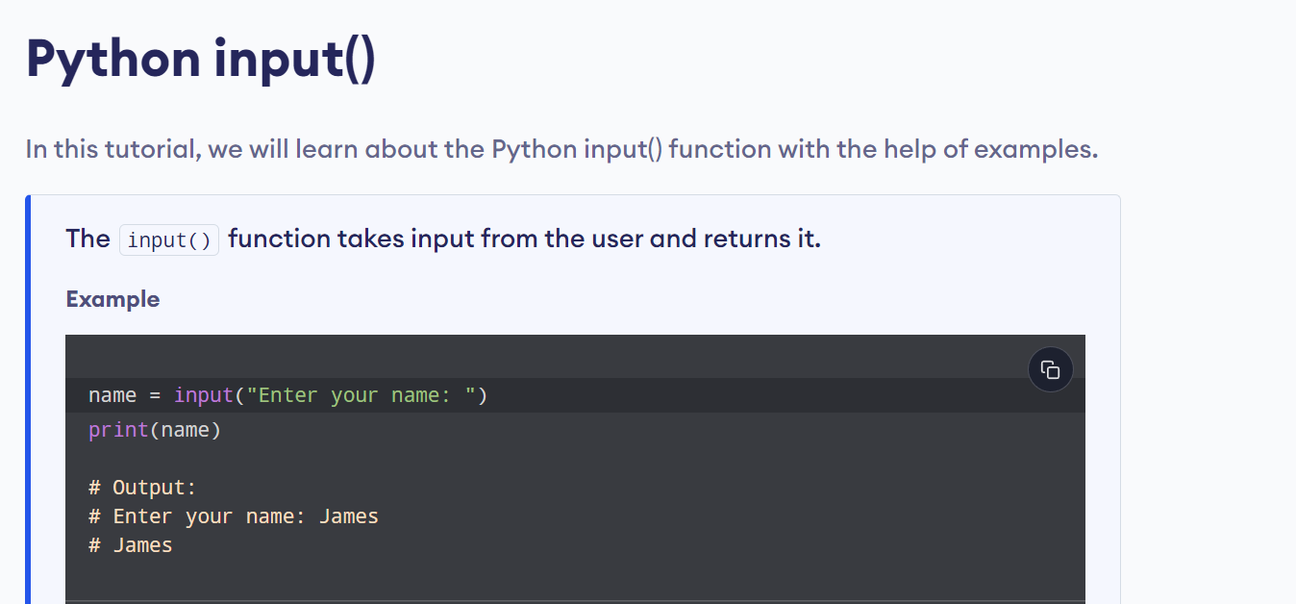

The code can also be written like this

print(“hello”+input(“what is your name “))

then the input function will run first and the ans of it will be replaced by the code and then the print function will run

in order to make the comments of the code then ***press Ctrl +/***

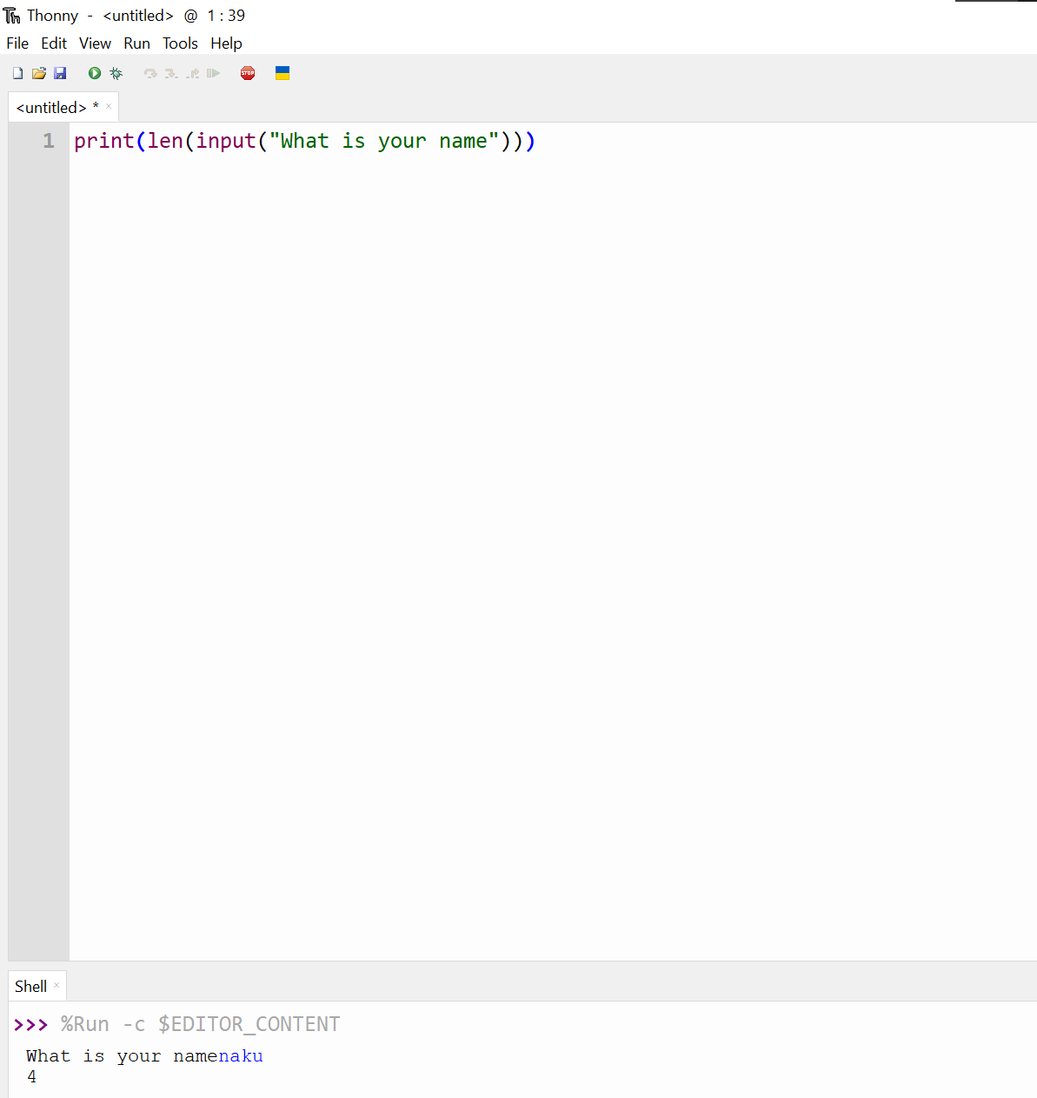

This is the way the program works

*The len function* is the one which counts the no characters in the String

# the eval function evaluates the “String” like a python expression and returns the result as an integer.  What is the difference between the input() and eval()?

Now you all know the input() takes the user input, but when the user enters an integer as an input the input function returns a string, but in the case of eval it will evaluate the returned value from a string to an integer

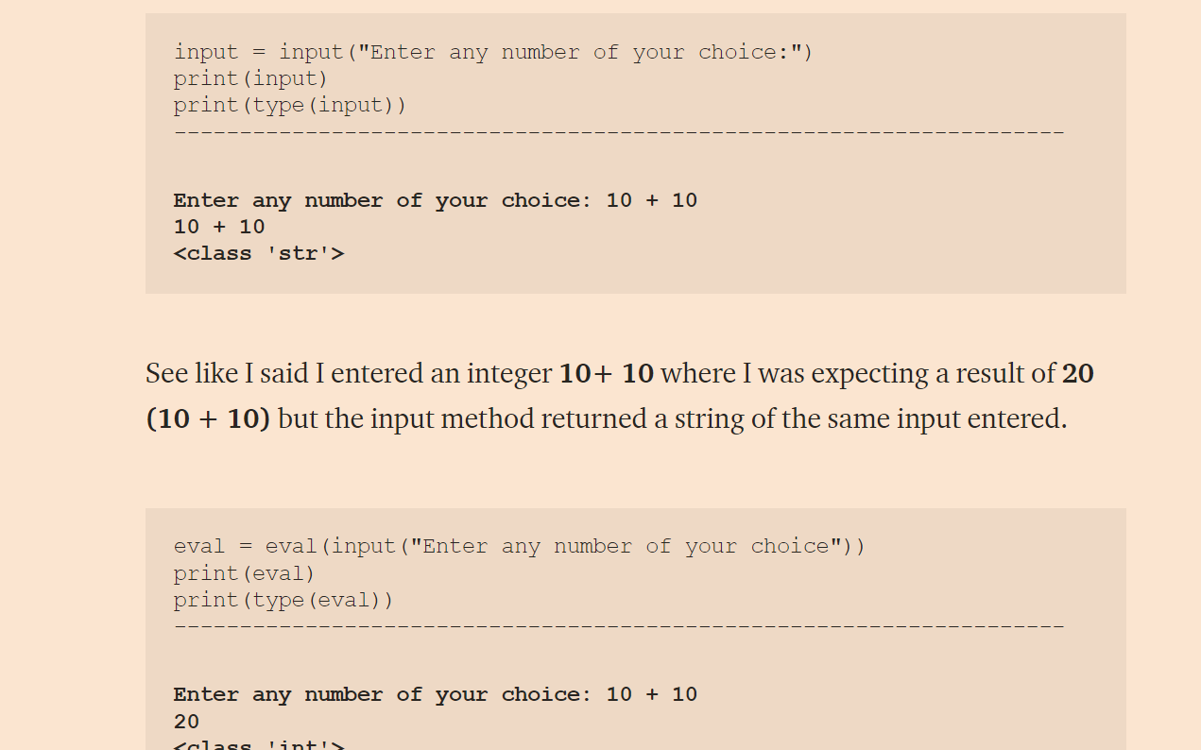

***What are python variables?***

They are used to save the data from the input functions

Like the input statement is typed

Input(“what is your name”)

On typing the name and entering it

The name gets printed over the input function now that particular string replaces the input function

And in order to store that string for further use in the code

The variables are used

So the code should be

***Name=input(“what is your name “)***

The printing of the length of the string can be stored in a variable

Name=input (“what is your name”);

Print(len(Name))

***the swapping of the values of the variables are done using this way***

a=b

b=c

c=a

***The rules for making the variable names***

The variables with two names should be divided with an underscore

Like ***My_name*** is correct

And ***My name*** is wrong

The variable name shoud never start with a number

The python keywords should not be used as variable name

The variable name should never be used for operations like printing if the name is not even declared

***Now we are going to learn about the Data Types,Numbers ,Operations,Conversions types, FStrings***

Making the subscript

The particular string character can be taken out of the String by the following method

*print(“Hello”[0])*

**so the output will be H**

the other data types are the int,Float,Boolean

int are the integers

print(“123”+”345”) ->>> will give the output of 123345

because here the numbers are in the inverted commas so acting like a String

but if

print(123+345) comes then the output will be 468 as here the integers are just typed as it is

then integers of higher length can be like 123456789 aree normally divided by the commas in normal world for better understanding but in python they are divided by (_)

***so 123456789 can be written as 123_456_789***

the other data tye which is primitive is the Float data type ->> 67.4567

and the final one is the BOOLEAN which gives answer only in the form of True or False

***Type error,Type Checking ,Type Conversion***

See the len() function is used for checking the length of the string returns always an integer value

We cannot concatenate the String with the Number (integer )

**The len() function is not used for checking the length of the Integer**

We can change the data type of the numbers from one to the other

Which is known as the Type Casting

See like a=len(input(“what is your name”)

This a can be converted to String though it is an integer   
using the following code

b=str(a)

where the Str actually means String

the type() function is used for showing the type of data type there in the brackets

the Type casting can be done to any data tyoe like in the following statement

b=str(a)

in place of Str I can also write the float,integer and of course the str

the following code line helps to print the data type of the value entered in the brackets

print(type(“what is your name”)

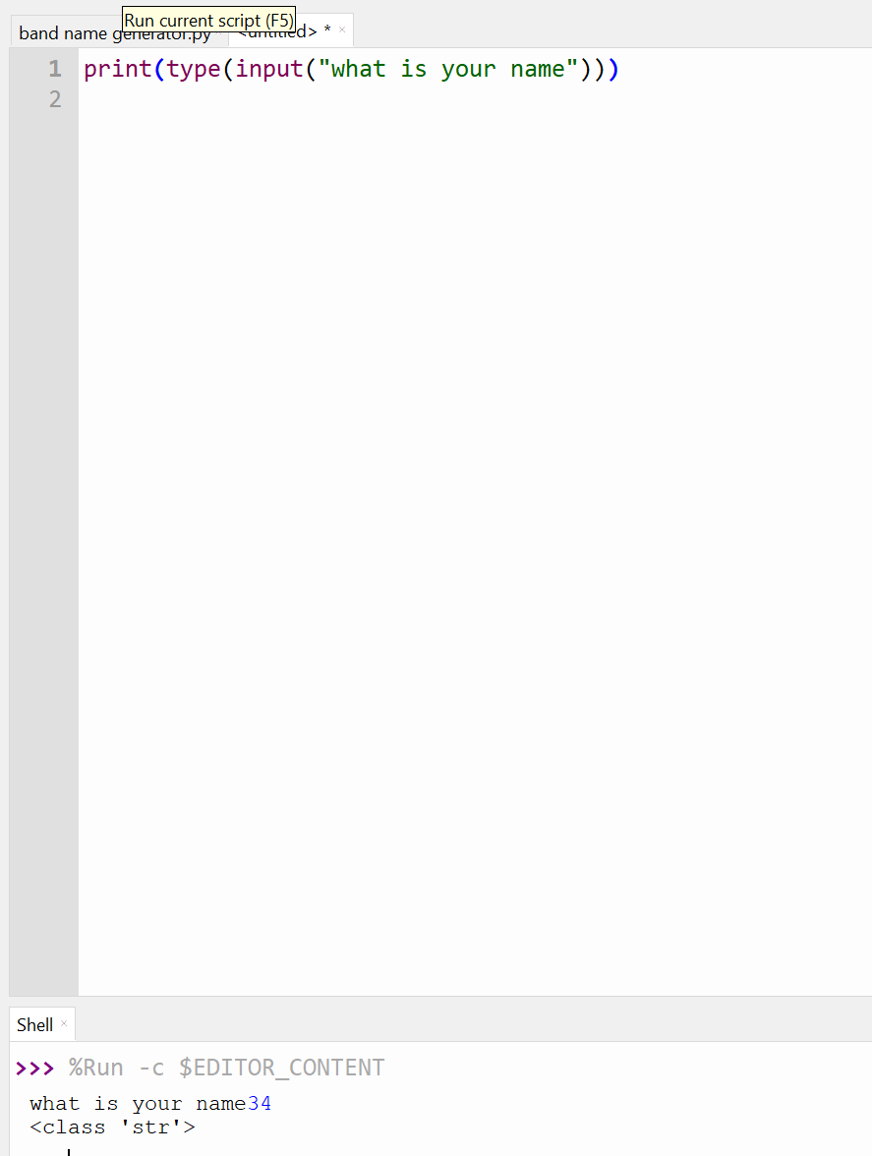

See even though I wrote the integer for the asked input and it shows that it is of String data type

The priority for the calculation is like ->>

()

**

(*, /)

(+.-)

The calculation will occur from left to right for the equal priority Calculation

The Mathemetical Calculation cannot be performed on the String data type

When the 8 is divided by 3 then the answer in float is 2.66666 which should be rounded off to 3 but the typecasting to int cuts all the integer part of the number

But does not round off

So the final answer is when round is applied is three

The following is the code

print(round(8/3))

this will give answer of 3

I can also round off the answer upto some decimal places by the following code

print(round(8/3,2))

// ->> in the place of 8/3 we can also write the name of the variable in which the value is to be stored at the end

in place of 2 I can also write either three or four or the number upto which the decimal of the calculation to be displayed

instead of converting the number to int using the type casting I can also do like this

print(8//3)

this will give the straight away answer of 2

because using this will give the round of answer

and if the type is checked of it using the type function

***print(type(8//3))***

will give the int type

using the calculation like this way

a +=b =>> a=a+b

same is the way with the other calculation

in order to print the integer as the string -> the type casting is done which converts the integer to the string data type so can be used printed using the print statement

***so converting any other data type which is other than the String to the String is sometimes difficult so there is a solution of it***

as-> instead of doing the type casting the we can do the following way

***score =0***

***print(f”your score is {score}”)***

sp this way on writing the f and then keeping the variable name inside the curly brackets

so just before starting the curly brackets

the f should be written before the String and then the string to be typed and the variables to be converted to the String should be in the curly brackets

the ***input function*** which receives the values always do in the String data type   
the string ofcourse can be stored in a variable also

->> we cannot concatenate string to an integer

In python spacing and indentation is very very important

***The syntax for the if else conditional***

If<condition>:  
 print(“the statement to be printed”)  
else:  
 print(“the other condition statement if the first one failed to get executed”)

***The yellow marked thing and the spacing are the most important one***



See the automatic indentation is provided on the vs code but need to be kept in mind while writing the code

In the condition area needs to be result in 1 or 0

These following are the comparison operators

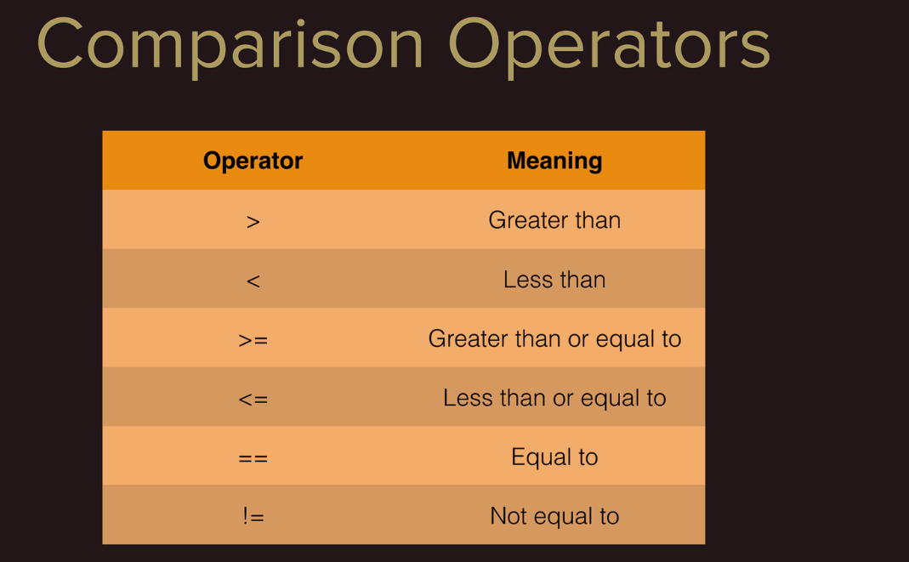

(=) is the assignment operator and the (==) is the one of the comparison operator

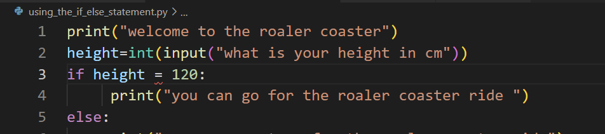see in the above code the indentation should be right near the conditions of the if else statement

The Modulo Operation will give the remainder of the result operation  
  
so 7%2 will gives the remainder of the

So 7%3 will give one

The even number (2n %2 will give the remainder as 0)  
the Odd number (2n+1 will give the remainder as the 1)

If number

The direct calculation can be added in the print statement -> the answer will be the result of it

Nested IF ELSE LOOP  
  
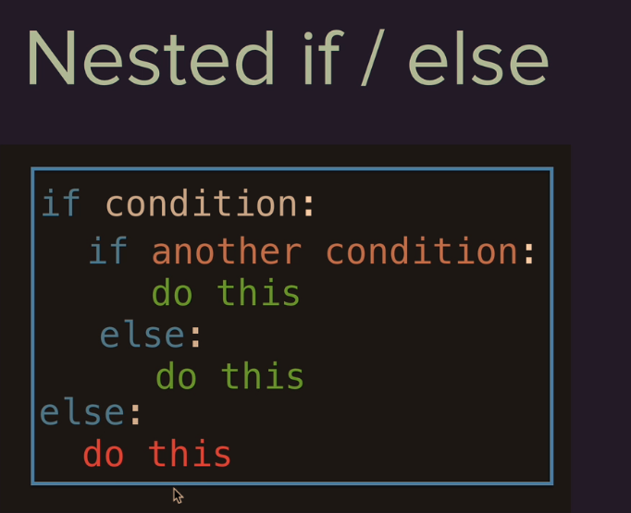



For the happening of the above statement as marked both the ***if CONDITION*** need to be true

And for the else condition , the outer IF condition need to be true and the inner IF Condition need to be false

***This is the chart for the NESTED IF ELSE statement***

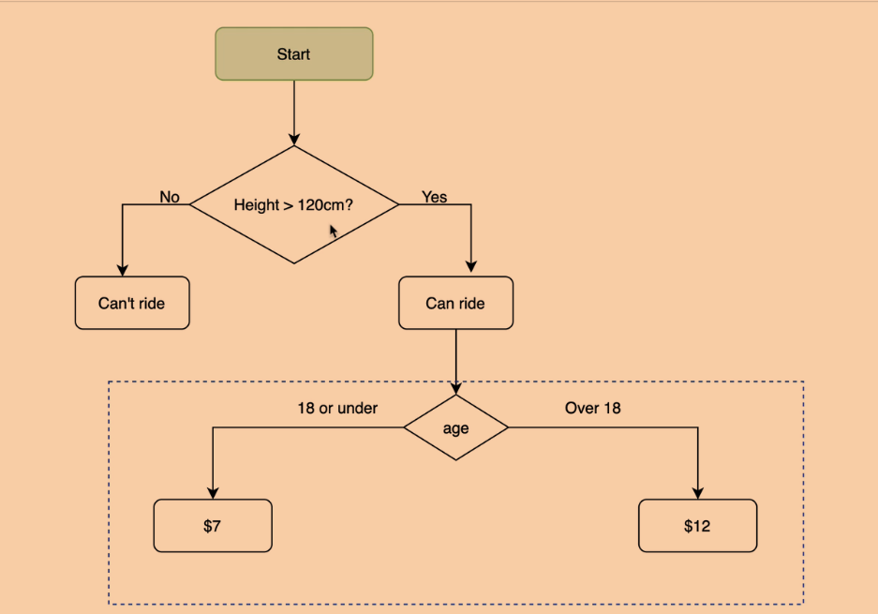

Here in PYTHON the ***else if*** is written as ***Elif***

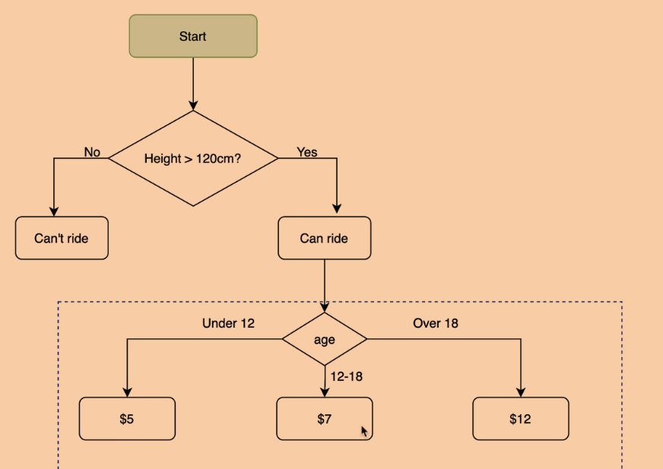

This is the another flow chart for the nested IF ELSE STATEMENT containing the conditions to be written in the following code   
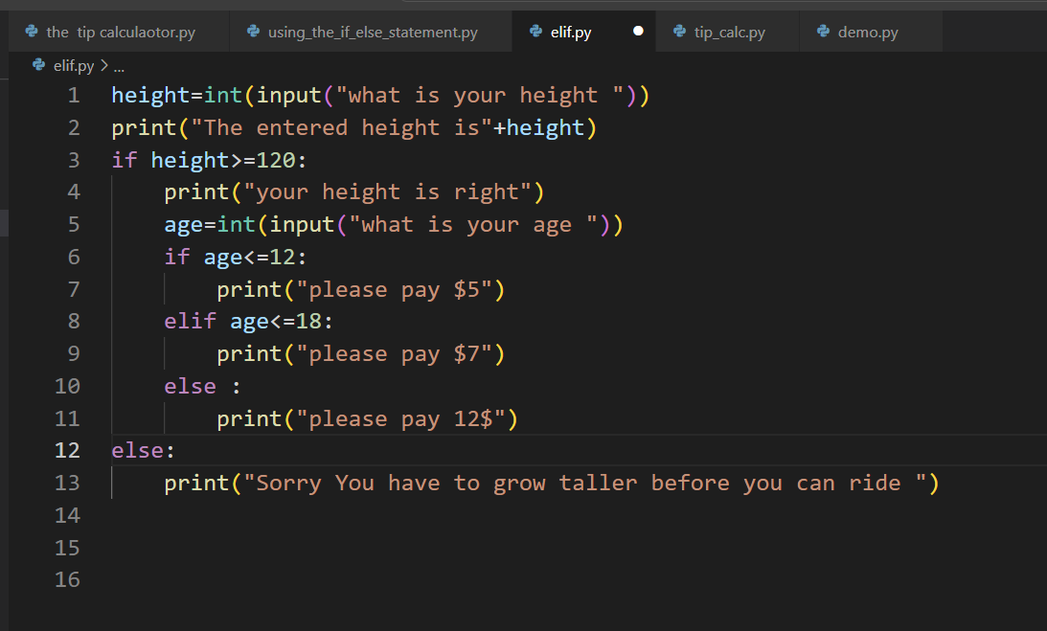

This is the right indentation for the Python code

***Formula to determine a Leap Year***

### How to determine whether a year is a leap year

To determine whether a year is a leap year, follow these steps:

1. If the year is evenly divisible by 4, go to step 2. Otherwise, go to step 5.
2. If the year is evenly divisible by 100, go to step 3. Otherwise, go to step 4.
3. If the year is evenly divisible by 400, go to step 4. Otherwise, go to step 5.
4. The year is a leap year (it has 366 days).
5. The year is not a leap year (it has 365 days).

I cannot concatenate String with the integer data type

***Conditionals in python***

If condition   
do this   
else:  
do this

Water level =50   
if(water_level>80:  
 print (“Drain Water”)  
else :

***Multiple IF Statements in Sucession***

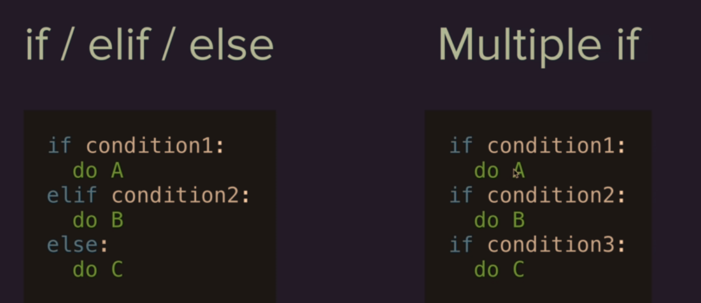  
this is the flowchart of the MULTIPLE IF  
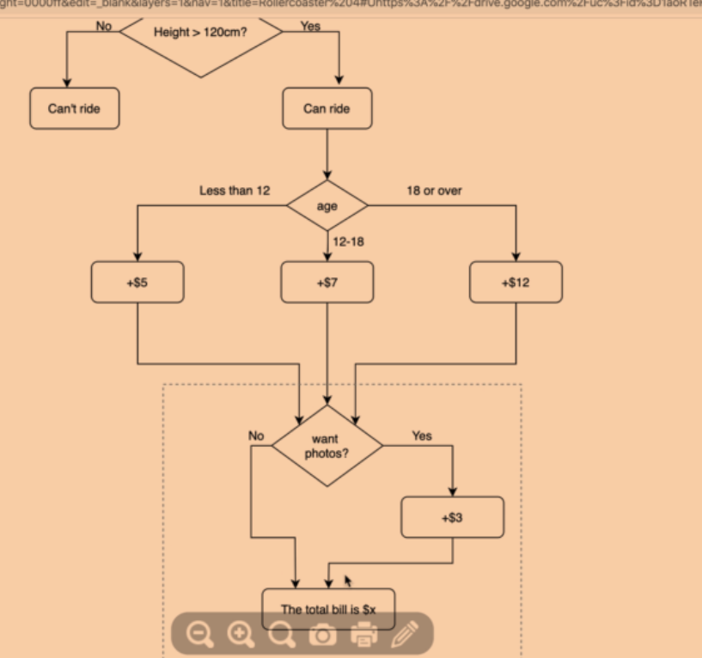  
A [String](https://www.askpython.com/python/string/strings-in-python) is a sequence of characters. You are allowed to **start** and **end** a string literal with single and double quotes in Python

Example usage of single quotes in Python

Below is the code where you can see the implementation of single quote.

word = 'Ask?'

print(word)

sentence = 'Python Programming'

print(sentence)

name = '"Hi" ABC'

print(name)

congrat = 'We congrat's you.'

print(congrat)

## Double Quotes in Python A double quotation mark is to set off a direct (word-for-word) quotation. For example – “I hope you will be here,” he said. In Python Programming, we use Double Quotes for string representation. **NOTE:** Use double quotes to enclose your strings when you know there are going to be single quotes within your string Bonus – Triple Quotes in Python

What if you have to use strings that may include both single and double quotes? For this, Python allows you to use triple quotes. A simple example for the same is shown below.

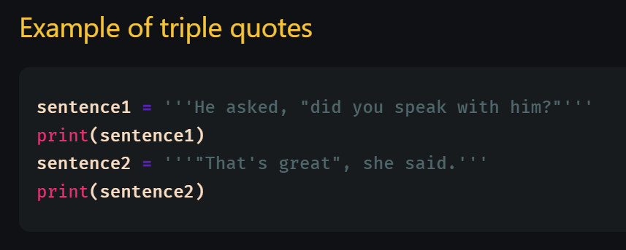

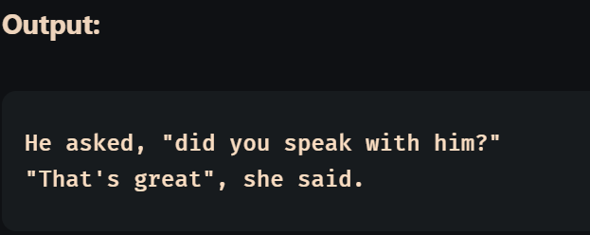

FACT -> the colon need to be put irrespective it is after the   
if condition  
elif condition  
else

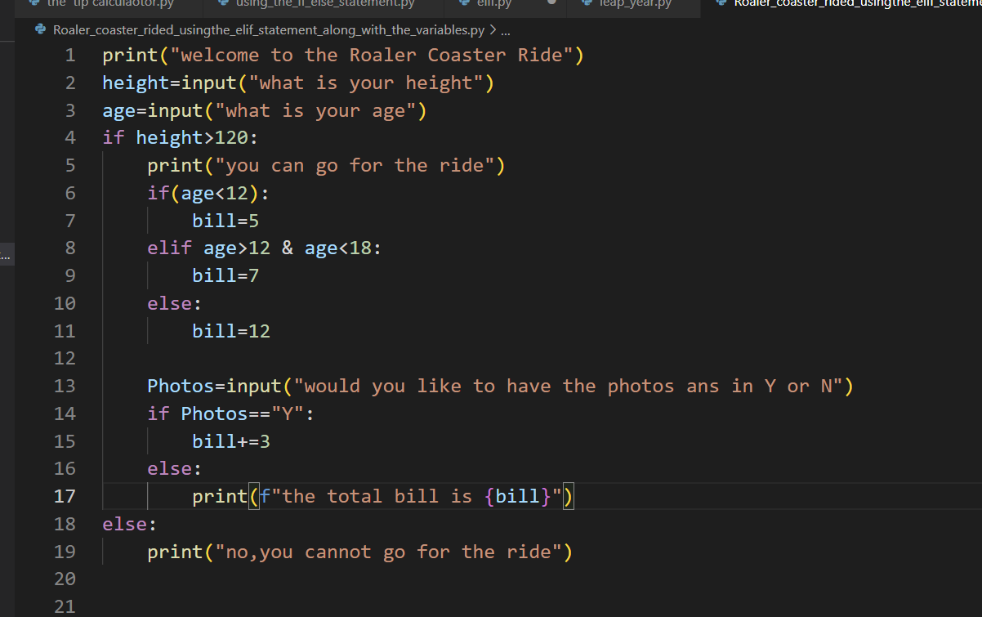

Check out the indentation part in the roaler coaster problem

***Complete the projects of the Day 3***

***What are Logical Operators***

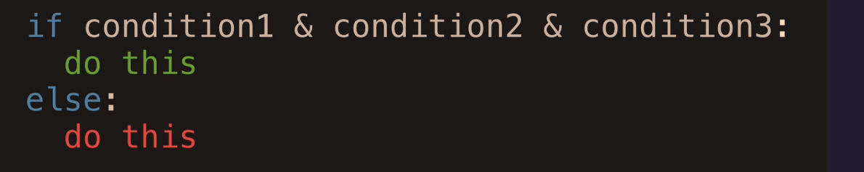

There are basically three types of logical operators   
-> the AND Statement   
-> the OR Statement   
-> the not

The NOT operator (reverses the condition) the condition becomes true otherwise which is false the condition become false

***the treasure Island game***

consisting of many if else conditions and elif statements

For Loop

* For item in list of items

The simple for loop is   
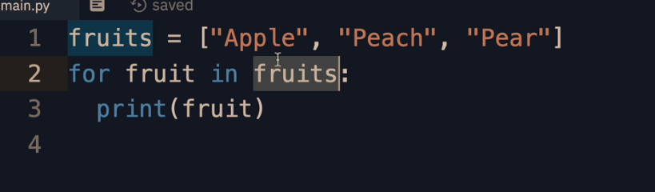

First we have the list for three Strings Apple, Peach, pear  
so now I have a variable fruits which hosts a list of Strings

So the for loop will be assigning the name of the fruit to the fruit variable

So the for loop is not just used for making the name printed present in the list   
print(it is also used for doing things multiple times   
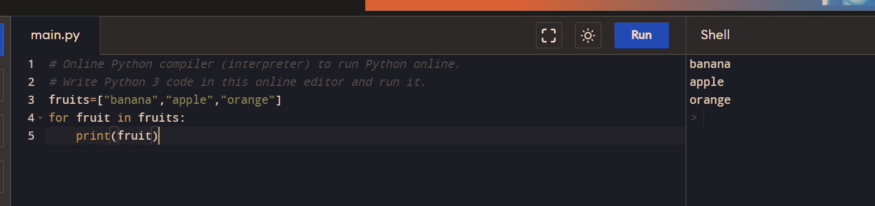

This is how it is

The name of the fruit in the list is assigned to the variable name   
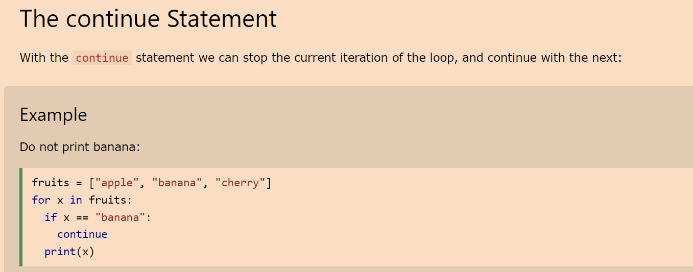

We can also add modifiers like the break statement or the break statement

***The Range function***



So the value in the brackets are the values of the max so it will be printing from 0(the Default value) to the value of 5  
***The range() function defaults to 0 as a starting value, however it is possible to specify the starting value by adding a parameter: range(2, 6), which means values from 2 to 6 (but not including 6):***

***The range() function defaults to increment the sequence by 1, however it is possible to specify the increment value by adding a third parameter: range(2, 30, 3)***

The Syntax of the Range function  
->> ***Syntax:****range(start, stop, step)*

***Parameter:***

* ***start****: integer starting from which the sequence of integers is to be returned*
* ***stop:****integer before which the sequence of integers is to be returned. The range of integers ends at stop – 1.*
* ***step:****integer value which determines the increment between each integer in the sequence*

## What is the use of the range function in Python

In simple terms, range() allows the user to generate a series of numbers within a given range. Depending on how many arguments the user is passing to the function, the user can decide where that series of numbers will begin and end as well as how big the difference will be between one number and the next.range() takes mainly three arguments.

* range(stop) takes one argument.
* range(start, stop) takes two arguments.
* range(start, stop, step) takes three arguments.

**

this is the way the range function make a series of the numbers and out of which using the for loop the numbers can be printed

students_heights=input("input a list of students height").split(",")

for i in range(0,len(students_heights)):

    students_heights[i]=int(students_heights[i])# this is the conversion of the numbers present in the list to an Integer

print(students_heights)# this is the printing of the list 1

this is the way the code can be printed using the range and the for lop

when a range is made from one value to the (final value given in the paranthesis -1)   
so when a range is made   
ele **=** range(10)[0]

print("First element:", ele)

ele **=** range(10)[**-**1]// this is because from back the element counting starts from -1

**print**("\nLast element:", ele)

ele **=** range(10)[4]

print("\nFifth element:", ele)

students=input("mention the no of marks of the fice students to get their average").split(",")

sum=0

for m in students:

    sum=sum+int(m)

print(f"the sum of all the marks are {sum}")

averge=sum/len(students)

print(f"the averge of all the marks entered by the students {averge}")

the average is find by the usage by this way also using the for loop and the len functions of the

***the split function in python***

The split() function works by scanning the given string or line based on the separator passed as the parameter to the split() function.  
The split() function returns the substrings as the elements of a list.

***Usage of the Else in For loop***   
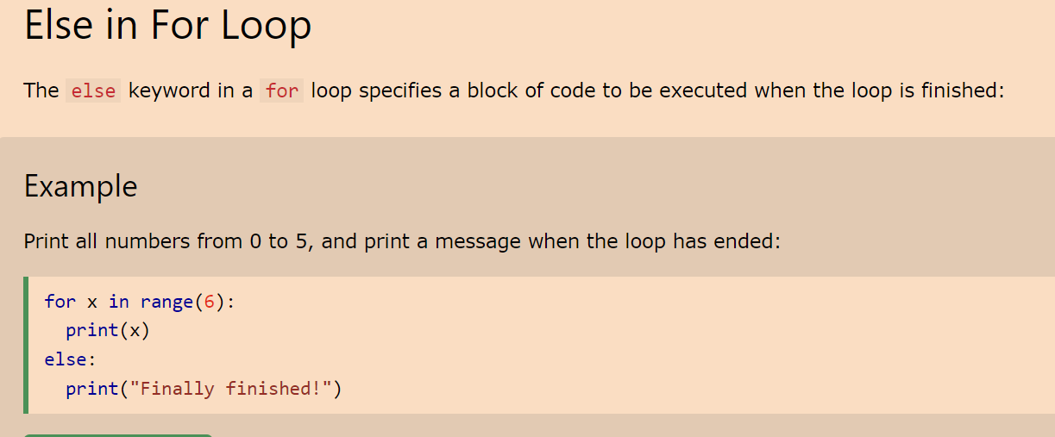

Check out this nested for loop  
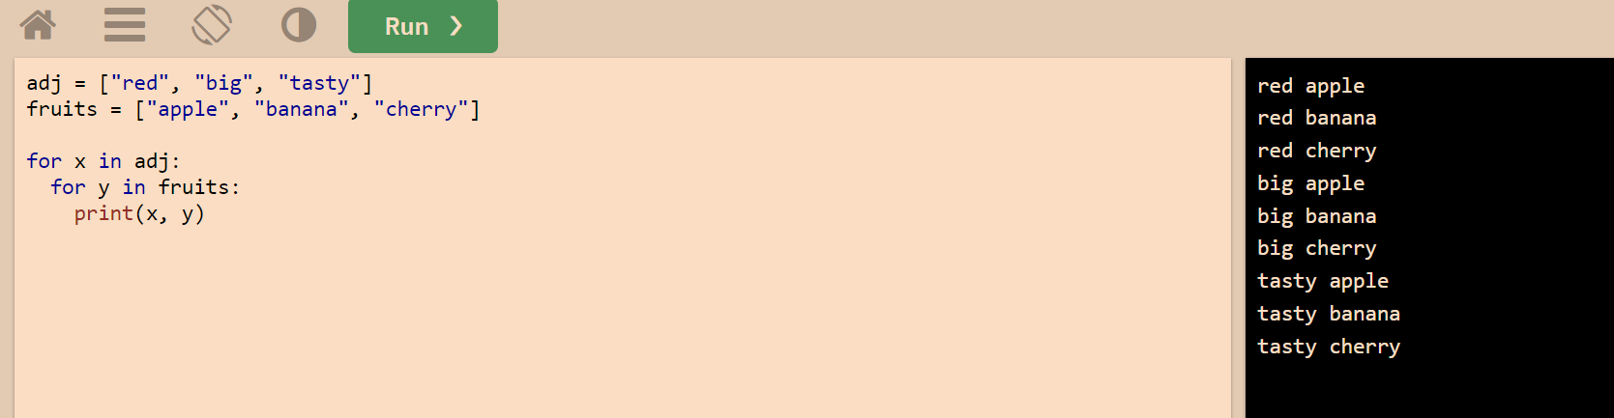

## **The pass Statement**

for loops cannot be empty, but if you for some reason have a for loop with no content, put in the pass statement to avoid getting an error.

### **Example**

for x in [0, 1, 2]:  
  pass

***some coding exercises for the Pass Statement***

such as the   
len() function->> to calculate the size of the list

## **Definition and Usage**

***The len() function returns the number of items in an object.or the length of the object***

When the object is a string, the len() function returns the number of characters in the string.

Return the length (the number of items) of an object. The argument may be a sequence (***such as a string, bytes, tuple, list, or range***) or a collection (***such as a dictionary, set, or frozen set***)

The function len() always returns an integer as it’s counting the number of items in the object that you pass to it.

***Syntax->>The len() function returns the number of items in an object.***

***When the object is a string, the len() function returns the number of characters in the string.***

Len(object)

Parameter Values

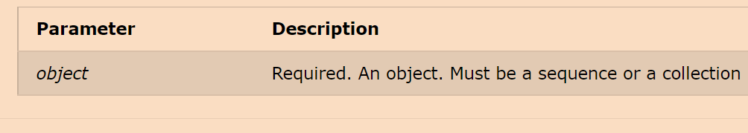

Another is the sum function for printing the sum of the characters present in the list

In order to find the maximum value of all the elements in the list

There is a function called Max() which results the max value of the list

But this function can be replaced with something coding done by the For LOOP using the Logical Operators

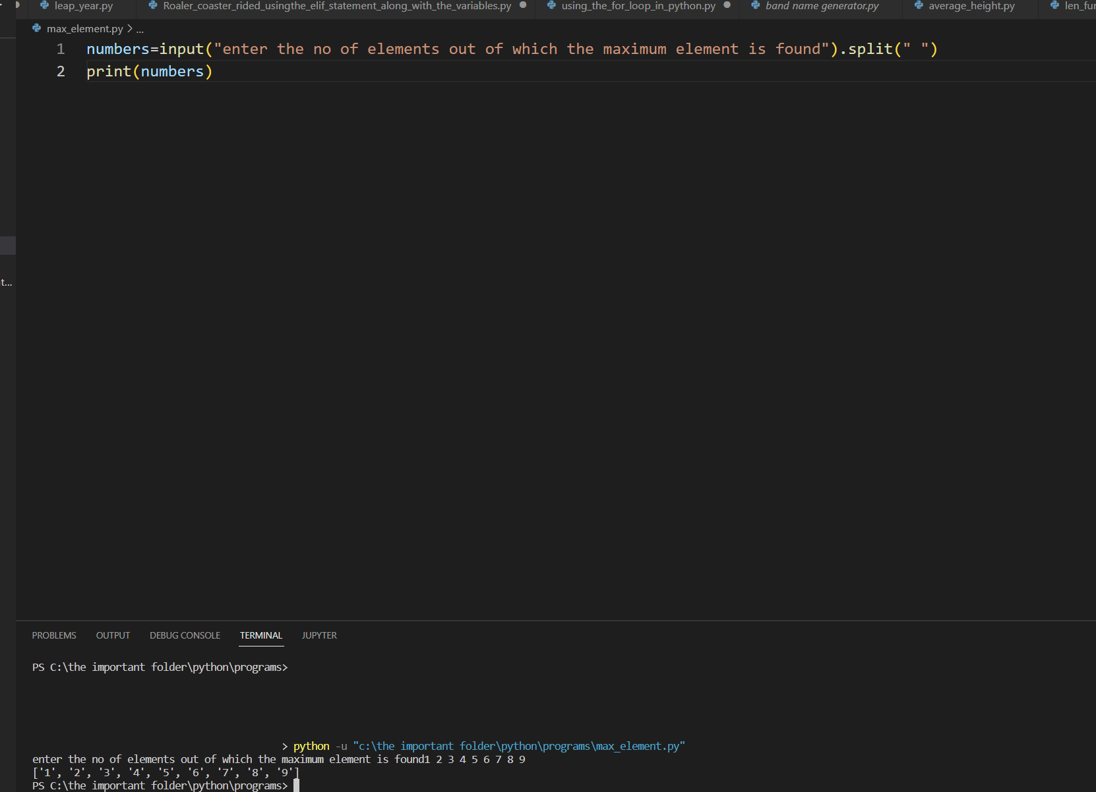

The simplest way of making and printing the list

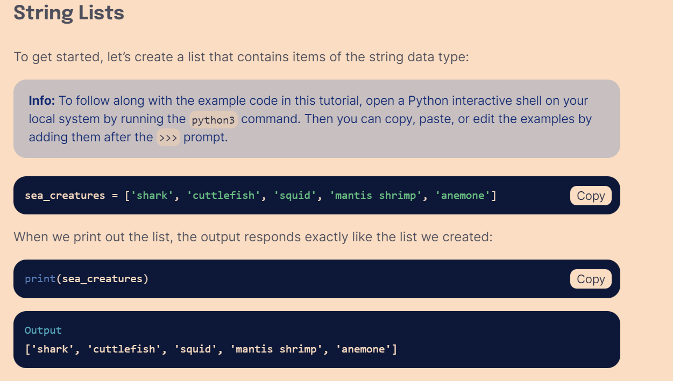

We can also make a list of the data type of the String   
and then get it printed

Program to print the max number from the list entered by the user

the_numbers=input("enter the numbers to get the max number").split(" ")

#in the first line i made a list of all the numbers

print(the_numbers)

highest_score=0

for n in range(0,len(the_numbers)):

    the_numbers[n]=int(the_numbers[n])

# I made a variable which will store the highest number from the list

for number in the_numbers:

    if number > highest_score:

        highest_score=number

print(f"the highest score is {highest_score}")

***FACT ->*** the entered number from the user is taken in the list

As w***e cannot typecast directly a list from string to another data type*** -> I ***have to type cast each number*** from the list which is in String data type to the integer data type using the ***Range function***

Till now we were only using the list to print the numbers which were entered in it   
but now we will be using the for and the range function

It can be used to generate a range of functions to loop through

So the syntax of the range function is   
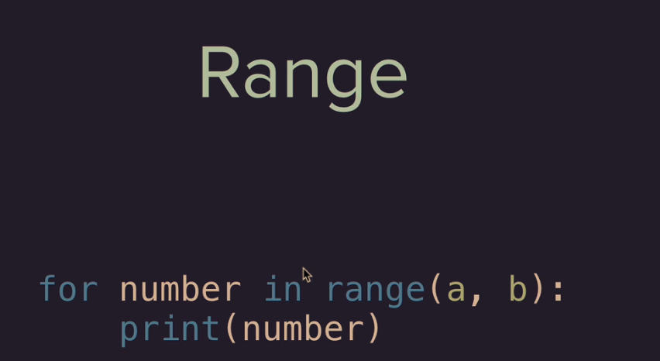  
the range function is also similar to using the for loop in the string

***Python user defined Functions***

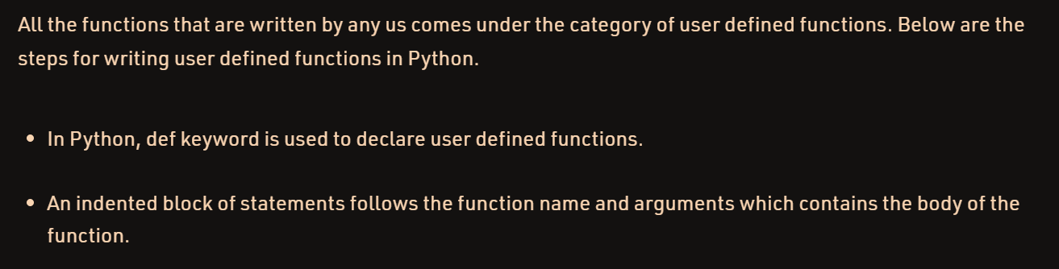

The def keyword is used for making a new function  
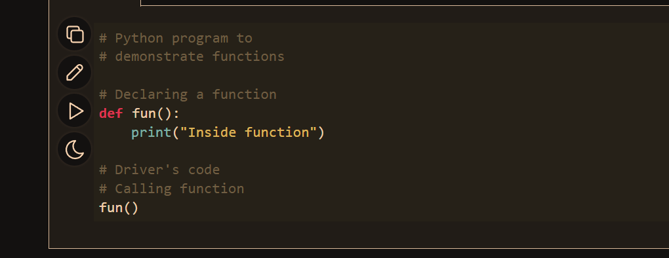

This is how a normal user defined function look like